A Ballooning Issue
To solve environmental problems, people usually need to assess the problem and then work to change the actions of individual people or groups. In this project, you will research information on the environmental impact of helium-filled balloons, particularly on animals.
Suppose you go to a school that releases helium balloons during every graduation – one balloon for each graduating senior. Sounds harmless enough, but you suspect otherwise.
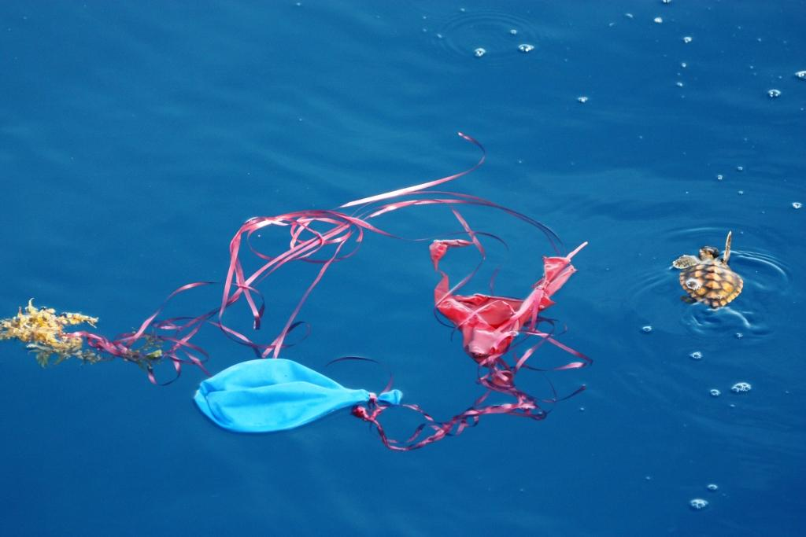

Task Number One
Your job is going to be to research the environmental costs of releasing helium filled balloons. To do this, you will need to answer the following questions IN YOUR OWN WORDS.
- Explain what happens when a helium-filled balloon is released and rises into the atmosphere. (Hint – Describe what happens to the balloon. Does it float forever, immediately pop?)
- Explain how the balloons break down in the environment. (There are two types of balloons – latex and metallic/Mylar – and they break down differently.)
- Describe what happens when an animal ingest pieces of balloons.
- Besides ingestion, explain the other major threat to animals that is often associated with balloons.
- Suggest an alternate investment of funds to celebrate graduation. Make sure this is an environmentally friendly suggestion. Also, explain why you believe it is a good choice.
Use these websites to help you answer the questions
https://www.fws.gov/news/blog/index.cfm/2015/8/5/Balloons-and-Wildlife-Please-Dont-Release-Your-Balloons
https://balloonsblow.org/impacts-on-wildlife-and-environment/
http://encenter.org/visit-us/programs/birthday-parties/balloons/
https://balloonsblow.org/latex-balloons-still-kill/
https://earth911.com/living-well-being/events-entertainement/balloons-environment/
Task Number Two
Go to Mr. B and have him check your answers. Make any corrections/changes/additions/subtractions that he suggests. When you have the okay from him, move on to step 3.

Task Number Three
Create ANY TYPE OF PRESENTATION/POSTER/PAMPHLET that shows all of the information that you just researched.
The only thing that is off limits is a traditional Google Slides presentation.
You have the freedom to choose how you want to present the information, just make sure you okay it with Mr. B before moving on. Your choices include, but are not limited to, the following:
- Poster
- Brochure
- Flier
- Prezi
- Story
- Comic Strip
- Any other option you can think of, just make sure you ask Mr. B

Grading
You will be graded on the following criteria:
In your project, did you answer all questions completely and correctly? 10 points
When creating your project, did you do so in a neat manner that reflects time and effort? 10 points
Did your project have 3 or less spelling and grammar errors? You will lose 2 points be spelling and grammar mistake after 3 errors. 10 points
Did you use your class time effectively? 10 points
Total points for this project – 40 points

