Create at least 8 ORIGINAL questions that cover the material from section 1 – Bacteria – from chapter 19/20. For this activity, write questions that require shorter answers or can be fill in the blank.
4 questions should cover material from your guided notes (Section 1 – Bacteria (Parts 1,2, & 3).
4 questions should cover material from your textbook (pages 580-585 – this is technically section 2 in your book, but it covers the same material)
When you are writing your questions, format them as they are in the picture below. Type your question (with a question mark at the end), type an asterisk (* - this is done by holding shift and 8), and then type the answer to the question. It must be in this format in order for the next step to work correctly.
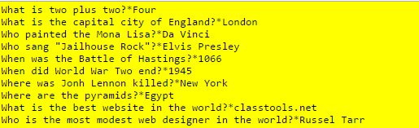

Type your questions on Google Docs and copy and paste the sharebale link into the Edmodo assignment
OR

Type your questions directly into the Edmodo assignment.

