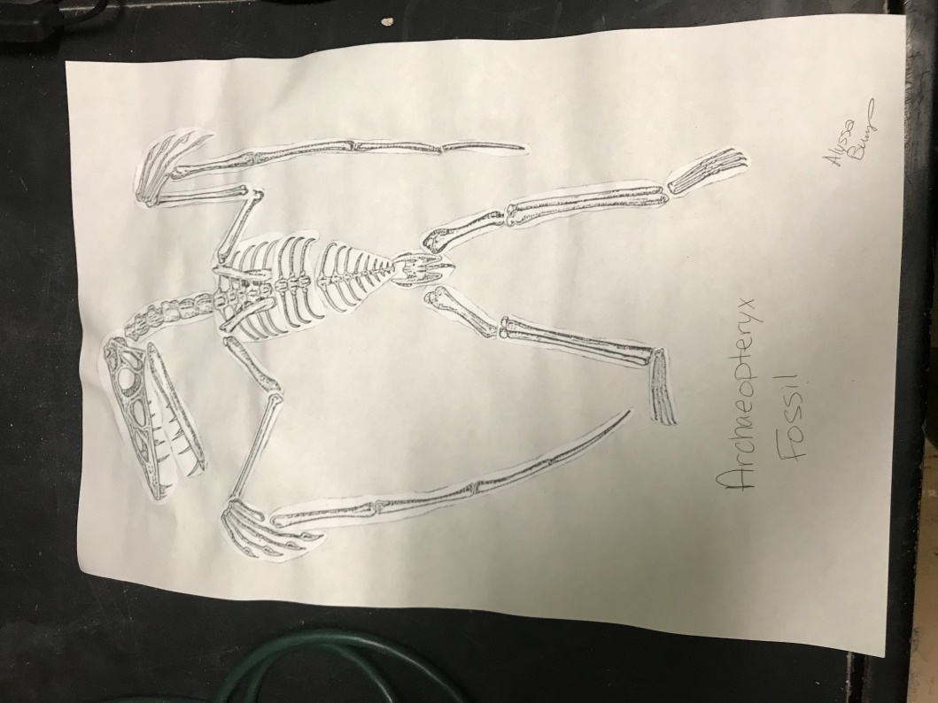

**Archaeopteryx Extra Credit**

**Step 1** – Glue your bones to a piece of paper in the correct locations. See the picture to the left to help you with the location of the bones.

Note – Yours does not have to look identical to this. You can make your arms more spread out to make it appear as if it was flying.

**Step 2** – Your next step will be to draw what you believe Archaeopteryx looked like when it was alive. Fossils do not illustrate color, so you have creative freedom to imagine what the color might be. You can use Google, but do not be limited by what they show you. Also, do not copy this drawing, it is a sample.

