Chapter 1 – The Science of Biology
Section 1 – What is Science?
- _____________is an organized way of using evidence to learn about the _____________ world.

- What is the _____________ of science?
  - investigate and _____________ the natural world.
  - explain_____________ in the natural world.
  - use those explanations to make useful _____________.

- Thinking like a __________ .
  - Scientific thinking begins with an_____________.
    - An_____________ is the process of gathering __________ about events or processes in a careful, orderly way.
  - The information gathered from observations is called _____________ .
    - _____________data are expressed as _____________, obtained by counting or measuring.
      - Examples –
    - _____________data are _____________ and involve characteristics that can’t easily be measured.
  - Scientists use data to make an_____________.
    - An____________ is a logical interpretation based on prior knowledge or experience.
- Explaining an interpreting evidence
  - A _____________ is a proposed scientific explanation for a set of observations.
    - They are _____________ out or _____________.
    - However, they must be designed in a way that can be __________.
Section 2 – How Scientists Work (Part 1)
- How do scientists_____________ a hypothesis?
  - Whenever possible, a hypothesis should be tested by an_____________ in which only one variable is changed at a time. All other variables should be kept _____________, or controlled.
- Parts of an Experiment
  - The variable that is deliberately changed is called the ______________ variable.
  - The variable that is observed and that changes in response to the manipulated variable is called the responding variable
- The process of designing an experiment to test a hypothesis includes:
  - Asking a _____________
  - Forming a _____________
  - Setting up a _____________experiment
  - Recording and analyzing ____________
  - Drawing a ____________
- Historical Example
  - Asking a Question
    - Many years ago people wanted to know how organisms came into _____________, so they asked, “How do _____________ come into being?”
  - Forming a hypothesis
    - One early hypothesis was __________________________, or the idea that life could come from nonliving matter. For example, most people thought that maggots spontaneously appeared on meat.
    - In 1668, _____________ proposed a different hypothesis: that maggots came from eggs that flies laid on meat.
  - Redi’s Experiment
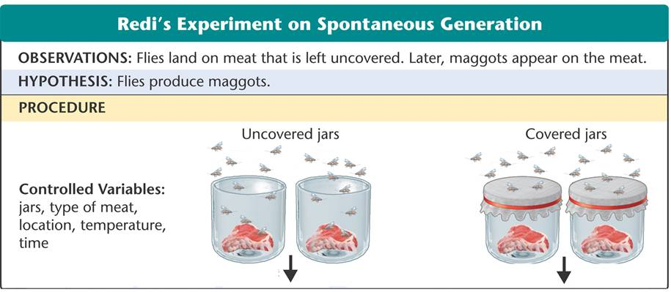
  - Redi’s Data and Conclusion
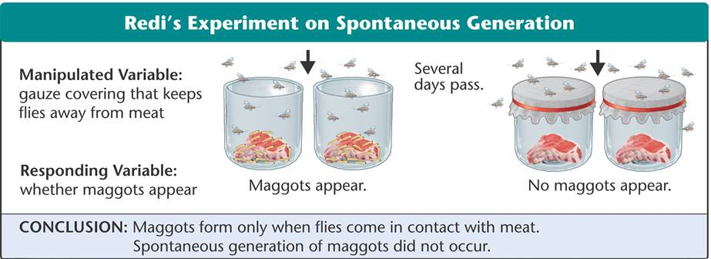

Section 2 – How Scientists Work (Part 2)
- Repeating _____________ .
  - Scientists___________ experiments to be sure that the results match those already _____________.
- _____________ Test of Redi's Findings
  - Needham challenged Redi’s results by claiming that spontaneous generation _____________ occur under the right conditions.
- Needham’s Test of Redi’s Findings
  - Needham heated a bottle of _____________
  - Allowed the gravy to _____________to room temperature
  - _____________ the bottle
  - After several days, the gravy was _____________ with microorganisms.
  - Needham concluded that these organisms came from the gravy by _______________ generation.
- What is the problem with this experiment?

  - ________________________________________________________________________________________________________________________________________________________________________________________________________________________
- Spallanzani’s Test of Needham’s
  - Spallanzani heated _____________ bottles of gravy.
  - He left one open and then _____________ the other.
  - Open flask - ____________ with microorganisms
  - Closed flask - ____________ of microorganisms.
- Pasteur’s test _____________Spallanzani’s results
  - The key portion of his experiment was the usage of ______________ neck flask.
  - Confirmed that spontaneous generation did not occur
- How a ______________ Develops
  - As evidence from numerous investigations builds up, a hypothesis may become so well supported that scientists consider it a _____________.
  - In science, the word _____________ applies to a well-tested explanation that unifies a broad range of observations.
  - No theory is considered absolute _____________.
  - As new evidence is uncovered, a theory may be revised or replaced by a more useful explanation.
Section 3 - Studying Life (Part 1)
- Characteristics of Living Things
    - No _____________ characteristic is enough to describe a living thing.
    - Some _____________ things share one or more traits with living things.
  - Living things are made up of _____________.
    - A _____________ is the smallest unit of an organism that can be considered alive.
  - Living things _____________ and develop.
    - During an organism’s development, cells differentiate, which means that the cells look different from one another and perform different _____________.
  - Living things are based on a universal _____________ code.
    - Organisms store the information they need to live, grow, and reproduce in a genetic code in a molecule called _____________.
  - Living things respond to their _____________.
    - A _____________ is a signal to which an organism responds.
  - Taken as a group, livings things change over time. Over many generations, groups of organisms typically _____________.
- Living things reproduce
  - In ___________________________ reproduction, cells from two different parents unite to form the first cell of the new organism.
  - In _________________________ reproduction, a single parent produces offspring that are identical to itself.
- Living things obtain materials and use _____________________.
  - The combination of chemical reactions through which an organism builds up or breaks down materials is called metabolism.
- Living things maintain a stable internal environment.
  - Although conditions outside an organism may change, conditions inside an organism tend to remain ___________________________________.
  - This process is called homeostasis.

- _____________ of Biology
  - There a many branches of biology. For example:
    - Zoologists study _____________.
    - Botanists study _____________.
    - Paleontologists study _____________ life.
Section 3 - Studying Life (Part 2)
- How can life be studied at different levels?
- Levels of _____________
  - _____________
    - Groups of _____________; smallest unit of most chemical compounds
  - _____________
    - Smallest functional unit of _____________
  - ______________ of Cells
    - Tissues, organs, and organ systems
  - ______________
    - Individual _____________ thing
  - ______________
    - Group of organisms of one type that live in the same _____________
  - _____________
    - Populations that live _____________ in a defined area
  - _____________
    - Community and its _____________ surroundings
  - _____________
    - The part of _____________ that contains all ecosystems
Section 4 Tools and Procedures
- A Common Measurement System
  - Scientists need a common system of measurements in order to ____________ each other’s experiments.
  - Most scientists use the ____________ system when collecting data and performing experiments.
    - The metric system is a decimal system of measurement whose units are based on certain physical standards and are scaled on multiples of _____________.
    - Because the metric system is based on multiples of 10, it is easy to use.
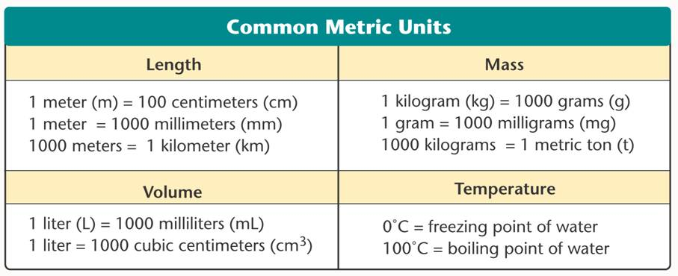
- Microscopes
  - Microscopes are devices that produce _____________ images of structures that are too small to see with the unaided eye.
  - Light microscopes produce magnified images by focusing visible light rays.
    - These are the most _____________ used microscopes
    - Light microscopes produce clear images of objects at a magnification of about 1000 times.
    - _____________ light microscopes allow light to pass through the specimen and use two lenses to form an image.
    - Limitations
      - Light microscopes cannot produce clear images of objects smaller than 0.2 micrometers, or about one-fiftieth the diameter of a typical ___________.
  - ____________ microscopes produce magnified images by focusing beams of electrons.
    - The best electron microscopes can produce images almost _____________ times more detailed than light microscopes can.
  - Laboratory Techniques
    - Cell _____________
      - To obtain enough material to study, biologists sometimes place a single cell into a dish containing a nutrient solution.
      - The cell is able to reproduce so that a group of cells, called a cell culture, develops from the single original cell.
    - Cell ___________
      - Biologists often use a technique known as cell fractionation to separate the different cell parts.
  - Working Safely in Biology
    - Remember you are responsible for your own safety as well as that of your teacher, classmates, and any live animals you handle.
    - ____________ safe practices.
    - Study the safety rules.
    - Read ALL the steps and safety precautions.
    - Follow your teacher’s instructions and textbook directions exactly.
    - If in doubt, ask your _____________ for an explanation.
    - Wash your hands thoroughly with soap and warm water after every scientific activity.

