Chapter 5 – Populations
Section 1 – How Populations Grow
Review – Define Population: ___________________________________________________________
___________________________________________________________________________________
- Characteristics of Populations
  - Three important characteristics of a population are its:
    - geographic distribution
    - density
    - _______________ rate
  - Geographic distribution, or range, describes the area inhabited by a population.
  - Population density is the number of ___________________ per unit area.
  - Growth rate is the increase or decrease of the number of individuals in a population over time.
- What factors affect population size?
  - Three factors can affect population size:
    - the number of births
    - the number of ______________________
    - the number of individuals that enter or leave the population
    - A population can grow when its birthrate is ______________ than its death rate.
  - Immigration, the movement of individuals into an area, is another factor that can cause a population to grow.
    - Populations can increase by immigration as animals in search of mates or food arrive from outside.
  - Emigration, the movement of individuals ______________________ of an area, can cause a population to decrease in size.
    - Emigration can occur when animals leave to find mates and establish new territories.
    - A shortage of ____________________ in one area may also lead to emigration.
- What are exponential growth and logistic growth?
- Exponential Growth
  - Under ideal conditions with unlimited resources, a population will grow exponentially.
  - Exponential growth occurs when the individuals in a population ___________________ at a constant rate.
  - The population becomes larger and larger until it approaches an infinitely large size.
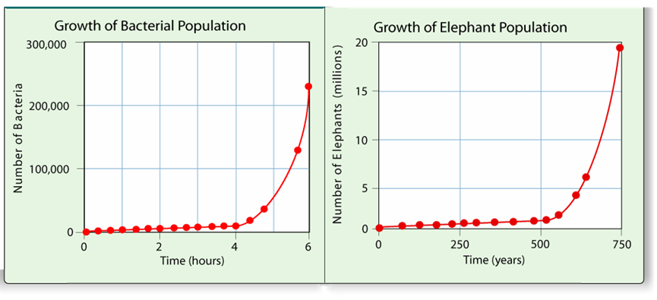
- Logistic Growth
  - In nature, exponential growth does not continue in a population for very long.
  - As resources become less available, the growth of a population slows or ____________.
  - Logistic growth occurs when a population's growth slows or stops following a period of exponential growth.
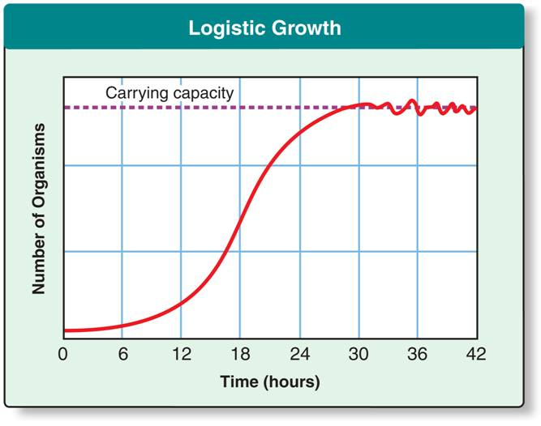

- Carrying Capacity
  - The largest number of individuals of a population that a given environment can support is called its __________________ capacity.
  - When a population reaches the carrying capacity of its environment, its growth levels off. The average growth rate is zero.
Section 2 – Limits to Growth
- What factors limit population growth?
- Limiting Factors
  - The primary productivity of an ecosystem can be reduced when there is an insufficient supply of a particular nutrient.
  - Ecologists call such substances limiting nutrients.
  - A limiting nutrient is an example of a more general ecological concept: a limiting factor.
  - In the context of populations, a limiting _______________ is a factor that causes population growth to decrease.
- Density-Dependent Factors
  - A limiting factor that depends on population size is called a density-dependent limiting factor.
  - Density-dependent limiting factors include:
    - competition
    - _________________
    - parasitism
    - _______________
  - Density-dependent factors operate only when the population density reaches a certain level. These factors operate most strongly when a population is __________ and dense.
  - They do not affect small, scattered populations as greatly.
- Competition
  - When populations become crowded, organisms compete for food, water space, sunlight and other essentials.
  - Competition among members of the same species is a density-dependent limiting factor.
  - Competition can also occur between members of different ___________________.
  - This type of competition can lead to evolutionary change.
  - Over time, the species may evolve to occupy different niches.
- Predation
  - Populations in nature are often controlled by predation.
  - The regulation of a population by predation takes place within a predator-____________ relationship, one of the best-known mechanisms of population control.
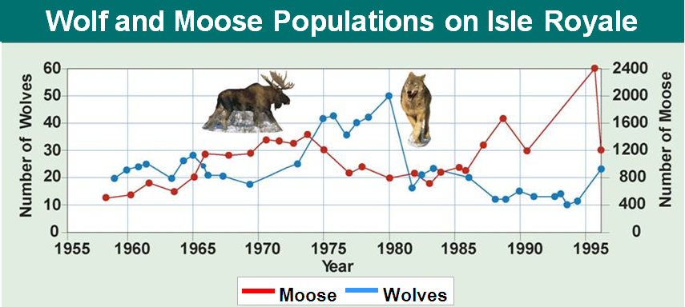

- Parasitism and Disease
  - Parasites can limit the growth of a population.
  - A parasite lives in or on another organism (the host) and consequently ____________ it.
- Density-Independent Factors
  - Density-independent limiting factors affect all populations in similar ways, regardless of the _________________ size.
- Examples of density-independent limiting factors include:
  - unusual weather
  - _______________ disasters
  - seasonal cycles
  - certain human activities—such as damming rivers and clear-cutting forests
Section 3 – Human Population Growth
- How has the size of the human population changed over time?
- Historical Overview
  - Like the populations of many other living organisms, the size of the human population tends to ________________ with time.
  - For most of human existence, the population grew slowly.
  - Limiting factors kept population sizes low.
  - About 500 years ago, the human population began growing more ________________.
  - Life was made easier and safer by advances in agriculture and industry.
  - Death rates were dramatically reduced due to improved sanitation, _______________, and healthcare, while birthrates remained high.
  - With these advances, the human population experienced exponential growth.
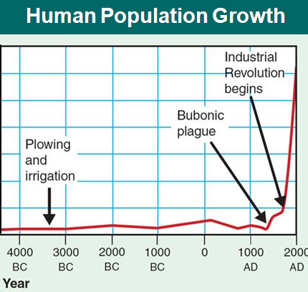

- Patterns of Population Growth
  - The scientific study of human populations is called ___________________.
  - Demography examines the characteristics of human populations and attempts to explain how those populations will change over time.
- Why do population growth rates differ in countries throughout the world?
  - Birthrates, death rates, and the age structure of a population help predict why some countries have high growth rates while other countries grow more slowly.
- The Demographic Transition
  - Over the past century, population growth in the United States, Japan, and much of Europe has __________________ dramatically.
  - According to demographers, these countries have completed the demographic transition, a dramatic change in birth and death rates.
- The demographic transition has three stages.
  - In stage 1, there are high death rates and ______________ birthrates.
  - In stage 2, the death rate drops, while the birthrate remains high. The population __________________ rapidly.
  - In stage 3, the birthrate decreases, causing population growth to slow.
  - The demographic transition is complete when the birthrate falls to meet the death rate, and population growth stops.
- Age Structure
  - Population growth depends, in part, on how many people of different ages make up a given population.
  - Demographers can predict future growth using models called age-structure diagrams.
  - Age-structure diagrams show the population of a country broken down by gender and ____________ group.
- In the United States, there are nearly equal numbers of people in each age group.
  - This age structure diagram predicts a slow but steady growth rate for the near future.
- In Rwanda, there are many more young children than teenagers, and many more teenagers than adults.
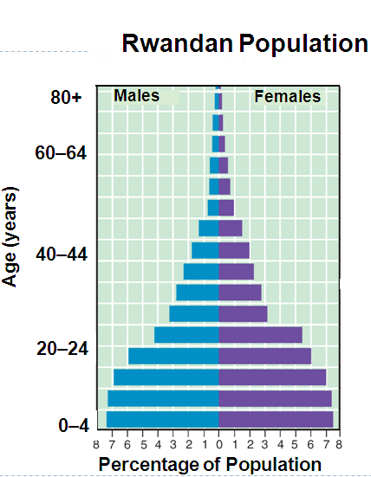
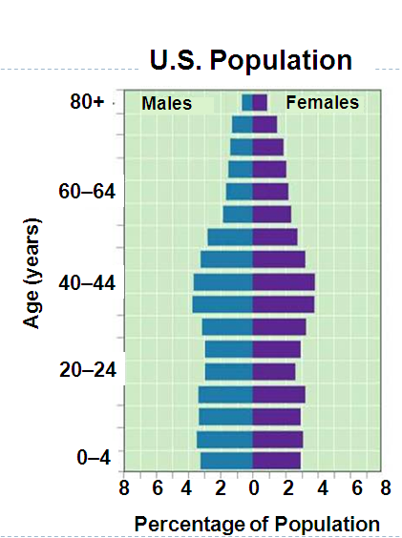
  - This age structure diagram predicts a population that will __________ in about 30 years.

- Ecologists suggest that if growth does not slow down, there could be serious damage to the __________________ and global economy.
- Economists assert that science, technology, and changes in society may control the negative impact of population growth.

