Chapter 8 – Photosynthesis
Section 1 – Energy and Life
- Autotrophs and Heterotrophs
  - Living things need ____________ to survive.
  - This energy comes from food. The energy in most food comes from the _____________.
  - Where do plants get the energy they need to produce food?
    - Plants and some other types of organisms are able to use light energy from the sun to produce _____________.
  - Organisms, such as plants, which make their own food, are called ______________.
  - Organisms, such as animals, that must obtain energy from the foods they consume are _____________.
- Chemical Energy and ATP
  - Energy comes in many forms including light, heat, and electricity.
  - Energy can be stored in chemical compounds, too.
  - An important chemical compound that cells use to store and release energy is adenosine triphosphate, abbreviated ______________.
  - ATP is used by all types of cells as their basic energy source.
  - ATP consists of:
    - adenine
    - ribose (a 5-carbon sugar)
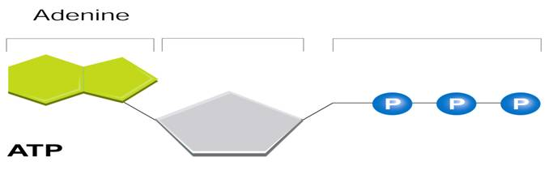
    - 3 phosphate groups

- The three phosphate groups are the ____________ to ATP's ability to store and release energy.
- Storing Energy
  - ADP has ___________ phosphate groups instead of three.
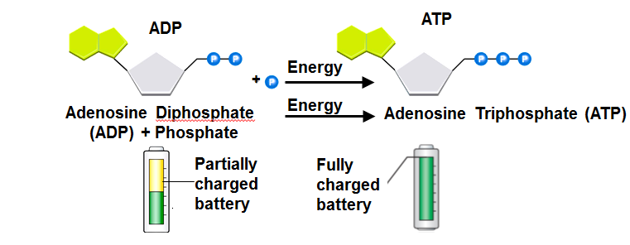
  - A cell can store small amounts of energy by adding a phosphate group to ADP.

- Releasing Energy
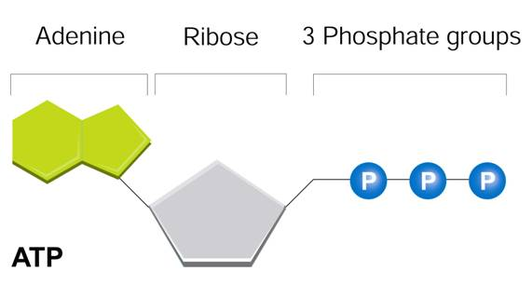
  - Energy stored in ATP is released by ____________ the chemical bond between the second and third phosphates.
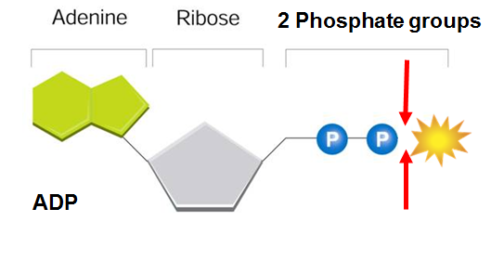

- What is the role of ATP in cellular activities?
  - The energy from ATP is needed for many _____________ activities, including active transport across cell membranes, protein synthesis and muscle contraction.
  - ATP’s characteristics make it exceptionally useful as the basic _____________ source of all cells.
  - Most cells have only a _____________ amount of ATP, because it is not a good way to store large amounts of energy.
  - Cells can regenerate ATP from ADP as needed by using the energy in foods like glucose.
Section 2 – Photosynthesis: An Overview
- The key cellular process identified with energy production is ______________.
- Photosynthesis is the process in which green plants use the energy of sunlight to _______________ water and carbon dioxide into high-energy carbohydrates and oxygen.
- Investigating Photosynthesis
  - What did the experiments of van Helmont, Priestley, and Ingenhousz reveal about how plants grow?
- Van Helmont’s Experiment
  - In the 1600s, Jan van Helmont wanted to find out if plants grew by taking material out of the _____________.
  - He determined the _____________ of a pot of dry soil and a small seedling, planted the seedling in the pot, and watered it regularly.
  - After five years, the seedling was a small tree and had gained 75 kg, but the soil’s mass was almost ____________.
  - Van Helmont concluded that the gain in mass came from ____________ because water was the only thing he had added.
  - His experiment accounts for the “hydrate,” or water, portion of the carbohydrate produced by photosynthesis.
  - But where does the carbon of the “carbo-” portion come from?
  - Although van Helmont did not realize it, _____________ dioxide in the air made a major contribution to the mass of his tree.
  - In photosynthesis, the carbon in carbon dioxide is used to ____________ sugars and other carbohydrates.
  - Van Helmont had only part of the story, but he had made a major contribution to science.
- Priestley’s Experiment
  - More than 100 years after van Helmont’s experiment, Joseph Priestley provided another insight into the process of photosynthesis.
  - Priestley took a ____________, placed a glass jar over it, and watched as the flame gradually died out.
  - He reasoned that the flame needed something in the air to keep burning and when it was used up, the flame went out. That substance was _____________.
  - Priestley then placed a live sprig of ______________ under the jar and allowed a few days to pass.
  - He found that the candle could be relighted and would remain lighted for a while.
  - The mint plant had produced the substance required for burning. In other words, it had released ______________.
- Jan Ingenhousz
  - Later, Jan Ingenhousz showed that the effect observed by Priestley occurred only when the plant was exposed to __________.
  - The results of both Priestley’s and Ingenhousz’s experiments showed that light is necessary for plants to produce ____________.
- The experiments performed by van Helmont, Priestley, and Ingenhousz led to work by other scientists who finally discovered that, in the presence of light, plants transform carbon dioxide and water into carbohydrates, and they also release oxygen.
Section 2 – Photosynthesis Overview (Part 2)
- What is the overall equation for photosynthesis?
  - The equation for photosynthesis is:
    - 6CO₂ + 6H₂O C₆H₁₂O₆ + 6O₂
    - carbon ____________ + water sugars + ____________
  - Photosynthesis uses the energy of sunlight to convert water and carbon dioxide into high-energy sugars and oxygen.
- Pigments
  - What is the role of light and chlorophyll in photosynthesis?
  - Plants gather the sun's energy with light-absorbing molecules called ______________.
  - The main pigment in plants is ______________.
  - There are two main types of chlorophyll:
    - chlorophyll a
    - chlorophyll b
  - Why are plants green?
    - Chlorophyll absorbs light ____________ in the blue-violet and red regions of the visible spectrum.
    - Chlorophyll does _____________ absorb light will in the green region of the spectrum. Green light is reflected by leaves, which is why plants look green.
- Light
  - Light is a form of energy, so any compound that absorbs light also ____________ energy from that light
  - When chlorophyll absorbs light, much of the energy is transferred directly to ______________ in the chlorophyll molecule, raising the energy levels of these electrons.
  - These ____________-energy electrons are what make photosynthesis work.
Section 3 – The Reactions of Photosynthesis
- Inside a Chloroplast
  - In plants, photosynthesis takes place inside _____________.
  - Chloroplasts contain _____________—saclike photosynthetic membranes.
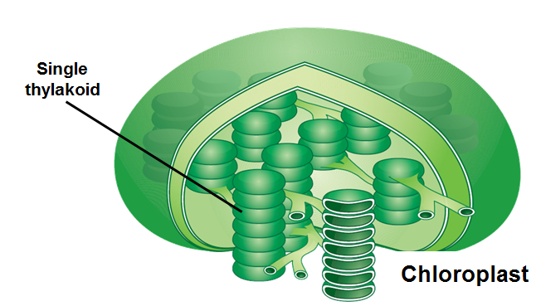

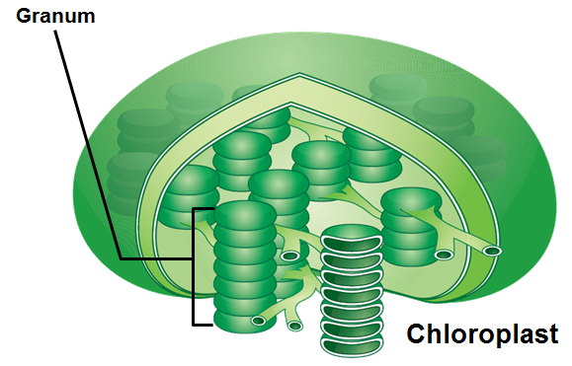
- Thylakoids are arranged in stacks known as ___________. A singular stack is called a granum.

- The reactions of photosystems include: the light-dependent reactions and the light-independent reactions, or Calvin cycle.
- The light-dependent reactions take place _____________ the thylakoid membranes.
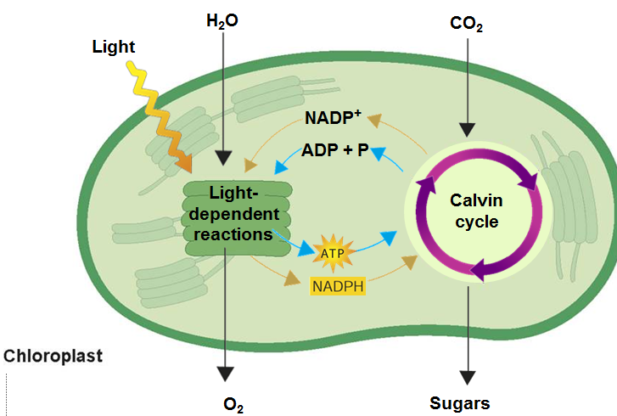
- The Calvin cycle takes place in the _____________, which is the region outside the thylakoid membranes.

- Electron Carriers
  - When electrons in chlorophyll absorb sunlight, the ____________ gain a great deal of energy.
  - Cells use electron ____________ to transport these high-energy electrons from chlorophyll to other molecules.
  - One carrier molecule is NADP⁺.
  - Electron carriers, such as NADP⁺, ____________ electrons.
  - NADP⁺ accepts and holds 2 high-energy electrons along with a hydrogen ion (H⁺). This converts the NADP⁺ into NADPH.
  - The conversion of NADP⁺ into NADPH is one way some of the energy of _______________ can be trapped in chemical form.
  - The NADPH carries high-energy electrons to chemical reactions elsewhere in the cell.
  - These high-energy electrons are used to help build a variety of molecules the cell needs, including carbohydrates like glucose.

