Create at least 10 ORIGINAL questions that cover the material from section 3 – RNA and Protein Synthesis – from chapter 12. For this activity, write questions that require shorter answers or can be fill in the blank.
5 questions should cover material from your guided notes (Section 3 – RNA and Protein Synthesis – Parts 1,2, &3).
5 questions should cover material from your textbook (pages 362-371 – this is technically section 3 in your book, but it covers the same material)
Spread your questions out! Don’t just write them over one section. That will not help you or your classmates.
When you are writing your questions, format them as they are in the picture below. Type your question (with a question mark at the end), type an asterisk (* - this is done by holding shift and 8), and then type the answer to the question. It must be in this format in order for the next step to work correctly.
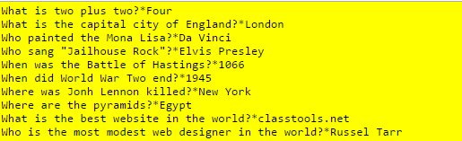

You have two options:
- Type your questions on A Google Doc and put the shareable link into the Edmodo assignment
- Or, type the questions directly into the assignment on Edmodo (Create text response)

