Create Your Own Worksheet – READ ALL INSTRUCTIONS
Directions: Your job is to create your own worksheet that covers the material that we have gone over in class so far in Section 1 from Chapter 4. You must use a variety of questions when creating your worksheet (example - multiple choice, fill in the blank, short answer, true/false, etc)
- Write 8 questions that can be answered using only your TEXTBOOK (questions can only come from pages 100-101)
- Write 4 questions that have to be answered using a picture from the chapter. You must include the picture on your worksheet!
  - See the instructions below on how to “Snip a Picture”
    - Find the picture you want to use
    - Hit Control +Shift + the top middle key (see below) all at the same time
    - It will pull up a little cross hair icon that will allow you to highlight a selected area.
    - After you highlight it, you should be able to copy (Choose copy to clipboard) and paste it onto your Google Doc.

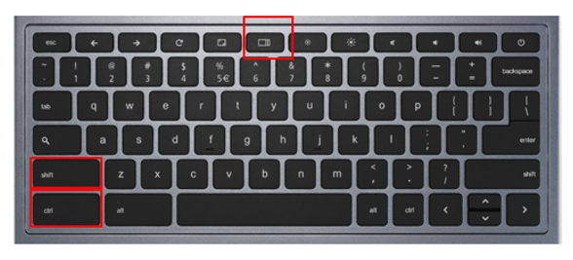

- Your worksheet will have a total of 12 questions! (and at least 1 picture)
  - You can write 4 questions to go with 1 picture
  - You can write 4 questions that go with two different pictures

Write the answers to your questions directly underneath each question!

You will use Google Docs to type up your worksheet!

Format your paper like an actual worksheet!

Turn in to Google Classroom!

