2 Factor Cross on Punnett Squares
Here are the steps to solving a two factor Punnett Square
First you have to establish your parental cross, or P1.
P1 ________________________X_________________________

Next you need to make a 16 square Punnett Square for your 2 traits you want to cross.
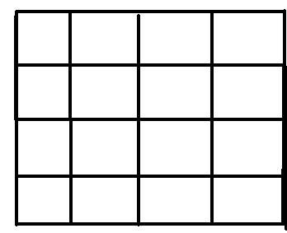

The next step is to determine the genotypes of the two parents and assign them letters to represent the alleles. Example: In pigs, curly tails (C) are dominant over straight tails (c). Pink color (P) is dominate over gray (p). You are to cross a male pig that is homozygous dominant for both traits with a female pig that is homozygous recessive for type of tail and heterozygous for body color. Let's look at how we will assign the letters to represent the alleles and fill in the P1 cross.
P1 ______________ X ______________

Since the male pig is homozygous dominant for both traits, the letters assigned for both traits must be capital letters. Remember, it takes 2 letters (alleles) to represent each trait. For the female pig she is homozygous recessive for type of tail (2 lowercase letters) and heterozygous for color (One capital and one lowercase letter. Follow the directions in the next step to prepare how you will take the possible combinations of alleles for each parent to place them on your punnett square.
Possible Gene Combinations
CCPP x ccPp
Male Pig - ________, _________, _________, __________
Female Pig - _________, _________, _________, _________

