Advanced Biology
What is Advanced Biology?
In this class, we will review the topics covered in General Biology. However, we will learn new information about the living world as well as going much more in depth into the topics that were covered last year.
Topics we will cover
- Macromolecules
- Photosynthesis
- Cellular Respiration
- Genetics
- Microorganisms
- Ecology
- Evolution
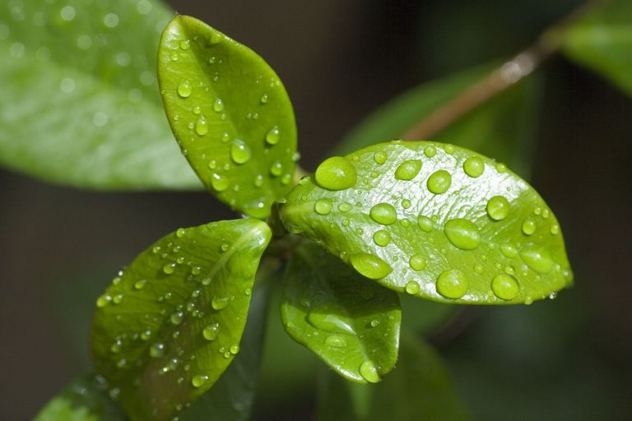
Materials that are needed for Biology
- Notebook (Only for Biology)
- Folder (Only for Biology)
- Headphones – EVERYDAY!
- Computer Charger (D-Lunch can be assigned)
- Laptop - Bring it with you to class EVERY DAY

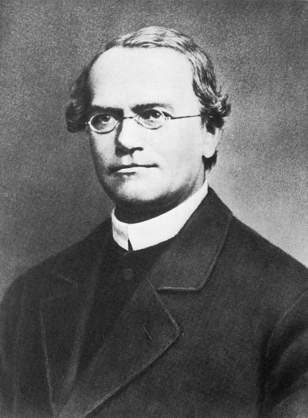
Extra Credit
- There will be very little extra credit opportunities offered in this class.
Other Information
Tardy Policy = Show up on time. You have 4 minutes between classes, use the restroom then!
No Food and Drink = Water ONLY!!!!! (Mr. B will sell sodas to cover animal expenses)

Classroom Rules and Expectations
1. All students will be respectful to other students, teachers, administrators, school property and themselves.
2. All students will refrain from cheating in any way, shape, or form.
3. All students will practice safe laboratory procedures when participating in lab activities.
4. All students will refrain from using electronics (cell phones, iPods, etc) during class. New School Policy – Phones will be turned into the teacher at the beginning of each class period or kept out of sight. If a phone is out for any reason, the student will turn the phone into the office for the remainder of the day
5. All students will work only on Biology when they are in Biology class.
6. All students will put forth their full effort in class every day.
7. All students will bring their materials to class every single day!
Absence Policy
If you are absent:
- You need to come ask me about work that you missed from the previous day.
- You need to check my online presence for any assignments that need to be completed
- You will be required to take all quizzes upon your return to class.
- You are not exempt from the work that was completed in class the previous day.
Note – The Flipped Model of Education is perfect for students that are absent. You can stay on top of your work without falling behind at all.
Late Work
- This is a weighted class, so when a due date is set, then the work is due on that day. NO EXCEPTIONS!

Note Book

- You will be required to keep an organized notebook throughout the entire year. Make sure you have one that is dedicated solely to this class.
- The specifics of this notebook will be covered in class.

Online Textbook

- This class operates on a different platform outside of Pearson Easy Bridge. You will need to go the website masteringbiology.com

