Create at least 10 ORIGINAL questions that cover the material THAT MR. B ASSIGNS YOU IN CLASS. For this activity, write questions that require shorter answers or can be fill in the blank.
Focus your questions on things you might expect to see on a test.
When you are writing your questions, format them as they are in the picture below. Type your question (with a question mark at the end), type an asterisk (* - this is done by holding shift and 8), and then type the answer to the question. It must be in this format in order for the next step to work correctly.
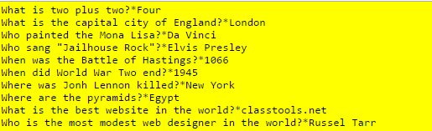

Type your questions directly into the Edmodo assignment.
OR
Type your questions on Google Docs and copy and paste the shareable link into the Edmodo assignment

