Create at least 6 ORIGINAL questions that cover the material from pages 73-74 in your online Pearson textbook. For this activity, write questions that require shorter answers or can be fill in the blank.
Focus your questions on things you might expect to see on a test.
When you are writing your questions, format them as they are in the picture below. Type your question (with a question mark at the end), type an asterisk (* - this is done by holding shift and 8), and then type the answer to the question. It must be in this format in order for the next step to work correctly.
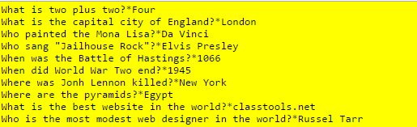

Turn your questions in to Google Classroom.

