Biology
What is Biology?
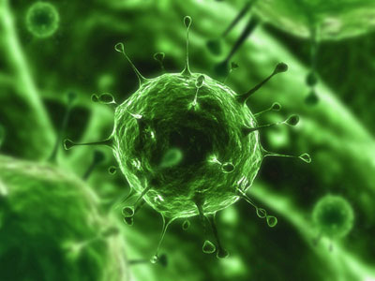
Biology is the study of all living things. In this class, we will explore, discuss, discover, analyze, explain, and observe how life “works” and how it came to be as it is today.
Topics we will cover
- What is Biology/Science?
- Cells
  - Structure and Function
  - Photosynthesis
  - Cellular Respiration
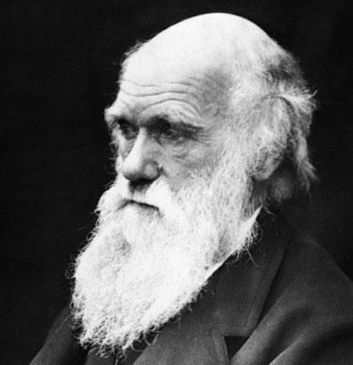
- Genetics
  - Gregor Mendel
  - DNA and RNA
  - Heredity
- Microorganisms
  - Bacteria & Viruses
- Ecology
  - Biosphere BiomeEcosystemCommunityPopulationSpecies
  - Humans and the Environment
- Evolution
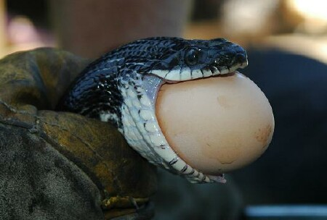
  - Charles Darwin
  - Genetics and Evolution
  - History of the Earth
Materials that are needed for Biology
- Notebook (Only for Biology)
- Folder (Only for Biology)
- Headphones
- Laptop - Bring it with you to class EVERY DAY
Extra Credit
- There will be various projects throughout the year that will allow you to earn extra credit.

Classroom Rules and Expectations
1. All students will be respectful to other students, teachers, administrators, school property and themselves.
2. All students will refrain from cheating in any way, shape, or form.
3. All students will practice safe laboratory procedures when participating in lab activities.
4. All students will refrain from using electronics (cell phones, iPods, etc) during class unless otherwise given permission.
5. All students will work only on Biology when they are in Biology class.
6. All students will put forth their full effort in class every day.
7. All students will bring their materials with to class every single day!
Accessing the Videos
- Go to Havana High School Homepage Teacher ContactsCraig Bals
- Type directly into your browser – www.hhsbio.weebly.com
- When on a school computer: my computer Flip Server (:F)cbalsBiology 1
Absence Policy
If you are absent:
- You need to come ask me about work that you missed from the previous day.
- You need to check my online presence for any videos that need to be watched or assignments that need to be completed.

- You will be required to take all quizzes upon your return to class.
- You are not exempt from the work that was completed in class the previous day.
Note – The Flipped Model of Education is perfect for students that are absent. You can stay on top of your work without falling behind at all.
Late Work
- All activities are designed to be completed within the allotted class time. If you use your time wisely in class, then you will never have a late assignment.
- If you do not complete the assignment in class that day, you are expected to complete it on your own time and turn it in within 2 days in order to receive full credit. (Example - Assigned on Monday = Due on Wednesday)
- Assignments that are not turned in within those two days will be taken for half credit.
- The final due date for all assignments is the day you take the chapter test. (Example - all work for chapter 1 is due on the day you take the test for chapter 1)
- You will receive a 0 for any assignments that are not turned in on that day.

