Biology
What is Biology?
Biology is the study of all living things. In this class, we will explore, discuss, discover, analyze, explain, and observe how life “works” and how it came to be as it is today.
Topics we will cover
- Ecology
  - Biosphere BiomeEcosystemCommunityPopulationSpecies
  - Humans and the Environment
- Evolution
  - Charles Darwin
  - Genetics and Evolution
  - History of the Earth

- What is Biology/Science?
- Cells
  - Structure and Function
  - Photosynthesis
  - Cellular Respiration
- Genetics
  - Gregor Mendel
  - DNA and RNA
  - Heredity
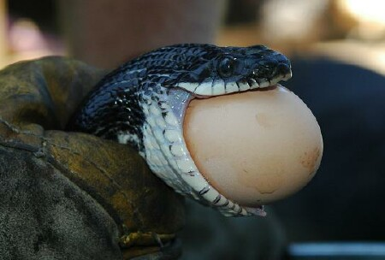
- Microorganisms
  - Bacteria & Viruses
Materials that are needed for Biology
- Notebook (Only for Biology)
- Folder (Only for Biology)
- Headphones – EVERYDAY!
- Laptop and Charger-Bring it with you to class EVERY DAY (D – Lunch can be assigned)
Extra Credit
- There will be various projects throughout the year that will allow you to earn extra credit.
- DON’T LOSE THIS PAPER! If you hold on to it, you will get extra credit at the end of each quarter
Tardy Policy = Show up on time. You have 4 minutes between classes, use the restroom then!
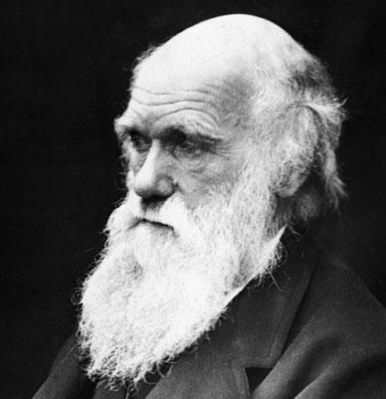
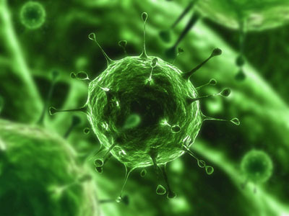
No Food and Drink = Water ONLY!!!!! (Mr. B will sell sodas to cover animal expenses)

Classroom Rules and Expectations
1. All students will be respectful to other students, teachers, administrators, school property and themselves.
2. All students will refrain from cheating in any way, shape, or form.
3. All students will practice safe laboratory procedures when participating in lab activities.
4. All students will refrain from using electronics (cell phones, iPods, etc) during class. New School Policy – Phones will be turned into the teacher at the beginning of each class period or kept out of sight. If a phone is out for any reason, the student will turn the phone into the office for the remainder of the day
5. All students will work only on Biology when they are in Biology class. – ZEROS WILL BE GIVEN!
6. All students will put forth their full effort in class every day.
7. All students will bring their materials to class every single day!
Accessing the Videos
- Go to Havana High School Homepage (havana126.net) MenuStaffCraig Bals (the link for my website is at the bottom of the box below my email address)

- Type directly into your browser – www.hhsbio.weebly.com
- When on a school computer: Go to Edmodo Find the folder for current chapter Download Video View in offline folder
Absence Policy
If you are absent:
- You need to come ask me about work that you missed from the previous day.
- You need to check my online presence for any videos that need to be watched or assignments that need to be completed
- You will be required to take all quizzes upon your return to class.
- You are not exempt from the work that was completed in class the previous day.
- You have 2 days to complete the assignments in order to receive full credit. (Example - Assigned on Monday = Due on Wednesday)
Note – The Flipped Model of Education is perfect for students that are absent. You can stay on top of your work without falling behind at all.
Late Work
- All activities are designed to be completed within the allotted class time. If you use your time wisely in class, then you will never have a late assignment.
- If you do not complete the assignment in class that day, you are expected to complete it on your own time and turn it in at the beginning of class the next day.
- Assignments that are not turned in the next day will be taken for half credit only.
- All assignments are due on the day you take the chapter test. (Example - all work for chapter 1 is due on the day you take the test for chapter 1)
- You will receive a 0 for any assignments that are not turned in on that day.

