Chapter 10 – Cell Growth and Division
Section 1 – Cell Growth
- Limits to Cell Growth
  - The larger a cell becomes, the more ______________ the cell places on its DNA. In addition, the cell has more trouble moving enough nutrients and wastes across the cell _____________.
  - The rate at which food, oxygen, water, and wastes are moved in and out of the cell is dependent on the surface ______________ of the cell.
  - The rate at which food, oxygen and water are used and waste is produced depends on the cell’s _______________.
- Ratio of Surface Area to Volume
  - As the length of a cell increases, its volume increases faster than the surface area.
  - The decrease in the cell’s ratio of surface area to volume makes it more difficult for the cell to ______________ needed materials in and waste products out quickly enough for the cell to survive.
  - Therefore, it is beneficial for cells to have a ____________ surface area and a ___________ volume
- Division of the Cell
  - Before it becomes too large, a growing cell ____________ forming two “daughter” cells.
  - The process by which a cell divides into two new daughter cells is called cell _____________.
Section 2 – Cell Division
- In eukaryotes, cell division occurs in two major stages.
  - The first stage, division of the cell nucleus, is called _____________.
  - The second stage, division of the cell cytoplasm, is called cytokinesis.
- Chromosomes
  - Genetic information is passed from one generation to the next on _____________.
  - Before cell division, each chromosome is ______________, or copied.
  - Each chromosome consists of two identical “_____________” chromatids.
  - Each pair of chromatids is attached at an area called the centromere.
  - When the cell divides, the chromatids separate.
  - Each new cell gets ________________ chromatid.

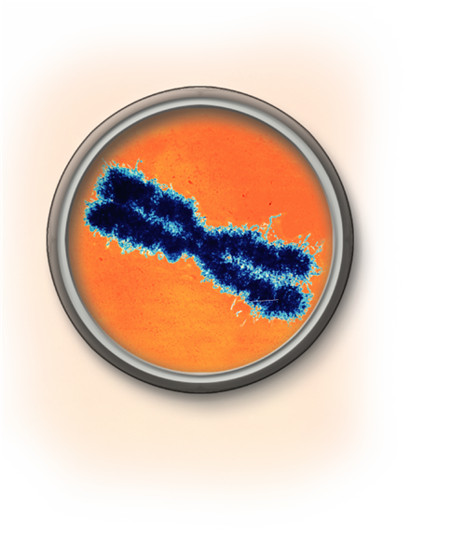

- The Cell Cycle
  - The cell _________ is the series of events that cells go through as they grow and divide.
  - ______________ is the period of growth that occurs between cell divisions.
  - The cell cycle consists of four phases:
    - G₁ (First Gap Phase)
    - S Phase
    - G₂ (Second Gap Phase)
    - M Phase
  - During G₁, the cell
    - increases in ________________
    - synthesizes new proteins and _______________
  - During the S phase,
    - ________________ are replicated
    - ______________ synthesis takes place
    - Once a cell enters the S phase, it usually completes the rest of the cell cycle.
  - The G₂ Phase (Second Gap Phase)
    - organelles and molecules required for cell _________________ are produced
    - Once G₂ is complete, the cell is ready to start the M phase—Mitosis
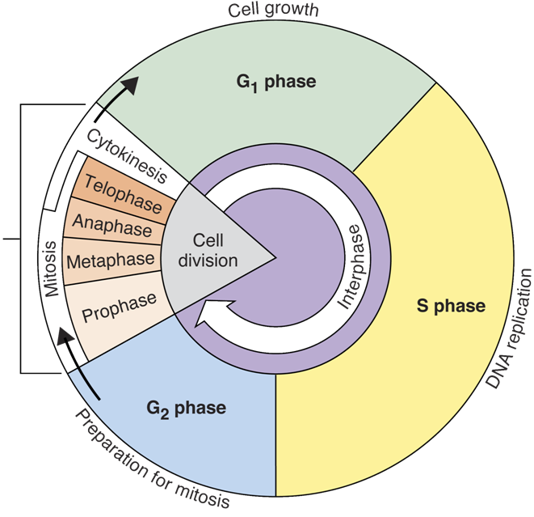

Section 2 – Cell Division (Part 2)
- Mitosis
  - Biologists divide the events of mitosis into _________ phases:
    - Prophase
    - Metaphase
    - Anaphase
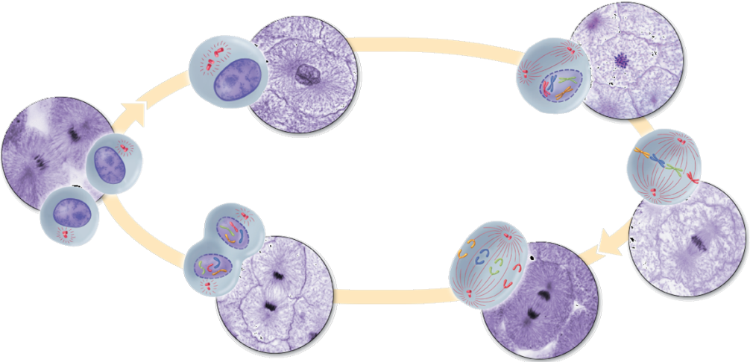
    - Telophase

  - Prophase
    - Prophase is the first and ______________ phase of mitosis.
    - The centrioles separate and take up positions on opposite sides of the nucleus.
    - The centrioles lie in a region called the centrosome.
    - The centrosome helps to organize the ______________, a fanlike microtubule structure that helps separate the chromosomes.
    - Chromatin condenses into ____________.
    - The centrioles separate and a spindle begins to form.
    - The nuclear ______________ breaks down.
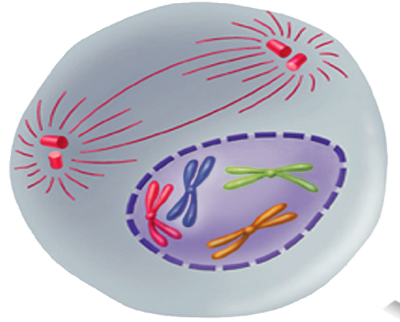

  - Metaphase
    - The second phase of mitosis is metaphase.
    - The chromosomes line up across the ___________ of the cell.
    - Microtubules connect the centromere of each chromosome to the poles of the spindle.
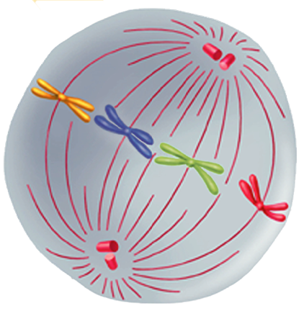

  - Anaphase
    - Anaphase is the third phase of mitosis.
    - The sister chromatids _______________ into individual chromosomes.
    - The chromosomes continue to move until they have separated into two groups.
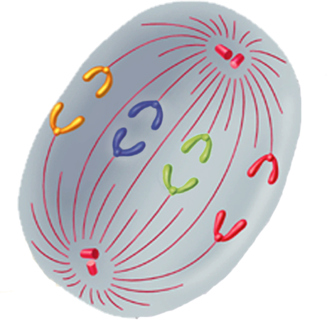

  - Telophase
    - Telophase is the fourth and final phase of mitosis.
    - Chromosomes gather at opposite _______ of the cell and lose their distinct shape
    - A new ______________ envelope forms around each cluster of chromosomes.
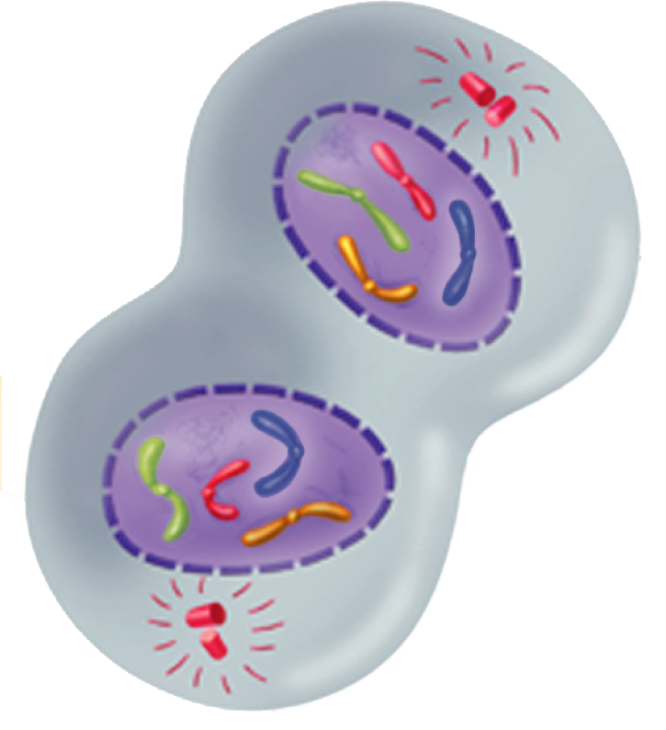

- Cytokinesis
  - During cytokinesis, the _____________ pinches in half.
  - Each daughter cell has an identical set of duplicate chromosomes
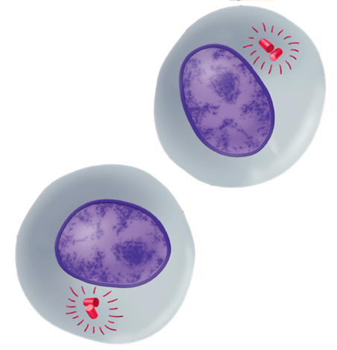

- Cytokinesis in Plants
  - In plants, a structure known as the cell _____________ forms midway between the divided nuclei.
  - The cell plate gradually develops into a separating membrane.
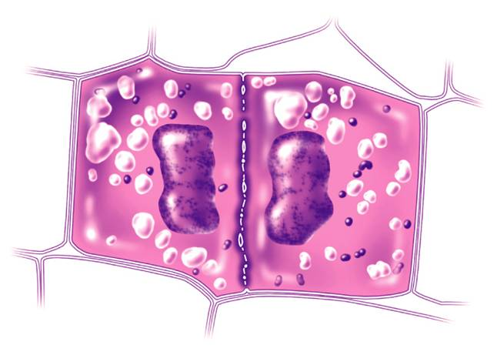
  - A cell wall then begins to appear in the cell plate.
Cell Plate

Section 3 – Regulating the Cell Cycle
- Controls on Cell Division
  - Experiments show that normal cells will reproduce until they come into contact with other cells.
  - When cells come into contact with other cells, they respond by not _____________.
  - This demonstrates that controls on cell growth and division can be turned on and off.
  - This is known an _______________ inhibition

- Cell Cycle Regulators
  - The cell cycle is regulated by a specific _____________.
  - The amount of this protein in the cell rises and falls in time with the cell cycle.
  - Scientists called this protein ____________ because it seemed to regulate the cell cycle.
  - Cyclins regulate the timing of the cell
cycle in eukaryotic cells.
- Internal Regulators
  - Proteins that respond to events _____________ the cell are called internal regulators.
  - Internal regulators allow the cell cycle to proceed only when certain processes have happened inside the cell.
- External Regulators
  - Proteins that respond to events ______________ the cell are called external regulators.
  - External regulators direct cells to speed up or slow down the cell cycle.
- Uncontrolled Cell Growth
  - _____________ is a disorder in which some of the body's own cells lose the ability to control growth.
  - How are cancer cells different from other cells?
    - Cancer cells do not respond to the signals that regulate the growth of most cells.
    - Cancer cells divide uncontrollably and form masses of cells called ________________ that can damage the surrounding tissues.
    - Cancer cells may break loose from tumors and spread throughout the body, disrupting normal activities and causing serious medical problems or even _______________.

