Chapter 12 – DNA and RNA
Section 1 – DNA (Part 1)
- Griffith and Transformation
  - In 1928, British scientist Fredrick Griffith was trying to learn how certain types of bacteria caused pneumonia.
  - He isolated two different strains of pneumonia bacteria from _____________ and grew them in his lab.
  - Griffith made two observations:
    - (1) The disease-causing strain of bacteria grew into _____________ colonies on culture plates.
    - (2) The harmless strain grew into colonies with ______________ edges.
- Griffith's Experiments
  - Griffith set up four individual experiments.
    - Experiment 1: Mice were injected with the disease-causing strain of bacteria. The mice developed pneumonia and ______________.
    - Experiment 2: Mice were injected with the harmless strain of bacteria. These mice didn’t get _______________.
    - Experiment 3: Griffith _______________ the disease-causing bacteria. He then injected the heat-killed bacteria into the mice. The mice survived.
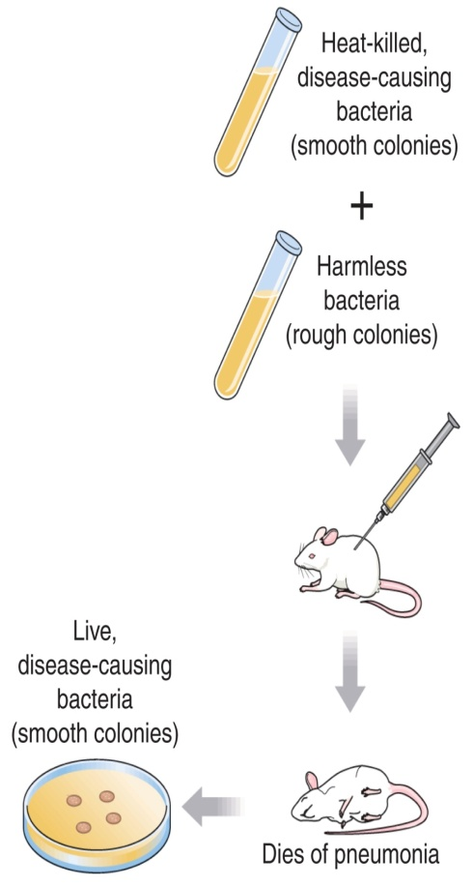
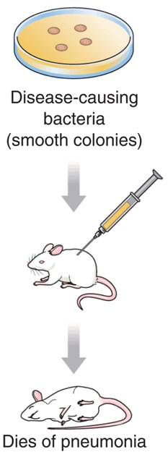
    - Experiment 4: Griffith mixed his heat-killed, disease-causing bacteria with live, harmless bacteria and injected the mixture into the mice. The mice developed pneumonia and ________________.
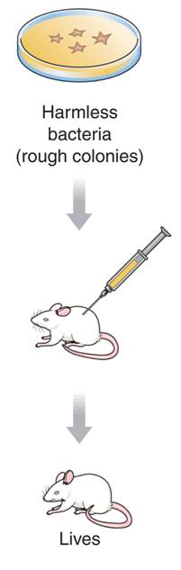
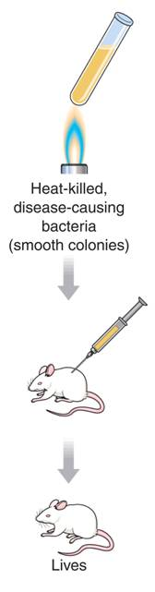

- Griffith concluded that the heat-killed bacteria ______________ their disease-causing ability to the harmless strain.
- Transformation
  - Griffith called this process transformation because one strain of bacteria (the harmless strain) had _______________ permanently into another (the disease-causing strain).
  - Griffith hypothesized that a factor must contain information that could change harmless bacteria into disease-causing ones.
- Avery and DNA
  - Oswald Avery repeated Griffith’s work to determine which molecule was most important for _________________.
  - Avery and his colleagues made an extract from the heat-killed bacteria that they treated with _______________.
  - The enzymes destroyed proteins, lipids, carbohydrates, and other molecules, including the nucleic acid RNA.
    - Transformation still _______________.
  - Avery and other scientists repeated the experiment using enzymes that would break down ______________.
  - When DNA was destroyed, transformation DID NOT occur. Therefore, they concluded that DNA was the transforming factor.
- What did scientists discover about the relationship between genes and DNA?
  - Avery and other scientists discovered that the nucleic acid DNA stores and transmits the ________________ information from one generation of an organism to the next.
Section 1 – DNA (part 2)
- The Hershey-Chase Experiment
  - Alfred Hershey and Martha Chase studied _______________—nonliving particles smaller than a cell that can infect living organisms.
  - Bacteriophages
    - A virus that infects bacteria is known as a bacteriophage.
    - Bacteriophages are composed of a DNA or RNA core and a protein coat.
    - When a bacteriophage enters a bacterium, the virus _________________ to the surface of the cell and injects its genetic information into it.
    - The viral genes produce many new bacteriophages, which eventually _______________ the bacterium.
    - When the cell splits open, hundreds of new viruses burst out.
  - If Hershey and Chase could determine which part of the virus _______________ an infected cell, they would learn whether genes were made of protein or DNA.
  - They grew viruses in cultures containing radioactive isotopes of phosphorus-32 (³²P) and sulfur-35 (³⁵S).
  - If ³⁵S was found in the bacteria, it would mean that the viruses’ ________________ had been injected into the bacteria.
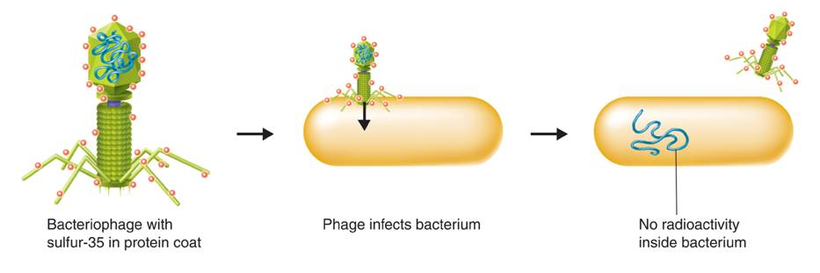

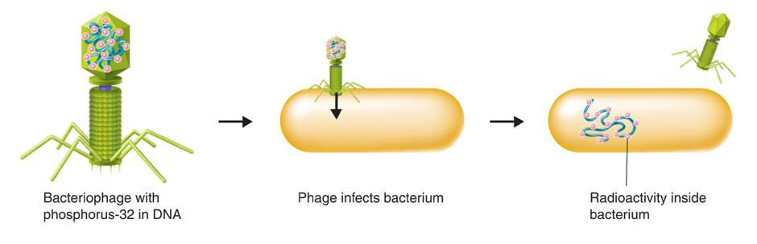
  - If ³²P was found in the bacteria, then it was the ____________ that had been injected.

- Nearly all the radioactivity in the bacteria was from phosphorus (³²P).
- Hershey and Chase concluded that the genetic material of the bacteriophage was _______________, not protein.
Section 1 – DNA (Part 3)
- What is the overall structure of the DNA molecule?
- The Components and Structure of DNA
- DNA is made up of nucleotides.
  - A nucleotide is a monomer of nucleic acids made up of a five-carbon sugar called deoxyribose, a phosphate group, and a nitrogenous base.
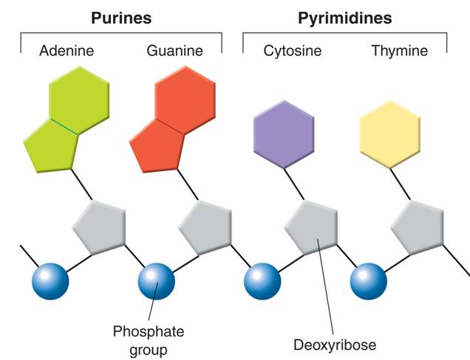
- There are ___________ kinds of bases in in DNA:
  - adenine
  - guanine
  - cytosine
  - thymine
- The backbone of a DNA chain is formed by sugar and phosphate groups of each nucleotide.
  - The nucleotides can be joined together in any _________________.
- Chargaff's Rules
  - Erwin Chargaff discovered that:
    - The percentages of guanine [G] and cytosine [C] bases are almost _____________ in any sample of DNA.
    - The percentages of adenine [A] and thymine [T] bases are almost ______________ in any sample of DNA.
- X-Ray Evidence
  - Rosalind Franklin used ______ diffraction to get information about the structure of DNA.
  - She aimed an X-ray beam at concentrated DNA samples and recorded the scattering pattern of the X-rays on film.
- The Double Helix
  - Using clues from Franklin’s pattern, James Watson and Francis Crick built a model that explained how DNA carried information and could be copied.
  - Watson and Crick's model of DNA was a double ______________, in which two strands were wound around each other.
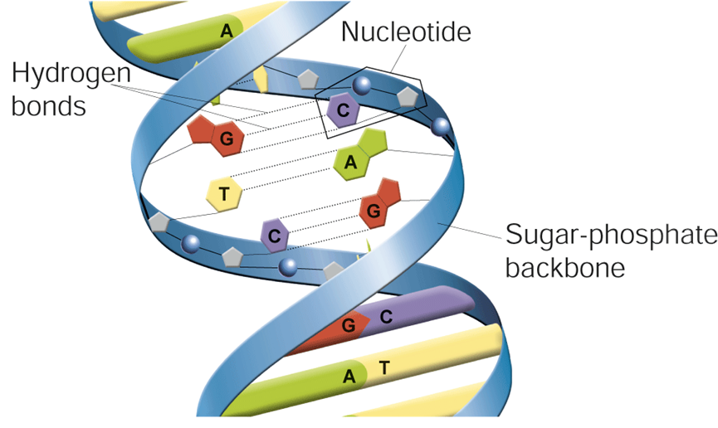
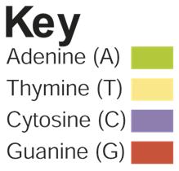

- Watson and Crick discovered that hydrogen bonds can form only between certain base pairs—adenine and thymine, and guanine and cytosine.
- This principle is called ________________ pairing

Section 2 – Chromosomes and DNA Replication
- DNA and Chromosomes
  - In prokaryotic cells, DNA is located in the _________________.
    - Most prokaryotes have a single DNA molecule containing nearly all of the cell’s genetic information.
  - Many eukaryotes have __________ times the amount of DNA as prokaryotes.
    - Eukaryotic DNA is located in the cell nucleus inside chromosomes.
    - The number of chromosomes varies widely from one species to the next.
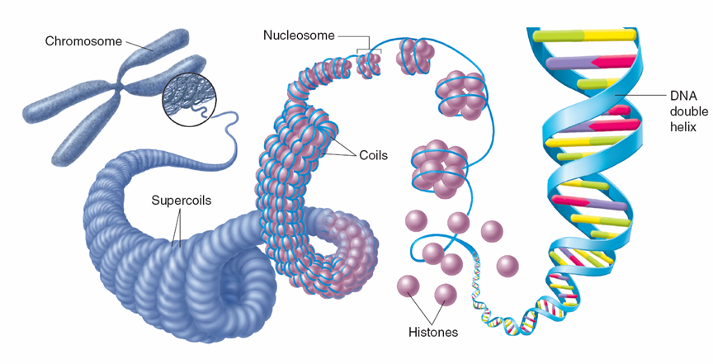

- What happens during DNA replication?
- DNA Replication
  - Each strand of the DNA double helix has all the information needed to reconstruct the other half by the mechanism of ______________ pairing.
  - In most prokaryotes, DNA replication begins at a ___________ point and continues in two directions.
  - In eukaryotic chromosomes, DNA replication occurs at hundreds of places. Replication proceeds in both directions until each chromosome is completely copied.
    - The sites where separation and replication occur are called replication ______________.
  - Duplicating DNA
  - Before a cell divides, it duplicates its DNA in a process called _________________.
    - Replication ensures that each resulting cell will have a complete set of ________.
- How Replication Occurs
  - DNA replication is carried out by enzymes that “_____________” a molecule of DNA.
  - Hydrogen bonds between base pairs are broken and the two strands of DNA unwind.
  - The principal enzyme involved in DNA replication is DNA ________________.
  - DNA polymerase joins individual nucleotides to produce a DNA molecule and then “________________” each new DNA strand.
Section 3 – RNA and Protein Synthesis
- Genes are coded DNA instructions that control the production of _______________.
  - Genetic messages can be decoded by copying part of the nucleotide sequence from DNA into RNA.
  - RNA contains coded information for ________________ proteins.
- The Structure of RNA
  - RNA consists of a long chain of nucleotides.
  - Each nucleotide is made up of a 5-carbon sugar, a phosphate group, and a nitrogenous base.
- There are three main differences between RNA and DNA:
  - The ___________ in RNA is ribose instead of deoxyribose.
  - RNA is generally _______________-stranded.
  - RNA contains ____________ in place of thymine.
- What are the three main types of RNA?
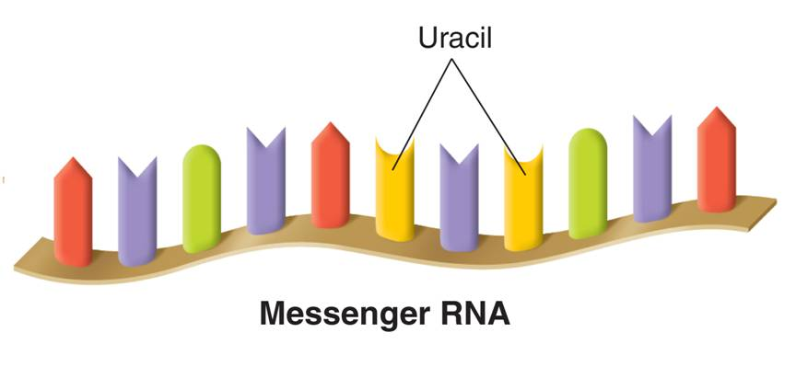
  - Messenger RNA (mRNA) _______________ copies of instructions for assembling amino acids into proteins.

  - __________________ are made up of proteins and ribosomal RNA (rRNA).
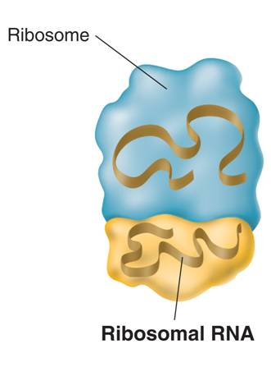

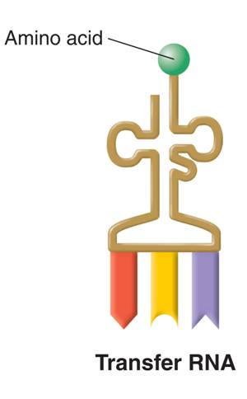
  - During protein construction, transfer RNA (tRNA) _____________ each amino acid to the ribosome.

Section 3 – RNA and Protein Synthesis (Part 2)
- What is transcription?
- Transcription
  - RNA molecules are produced by copying part of a nucleotide sequence of DNA into a complementary sequence in RNA. This process is called __________________.
  - Transcription requires the enzyme _______ polymerase.
  - During transcription, RNA polymerase binds to DNA and ________________ the DNA strands.
  - RNA polymerase then uses one strand of DNA as a template from which nucleotides are assembled into a strand of RNA.
  - RNA polymerase binds only to regions of DNA known as promoters.
  - Promoters are ______________ in DNA that indicate to the enzyme where to bind to make RNA.
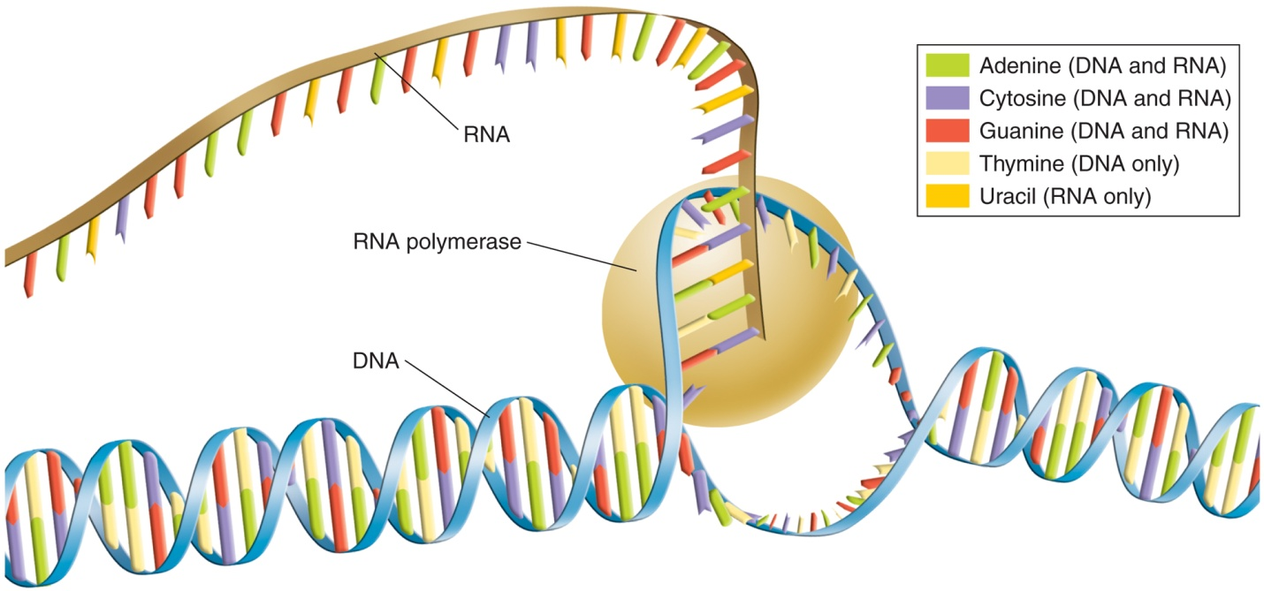

- RNA Editing
  - The DNA of eukaryotic genes contains sequences of nucleotides, called _______________, that are not involved in coding for proteins.
  - The DNA sequences that code for proteins are called _____________.
  - When RNA molecules are formed, introns and exons are copied from DNA.
  - The introns are cut ______________ of RNA molecules.
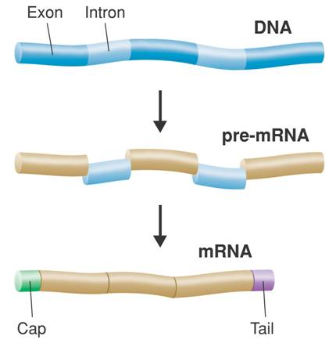
  - The exons are the spliced together to form mRNA.

- The Genetic Code
  - The genetic code is the “_______________” of mRNA instructions.
  - The code is written using four “letters” (the bases: A, U, C, and G).
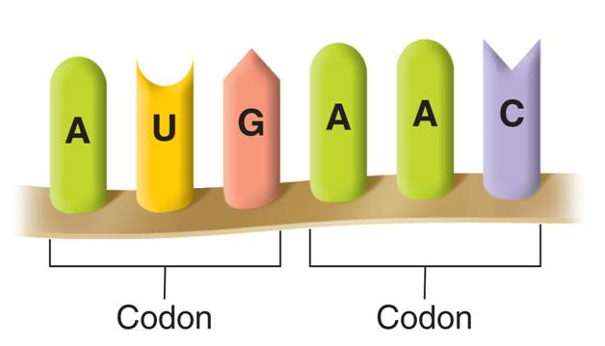
  - A codon consists of _____________ consecutive nucleotides on mRNA that specify a particular amino acid.

- Each codon specifies a particular amino __________ that is to be placed on the polypeptide chain.
- Some amino acids can be specified by more than one codon.

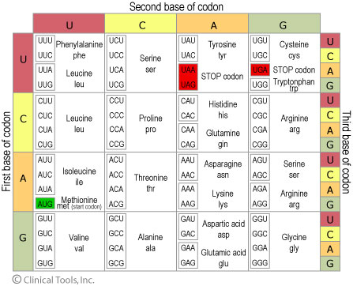

- There is one codon AUG that can either specify the amino acid methionine or serve as a “_____________” codon for protein synthesis.
- There are three “_____________” codons that do not code for any amino acid. These “stop” codons signify the end of a polypeptide.
Section 3 – RNA and Protein Synthesis (Part 3)
- Translation
  - Translation is the decoding of an mRNA message into a _____________ (polypeptide chain).
  - Translation takes place on ribosomes.
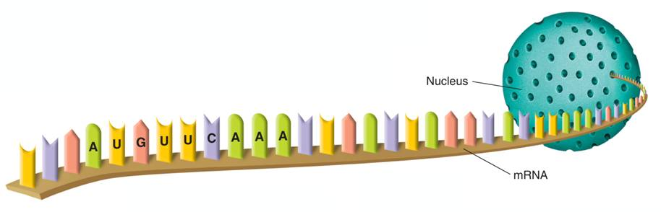
  - During translation, the cell uses information from messenger RNA to produce ______________.

- Steps of Translation
  - Messenger RNA is transcribed in the nucleus, and then enters the __________________ where it attaches to a ribosome
  - Translation begins when an mRNA molecule attaches to a ________________.
  - As each codon of the mRNA molecule moves through the ribosome, the proper amino acid is brought into the ribosome by tRNA.
  - In the ribosome, the amino acid is transferred to the growing polypeptide chain.
  - Each tRNA molecule carries only ___________ kind of amino acid.
  - In addition to an amino acid, each tRNA molecule has three unpaired bases.
  - These bases, called the ________________, are complementary to one mRNA codon.
  - The ribosome binds new tRNA molecules and amino acids as it moves along the mRNA.
  - The process continues until the ribosome reaches a stop codon.
- The Roles of RNA and DNA
  - The cell uses the DNA “master plan” to prepare RNA “blueprints.” The DNA stays in the ___________________.
  - The RNA molecules go to the protein building sites in the cytoplasm—the ribosomes.
- Genes and Proteins
  - Genes contain instructions for assembling proteins.
  - Many proteins are ____________, which catalyze and regulate chemical reactions.
  - Proteins are each specifically designed to build or operate a component of a living cell.
  - The sequence of bases in DNA is used as a ________________ for mRNA.
  - The codons of mRNA specify the sequence of amino acids in a protein.

Section 4 – Mutations
- What are mutations?
  - Mutations are changes in the _______________ material.
- Kinds of Mutations
  - Mutations that produce changes in a single gene are known as _________ mutations.
  - Mutations that produce changes in whole chromosomes are known as __________________ mutations.
- Gene Mutations
  - Gene mutations involving a change in one or a few nucleotides are known as _______________ mutations because they occur at a single point in the DNA sequence.
  - Point mutations include substitutions, insertions, and deletions.
- Substitutions
  - Substitutions usually affect no more than a ______________ amino acid.
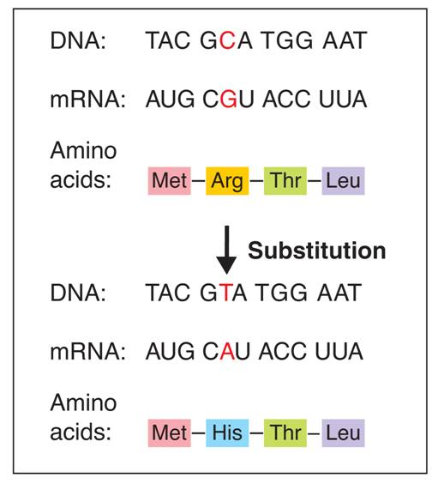

- Insertions and Deletions
  - The effects of insertions or deletions are more dramatic.
  - The addition or deletion of a nucleotide causes a shift in the grouping of codons.
  - Changes like these are called ____________________ mutations.
- Frameshift Mutations
  - Frameshift mutations may change _____________ amino acid that follows the point of the mutation.
  - Frameshift mutations can alter a protein so much that it is unable to perform its normal __________________.
- Insertions
  - In an insertion, an extra ______________ is inserted into a base sequence.
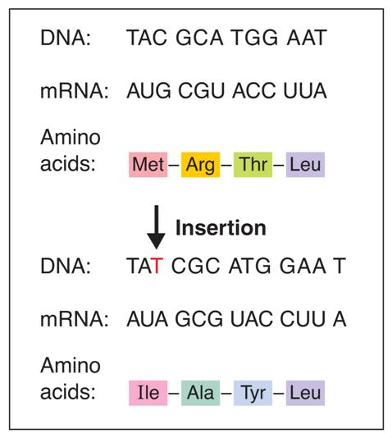

- Deletions
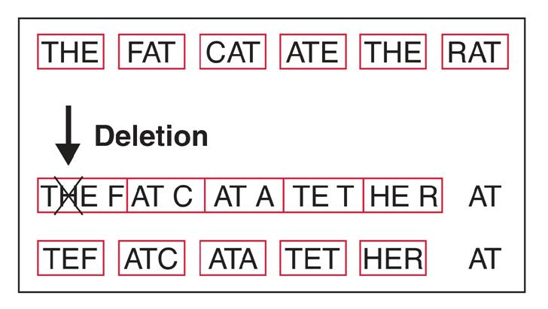
  - In a deletion, the loss of a single base is ____________ and the reading frame is shifted.

Section 4 – Mutations (Part 2)
- Chromosomal Mutations
  - Chromosomal mutations involve changes in the number or structure of chromosomes.
  - Chromosomal mutations include deletions, duplications, inversions, and translocations.
- Deletions involve the loss of all or part of a ______________________.
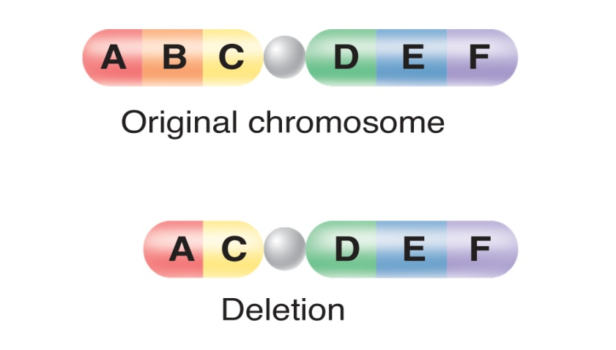

- Duplications
  - Duplications produce ______________ copies of parts of a chromosome.
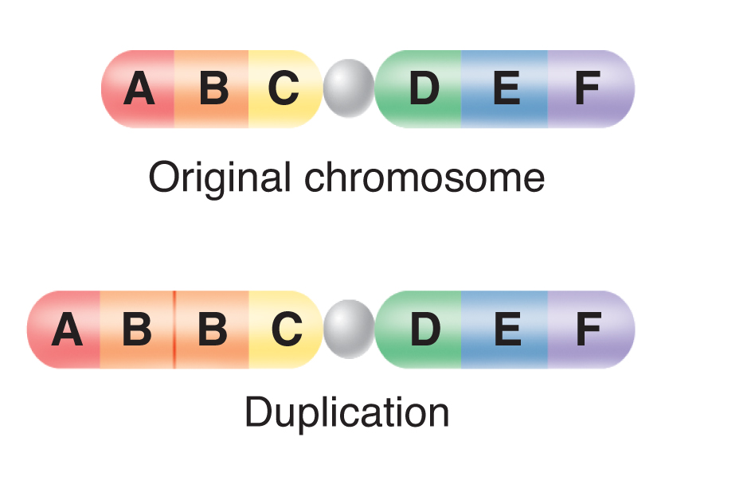

- Inversions
  - Inversions ________________ the direction of parts of chromosomes.
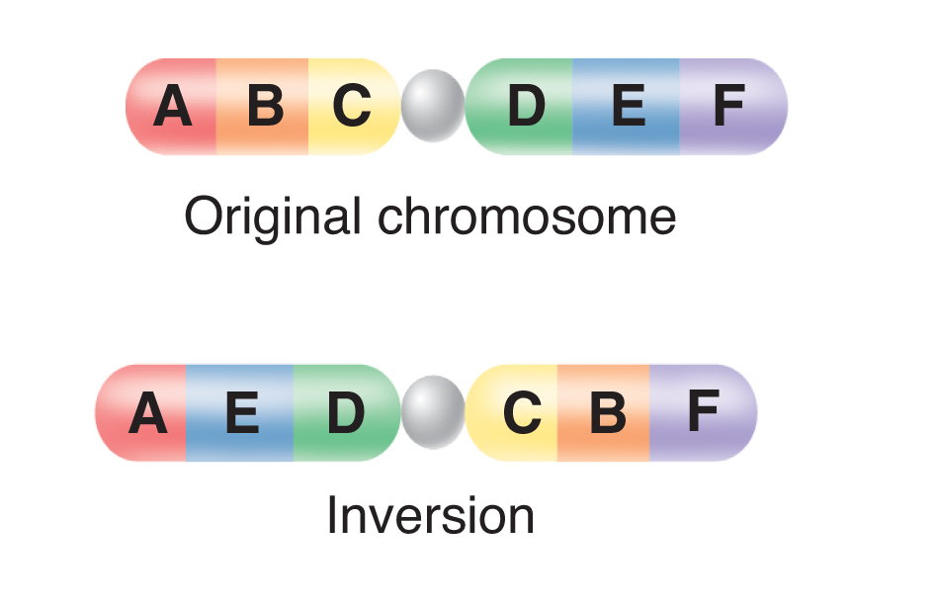

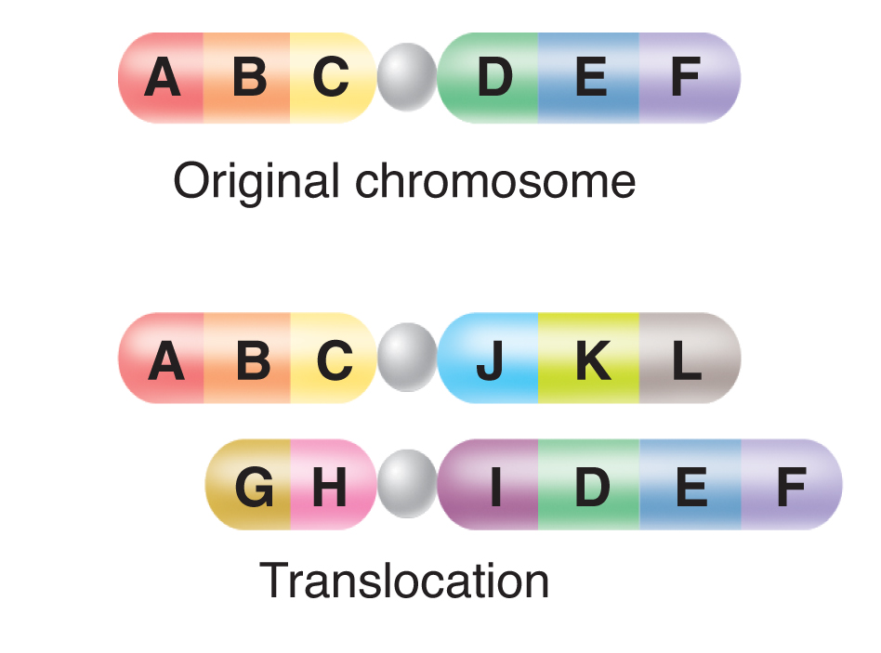
- Translocations occurs when part of one chromosome breaks off and_______________ to another.

- Significance of Mutations
  - Many mutations have little or __________ effect on gene expression.
  - Some mutations are the cause of genetic _______________.
  - Beneficial mutations may produce proteins with new or altered activities that can be useful.
  - Polyploidy is the condition in which an organism has extra sets of ____________________.

