Chapter 15 – Darwin’s Theory of Evolution
Section 1 – The Puzzle of Life’s Diversity
- ______________________ is the process by which modern organisms have descended from ancient organisms. (change)
- A scientific _________________ is a well-supported testable explanation of phenomena that have occurred in the natural world.
- Voyage of the Beagle
  - In 1831, Darwin set sail from England aboard the H.M.S. ________________ for a voyage around the world.
  - Darwin went ashore and collected plant and ____________ specimens for his collection.
  - He studied the specimens, read the latest scientific books, and filled many notebooks with his ________________________ and thoughts.
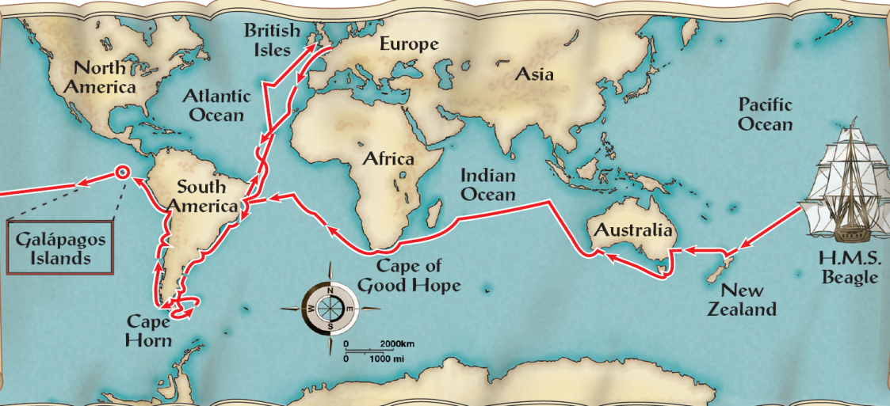

- What was Charles Darwin's contribution to science?
  - During his travels, Darwin made numerous observations and collected evidence that led him to propose a hypothesis about the way life ____________________ over time.
  - That hypothesis has become the theory of ____________________.
- Darwin's Observations
  - Darwin observed that many plants and animals were well suited to the environments they inhabited.
  - He was impressed by the ways in which organisms survived and produced ___________.
  - Darwin was puzzled by where different species lived and did not live.
  - Grasslands in some regions were similar to one another but were inhabited by very ____________________ animals.
- Living Organisms and Fossils
  - Darwin collected the preserved remains of ancient organisms, called _______________.
  - Some of those fossils resembled organisms that were still alive.
  - Others looked completely ___________________ any creature he had ever seen.
- The Galápagos Islands
  - Darwin observed that the __________________ Islands were close together but had very different climates.
- What pattern did Darwin observe among organisms of the Galápagos Islands?
  - Darwin observed that the characteristics of many animals and plants varied noticeably among the different ____________________ of the Galápagos.
Section 2 – Ideas that Shaped Darwin’s Thinking
- An Ancient, Changing Earth
  - How did Hutton and Lyell describe geological change?
  - Hutton and Lyell helped scientists recognize that Earth is many ___________________ of years old, and the processes that changed Earth in the past are the same processes that operate in the present.
- Hutton and Geological Change
  - In 1795, James Hutton published a hypothesis about the geological forces that shaped _________________.
  - Most of these geological forces operate very ________________, over millions of years.
  - Hutton proposed that Earth had to be much more than a few thousand years old.
- Lyell's Principles of Geology
  - Lyell stressed that scientists must explain past events in terms of processes that they can actually ______________________.
  - The processes that shaped the Earth millions of years earlier continue in the present.
  - Lyell’s work explained how geological features could be built up or torn down over __________________ periods of time.
- This understanding of geology influenced Darwin:
  - If the Earth could change over time, ___________________ might change as well.
  - It would have taken many years for life to _______________ in the way Lyell suggested.
    - This would have been possible only if the Earth were extremely ______________.
- According to Lamarck, how did species evolve?
- Lamarck's Evolution Hypotheses
- Jean-Baptiste Lamarck recognized that:
  - living things have ________________ over time.
  - all species were descended from other __________________.
  - organisms were ___________________ to their environments.
- Lamarck proposed that by selective use or ________________ of organs, organisms acquired or lost certain traits during their lifetime. These traits could then be passed on to their offspring. Over time, this process led to ____________________ in a species.
- Tendency Toward Perfection
  - Lamarck proposed that all organisms have an innate tendency toward complexity and ___________________.
  - They are continually changing and acquiring features that help them live more successfully in their environments.
- Use and Disuse
  - Lamarck proposed that organisms could alter the size or ____________________ of particular organs by using their bodies in new ways.
  - Example:
    - A male fiddler crab uses its front claw to ward off predators and to attract mates.
    - Because the front claw is used repeatedly, it becomes ____________________.
    - This characteristic (large claw) is passed onto its ________________.
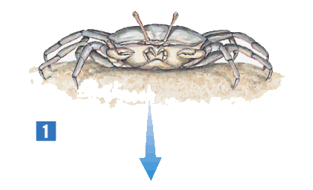

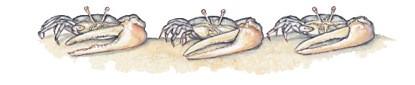
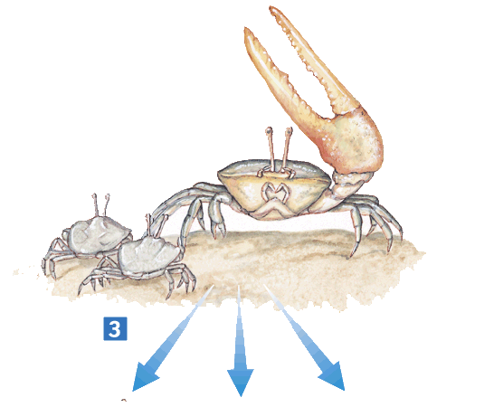
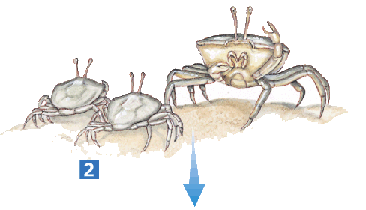

- Inheritance of Acquired Traits
  - Lamarck thought that ________________ characteristics could be inherited.
  - He believed that if an animal acquired a particular feature in its lifetime, that feature would be passed on to its ________________________.
- Evaluating Lamarck's Hypotheses
- Lamarck’s hypotheses of evolution are incorrect in several ways.
- Lamarck did not know:
  - how traits are ___________________.
  - that an organism’s behavior has no _________________ on its heritable characteristics.
    - However, he paved the way for the work of later biologists.
- What was Malthus's theory of population growth?
- Population Growth
  - In 1798, Thomas __________________ published a book in which he noted that babies were being born faster than people were dying.
  - The only forces he observed that worked against this growth were war, famine, and disease.
  - Malthus reasoned that if the human population continued to grow unchecked, sooner or later there would be insufficient living space and _______________ for everyone.
  - When Darwin read Malthus’s work, he realized that this reasoning applied to plants and _________________________.
  - If all the offspring of almost any species survived for several generations, they would _____________________ the world.
  - This information was central to _______________ explanation of evolutionary change.
Section 3 – Darwin Presents His Case (Part 1)
- Publication of On the Origin of Species
  - Darwin filled notebooks with his ideas about species diversity and the evolution process.
  - Darwin was ____________________ and disturbed by his discoveries.
  - He shelved his manuscript for years and told his _________ to publish it in case he died.
  - In 1858, Darwin received a short essay from naturalist Alfred ____________________.
  - The essay _______________________ Darwin’s thoughts on evolutionary change.
  - Later that year, Wallace’s essay was presented with some of Darwin’s work.
  - In 1859, Darwin published his book, On the Origin of ________________.
- In his book, Darwin:
  - proposed a mechanism for evolution called __________________ selection.
  - presented evidence that evolution has been taking place for _________________ of years—and continues in all living things.
- Inherited Variation and Artificial Selection
  - Members of each species vary from one another in important ways.
  - In Darwin’s day, variations were thought to be ___________________, minor defects.
  - Darwin argued that this variation ___________________.
  - Darwin noted that plant and animal breeders would breed only the largest hogs, the __________________ horses, or the cows that produced the most milk.
  - Darwin termed this process _____________________ selection.
- How is natural variation used in artificial selection?
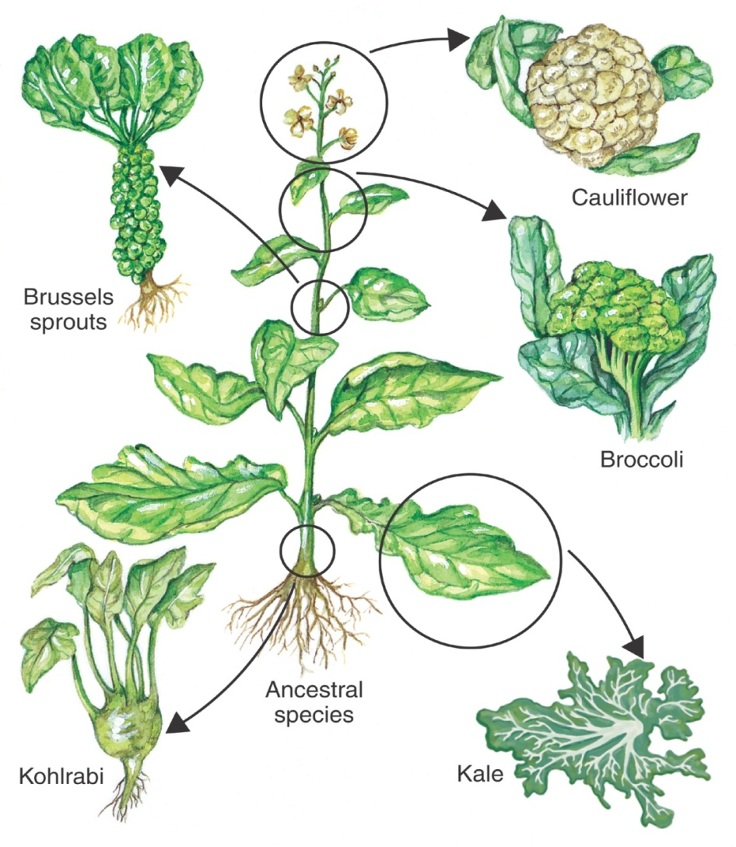
  - Artificial selection is the selection by __________________ for breeding of useful traits from the natural variation among different organisms.

- Evolution by Natural Selection
  - Darwin compared processes in ___________________ to artificial selection.
  - By doing so, he developed a scientific hypothesis to explain how evolution occurs.
- The Struggle for Existence
  - Darwin realized that high birth rates and a shortage of life's basic needs would force organisms to compete for _______________________.
  - The ___________________ for existence means that members of each species compete regularly to obtain food, living space, and other necessities of ________________.
  - The struggle for existence was central to Darwin's theory of ________________.
- How is natural selection related to a species' fitness?
  - Survival of the Fittest
  - The ability of an individual to survive and reproduce in its specific environment is ____________________.
  - Darwin proposed that fitness is the result of adaptations.
  - An adaptation is any inherited characteristic that increases an organism's chance of _____________________.
    - Successful adaptations enable organisms to become better suited to their environment and better able to survive and reproduce.
  - Individuals with characteristics that are not well suited to their environment either __________________ or leave few offspring.
  - Individuals that are better suited to their environment survive and reproduce most successfully.
  - Darwin called this process ________________ of the ___________________.
  - Because of its similarities to artificial selection, Darwin referred to the survival of the fittest as ____________________ selection.
    - In natural selection, the traits being selected contribute to an organism's fitness in its environment.
  - Over time, natural selection results in changes in the inherited characteristics of a population. These changes increase a species' _______________ in its environment.
Section 3 – Darwin Presents His Case (Part 2)
- Descent With Modification
  - Natural selection produces organisms that have different structures, establish different niches, or occupy different ____________________.
  - Each living species has descended, with changes, from other species over time.
  - Darwin referred to this principle as _________________ with modification.
  - Descent with modification implies that all living organisms are related to one another.
    - This is the principle known as common _________________.
- What evidence of evolution did Darwin present?
- Evidence of Evolution
  - Darwin argued that living things have been evolving on Earth for _________________ of years. Evidence for this process could be found in the _______________ record, the geographical distribution of living species, homologous structures of living organisms, and similarities in ________________ development, or embryology.
  - The Fossil Record
    - Darwin saw fossils as a record of the history of life on Earth.
    - By comparing fossils from older rock layers with fossils from younger layers, scientists could document that life on _______________ has changed over time.
  - Geographic Distribution of Living Species
    - Darwin decided that all Galápagos finches could have descended with modification from a common mainland ____________________.
    - Darwin’s theory was that species now living on different continents had each descended from different ancestors.
    - However, because some animals on each continent were living under similar ecological conditions, they were exposed to similar pressures of _________________ selection.
    - Because of these similar selection pressures, different animals ended up evolving certain features in ____________________.
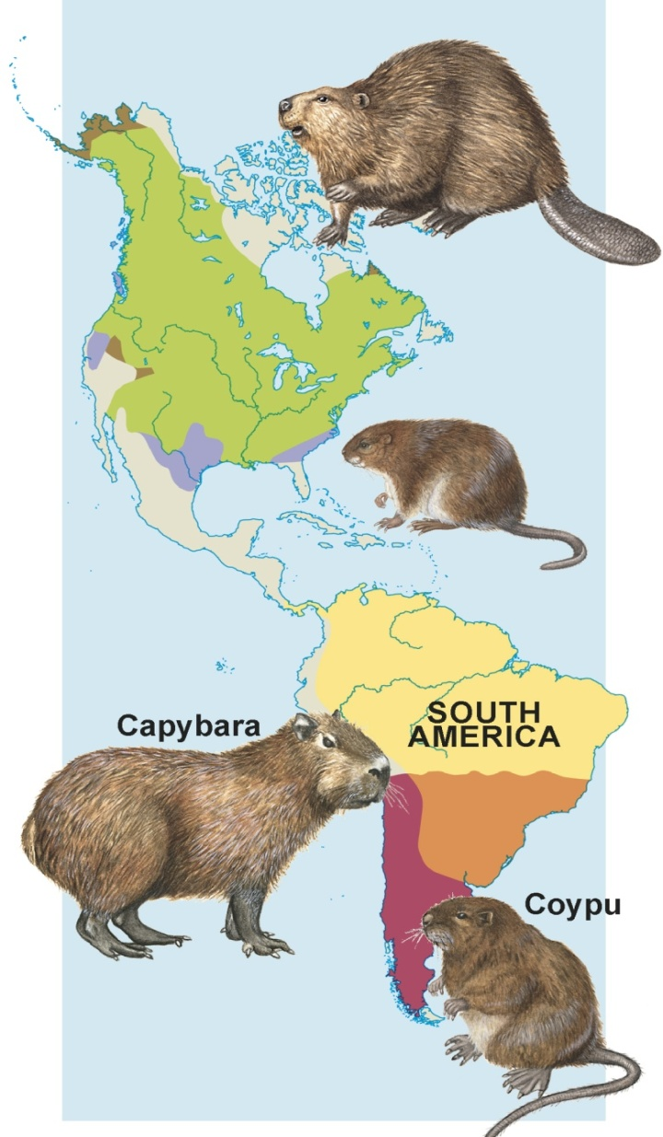

- Homologous Body Structures
  - Structures that have different mature forms but develop from the same embryonic tissues are called homologous ____________________.
  - Similarities and differences in homologous structures help biologists group animals according to how recently they last shared a common _______________________.

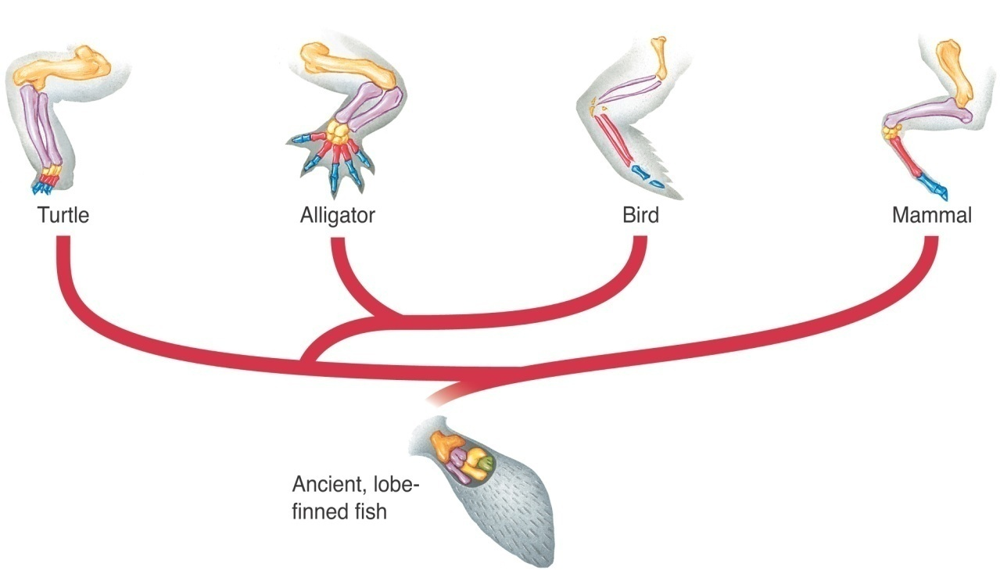

- Not all homologous structures serve important functions.
  - The organs of many animals are so reduced in size that they are just vestiges, or traces, of homologous organs in other species.
  - These organs are called _____________________ organs.
- Similarities in Embryology
  - The early stages, or embryos, of many animals with backbones are very similar.
  - The same groups of embryonic cells develop in the same order and in similar _____________________ to produce the tissues and organs of all vertebrates.
- Summary of Darwin's Theory
  - Individual organisms differ, and some of this ________________ is heritable.
  - Organisms produce more offspring than can survive, and many that do survive do not reproduce.
  - Because more organisms are produced than can survive, they compete for limited __________________
  - Individuals best suited to their environment survive and _______________ most successfully.
  - These organisms pass their heritable traits to their offspring. Other individuals die or leave fewer ____________________.
  - This process of natural selection causes species to change over time.
  - Species alive today are descended with __________________ from ancestral species that lived in the distant past.
  - This process, by which diverse species evolved from common ancestors, unites all organisms on Earth into a single tree of ________________.
- Evolutionary Theory
  - Scientific advances in many fields of biology, geology, and physics have confirmed and expanded most of Darwin’s hypotheses.
  - Evolutionary theory continues to change as new data are gathered and new ways of thinking ______________________.

