Chapter 16 - Evolution of Populations
Section 1 – Genes and Variation
- How Common Is Genetic Variation?
  - Many genes have at least two forms, or ______________________.
  - All organisms have genetic variation that is “invisible” because it involves small differences in biochemical processes.
  - An individual organism is heterozygous for many ____________________.
- Variation and Gene Pools
  - Genetic variation is studied in __________________.
  - A population is a group of individuals of the same _____________ that interbreed.
  - A gene ______________ consists of all genes, including all the different alleles, that are present in a population.
  - The relative ________________ of an allele is the number of times the allele occurs in a gene pool, compared with the number of times other alleles for the same gene occur.
  - Relative frequency is often expressed as a percentage.
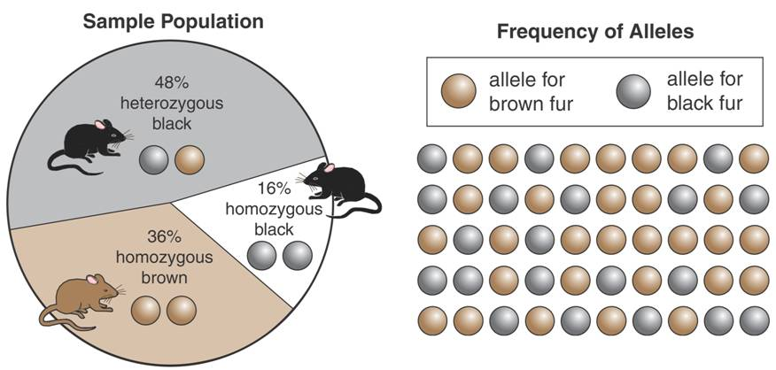

- How is evolution defined in genetic terms?
  - In genetic terms, _________________ is any change in the relative frequency of alleles in a population.
- Sources of Genetic Variation
  - The two main sources of genetic variation are _____________________ and the genetic shuffling that results from sexual ________________________.
- Mutations
  - A mutation is any change in a sequence of __________________.
  - Mutations occur because of mistakes in DNA replication or as a result of radiation or chemicals in the environment.
  - Mutations do not always ______________________ an organism’s phenotype.
- Gene Shuffling
  - Most heritable differences are due to gene ______________________.
  - Crossing-over increases the number of genotypes that can appear in offspring.
  - Sexual reproduction produces different _______________________, but it does not change the relative frequency of alleles in a population.
- What determines the numbers of phenotypes for a given trait?
- Single-Gene and Polygenic Traits
  - The number of phenotypes produced for a given trait depends on how many genes ________________________ the trait.
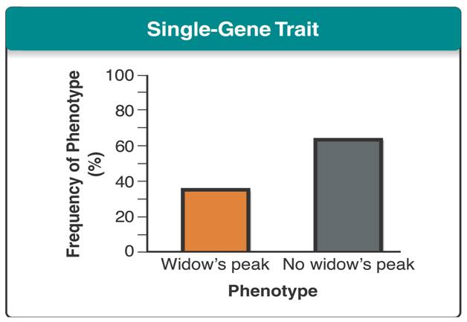
  - A single-gene trait is controlled by _________________ gene that has two alleles. Variation in this gene leads to only two possible phenotypes.

    - The allele for a widow’s peak is dominant over the allele for a hairline with __________ peak.
    - However, the presence of a widow’s peak may be less common in a population.
    - In real populations, phenotypic ratios are determined by the frequency of alleles as well as by whether the alleles are ____________________ or recessive.
  - Many traits are controlled by two or more genes and are called ______________ traits.
    - One polygenic trait can have many possible genotypes and phenotypes.
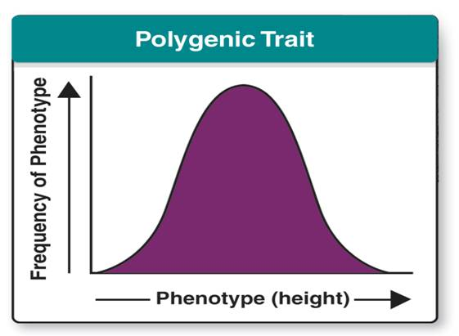
    - ____________________ in humans is a polygenic trait.

  - A _________________-shaped curve is typical of polygenic traits.
  - A bell-shaped curve is also called _______________________ distribution.
Section 2 – Evolution as Genetic Change (Part 1)
- Natural selection affects which individuals survive and __________________ and which do not.
- If an individual dies without reproducing, it does not contribute its alleles to the population’s gene _________________________.
- If an individual produces many offspring, its alleles stay in the gene pool and may ___________________ in frequency.
- Evolution is any change over time in the relative frequencies of alleles in a ______________________.
- Populations, not individual organisms, can evolve over time.
- Natural Selection on Single-Gene Traits
  - How does natural selection affect single-gene traits?
  - Natural selection on single-gene traits can lead to changes in allele frequencies and thus to ______________________.
  - Organisms of one color may produce fewer offspring than organisms of other colors.
    - For example, a lizard population is normally ____________________, but has mutations that produce red and black forms.
    - Red lizards are more visible to ____________________, so they will be less likely to survive and reproduce. Therefore, the allele for red color will become rare.
    - Black lizards may warm up faster on cold days. This may give them energy to avoid predators. In turn, they may produce more _________________________.
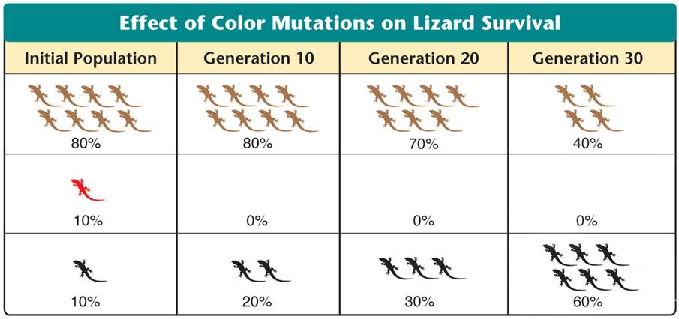
    - The allele for black color will _______________________ in relative frequency.
Black
Red
Brown

- Natural Selection on Polygenic Traits
  - How does natural selection affect polygenic traits?
- Natural selection can affect the distributions of __________________ in any of three ways:
  - ______________________ selection
  - _______________________ selection
  - ________________________ selection
- Directional Selection
  - When individuals at one end of the curve have higher fitness than individuals in the middle or at the other end, ___________________ selection takes place.
  - The range of phenotypes shifts as some individuals survive and reproduce while others do not.
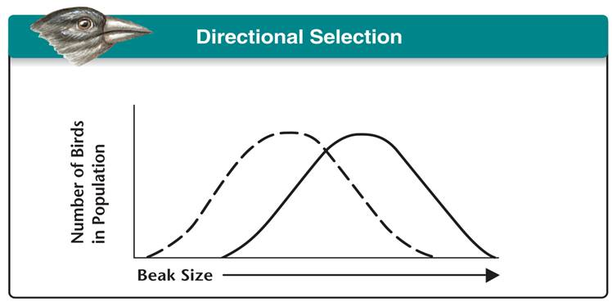
    - In this case, birds with _________________ beaks have higher fitness. Therefore, the average beak size increases.

- Stabilizing Selection
  - When individuals near the center of the curve have higher fitness than individuals at either end of the curve, ______________________ selection takes place.
  - This keeps the center of the curve at its current position, but it ____________________ the overall graph.
    - Human babies born at an average mass are more likely to ___________________ than babies born either much smaller or much larger than average.
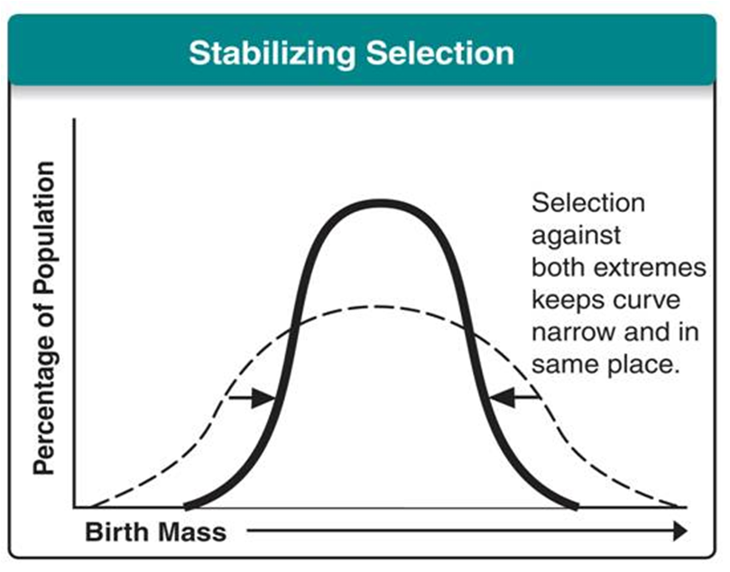

- Disruptive Selection
  - When individuals at the upper and lower ends of the curve have higher fitness than individuals near the middle, ____________________ selection takes place.
  - If the pressure of natural selection is strong enough and long enough, the curve will ___________________, creating two distinct phenotypes.
    - If average-sized seeds become __________________, a bird population will split into two groups: one that eats small seeds and one that eats large seeds.
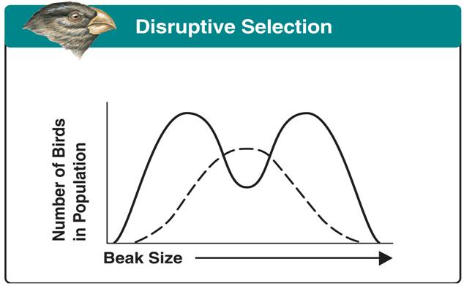

Section 2 – Evolution as Genetic Change (Part 2)
- Genetic Drift
- What is genetic drift?
  - A random change in allele frequency is called genetic ____________________.
  - In small populations, individuals that carry a particular allele may leave more descendants than other individuals do, just by _______________________.
  - Over time, a series of chance occurrences of this type can cause an allele to become ______________________________ in a population.
    - Genetic drift may occur when a small group of individuals colonizes a new _____________________.
    - Individuals may carry alleles in different relative frequencies than did the larger population from which they ____________________________.
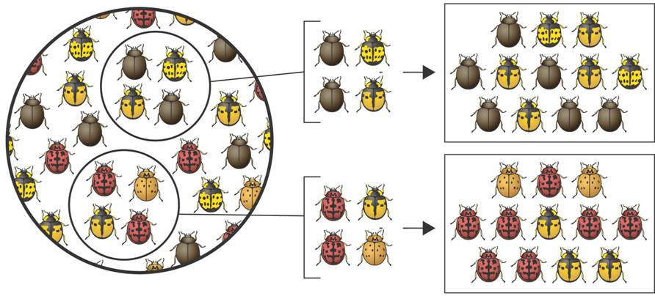
    - The new population will be genetically different from the parent population.
Descendents of Pop. A
Descendents of Pop. B
Founding Population A
Founding Population B
Sample of Original Population

  - When allele frequencies change due to migration of a small subgroup of a population it is known as the ___________________ effect.
- Evolution Versus Genetic Equilibrium
  - The Hardy-Weinberg ___________________ states that allele frequencies in a population will remain constant unless one or more factors cause those frequencies to change.
  - When allele frequencies remain constant it is called genetic _____________________.
- What five conditions are needed to maintain genetic equilibrium?
- ______________ conditions are required to maintain genetic equilibrium from generation to generation:
  - there must be random _____________________,
  - the population must be very large,
  - there can be no _________________________ into or out of the population,
  - there can be no ____________________, and
  - there can be no natural _______________________.
- Random Mating
  - Random mating ensures that each individual has an equal chance of passing on its alleles to ___________________________.
  - In natural populations, mating is rarely completely random. Many species select mates based on particular heritable ___________________.
- Large Population
  - Genetic drift has less effect on large populations than on small ones.
  - Allele frequencies of large populations are less likely to be _____________________ through the process of genetic drift.
- No Movement Into or Out of the Population
  - Because individuals may bring new _______________________ into a population, there must be no movement of individuals into or out of a population.
  - The population's gene pool must be kept together and kept separate from the gene pools of other ___________________________.
- No Mutations
  - If genes mutate, ___________________ alleles may be introduced into the population, and allele frequencies will change.
- No Natural Selection
  - All genotypes in the population must have equal probabilities of survival and _______________________.
  - No phenotype can have a selective advantage over another.
  - There can be no natural ______________________ operating on the population.

Section 3 – The Process of Speciation (Part 1)
- Natural selection and chance events can change the relative frequencies of alleles in a population and lead to speciation.
- Speciation is the formation of new _____________________.
- A species is a group of organisms that breed with one another and produce fertile _____________________.
- What factors are involved in the formation of new species?
  - The gene pools of two populations must become _____________________ for them to become new species.
- Isolating Mechanisms
  - As new species evolve, populations become reproductively _______________________ from each other.
  - When the members of two populations cannot interbreed and produce fertile offspring, reproductive ___________________ has occurred.
- Reproductive isolation can develop in a variety of ways, including:
  - ____________________ isolation
  - ____________________ isolation
  - _____________________ isolation
- Behavioral Isolation
  - ___________________ isolation occurs when two populations are capable of interbreeding but have differences in courtship rituals or other reproductive strategies that involve ________________________.
- Geographic Isolation
  - ____________________________ isolation occurs when two populations are separated by geographic barriers such as rivers or mountains.
  - Geographic barriers do not guarantee the formation of new species.
  - If two formerly separated populations can still interbreed, they remain a single _______________________.
  - Potential geographic barriers may separate certain types of organisms but not others.
- Temporal Isolation
  - ____________________ isolation occurs when two or more species reproduce at different ______________________.
- Testing Natural Selection in Nature
  - Studies showing natural selection in action involve descendants of the _______________________ that Darwin observed in the Galápagos Islands.
  - The finches Darwin saw were different, but he hypothesized that they had descended from a common ____________________________.

THIS IS A VERY IMPORTANT PAGE

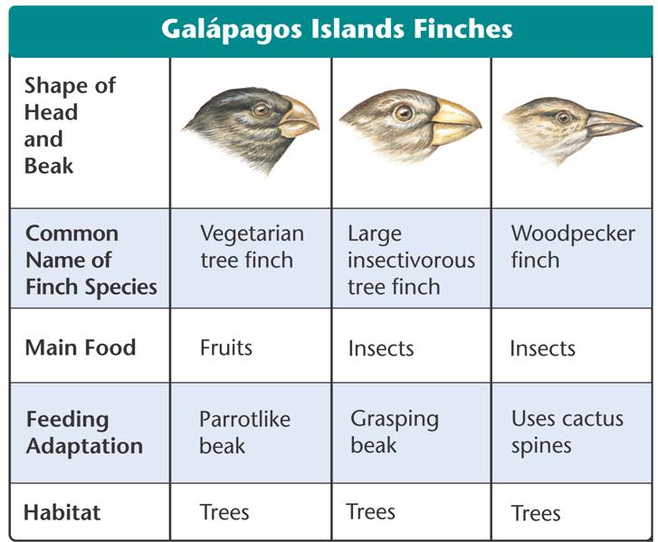

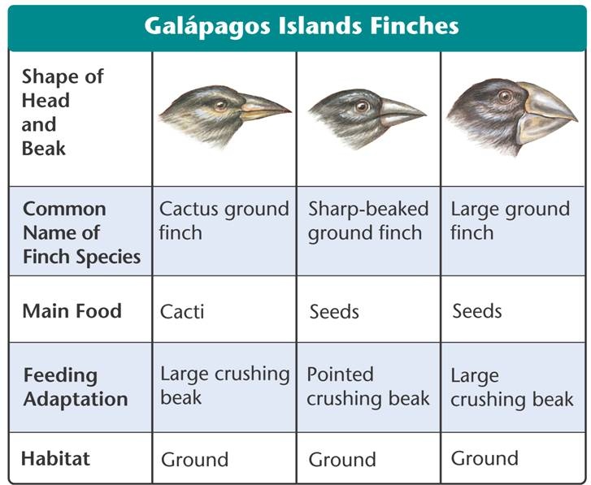

Section 3 – The Process of Speciation (Part 2)
- Peter and Rosemary __________________ tested Darwin’s hypothesis, which relied on two testable assumptions:
  - For beak size and shape to evolve, there must be enough heritable variation in those traits to provide raw material for ______________________ selection.
  - Differences in beak size and shape must produce differences in _____________________, causing natural selection to occur.
- The Grants tested these hypotheses on the medium ground ___________________ on Daphne Major, one of the Galápagos Islands.
  - During the rainy season, there is plenty of _______________________.
  - During droughts, food becomes scarce.
  - Individual birds with different-sized beaks had different chances of _____________________ during a drought.
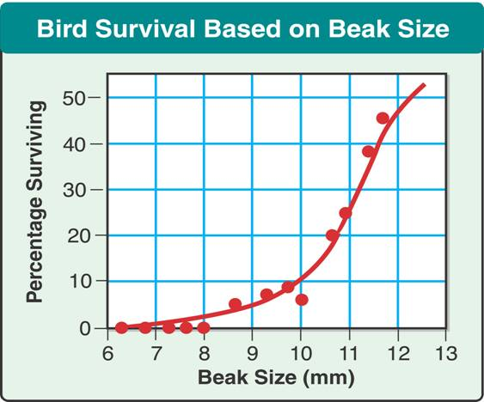
  - When food was scarce, individuals with large beaks were more likely to _____________.

  - The Grants provided evidence of the process of _________________________.
  - Beak size can be ____________________ by natural selection.
- Speciation in Darwin's Finches
  - Speciation in the Galápagos finches occurred by:
    - ______________________ of a new population
    - geographic isolation
    - changes in new population's gene _______________________
    - reproductive ______________________
    - ecological competition

- Founders Arrive
  - A few finches—species A—________________________ from South America to one of the Galápagos Islands.
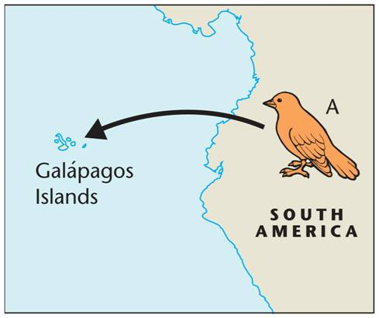
  - There, they survive and _________________________.

- Geographic Isolation
  - Some birds from species A cross to a second ______________________.
  - The two populations no longer share a gene ____________________.
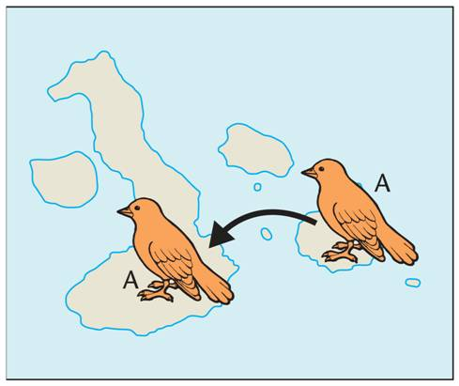

- Changes in the Gene Pool
  - Seed sizes on the second island favor birds with ___________________ beaks.
  - The population on the second island evolves into population B, with larger ____________________.
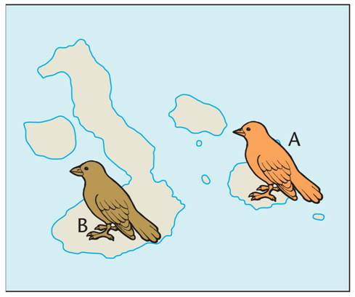

- Reproductive Isolation
  - If population B birds cross back to the first island, they will not _______________________ with birds from population A.
  - Populations A and B are separate ________________________.
- Ecological Competition
  - As species A and B compete for available seeds on the first island, they continue to evolve in a way that increases the _______________________ between them.
  - A new species—C—may evolve.
- Continued Evolution
  - This process of isolation, genetic change, and reproductive isolation probably repeated itself often ____________________ the entire Galápagos island chain.
- Studying Evolution Since Darwin
  - Scientific evidence supports the theory that living species descended with ________________________ from common ancestors that lived in the ancient past.
  - Scientists predict that as new ________________________ are found, they will continue to expand our understanding of how species evolved.

