Chapter 17 – The History of Life
Section 1 – The Fossil Record (Part 1)
- Fossils and Ancient Life
  - Paleontologists are scientists who collect and study _________________________.
  - All information about past life is called the fossil _____________________.
    - The fossil record includes information about the structure of organisms, what they _________________, what ate them, in what environment they lived, and the _______________________ in which they lived.
  - The fossil record provides evidence about the history of life on Earth. It also shows how different groups of organisms, including species, have ___________________ over time.
  - The fossil record provides ____________________ information about the history of life.
    - Over __________% of all species that have lived on Earth have become extinct, which means that the species has died out.
- How Fossils Form
  - Fossils can be as large as a complete, preserved animals, or as small as a _____________________.
  - Most fossils form in sedimentary rock.
    - Sedimentary rock forms when exposure to the elements ____________________ down existing rock into small particles of sand, silt, and ___________________.
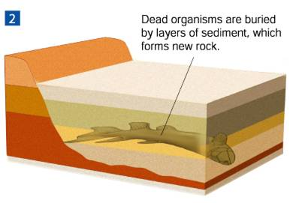
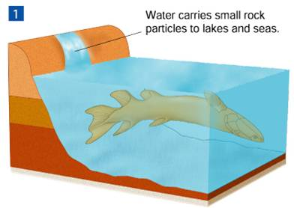

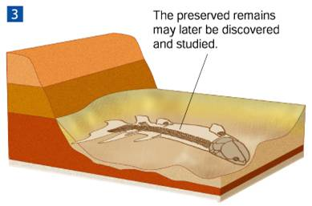

- Interpreting Fossil Evidence
  - Paleontologists determine the age of fossils using __________________ dating or ___________________ dating.
- What information do relative dating and radioactive dating provide about fossils?
- Relative Dating
  - In relative dating, the age of a fossil is determined by comparing its________________________ with that of fossils in other layers of rock.
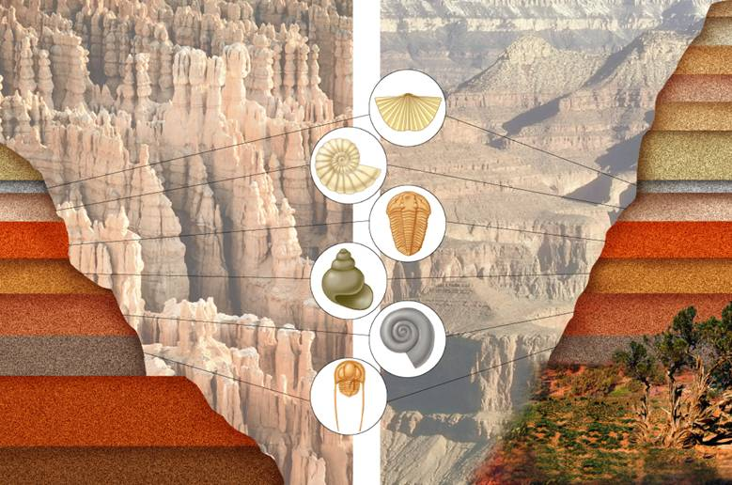
  - Rock layers form in order by age—the oldest on the ____________________, with more recent layers on _______________________.

  - Index fossils are used to compare the relative ages of fossils.
  - An_______________________ fossil is a species that is recognizable and that existed for a short period but had a wide geographic range.
  - Relative dating allows paleontologists to __________________________ a fossil's age compared with that of other fossils.
- Radioactive Dating
  - Scientists use radioactive decay to assign an absolute __________________ to rocks.
  - Some elements are radioactive and steadily break down into nonradioactive elements.
  - ____________________ dating is the use of half-lives to determine the age of a sample.
  - A _______________________-life is the length of time required for half of the radioactive atoms in a sample to decay.
  - In radioactive dating, scientists calculate the age of a sample based on the amount of remaining radioactive isotopes it ______________________________.
  - Carbon-14 begins to decay when an organism ___________________________.
  - Carbon-12 is not radioactive and does not ____________________________.
  - By comparing the amounts of carbon-14 and carbon-12 in a fossil, researchers can determine when the ___________________________________ lived.
Section 1 –The Fossil Record (Part 2)
- Geologic Time Scale
  - What are the main divisions of the geologic time scale?
- Paleontologists use a scale called the geologic _________ scale to represent evolutionary time.
  - Scientists first developed the geologic time scale by studying __________________ layers and index fossils worldwide.
  - ***The basic divisions of the geologic time scale are eras and periods.***
- Geologic Time
  - Geologic time begins with Precambrian Time, which covers about __% of Earth’s history.
  - Eras
  - Geologists divide the time between Precambrian time and the present into three eras:
    - ________________________ Era
    - Mesozoic Era
    - ________________________ Era
  - The Paleozoic began about 544 million years ago.
    - Many vertebrates and __________________________ lived during this time.
  - The Mesozoic began about ___________ million years ago.
    - _______________________________ lived during this time.
    - Mammals began to evolve during this era.
  - The Cenozoic began about ___________ million years ago and continues to the present.
    - Mammals became ____________________________ during the Cenozoic.
  - Periods
    - Eras are subdivided into ____________________, which range in length from tens of millions of years to less than two million years.
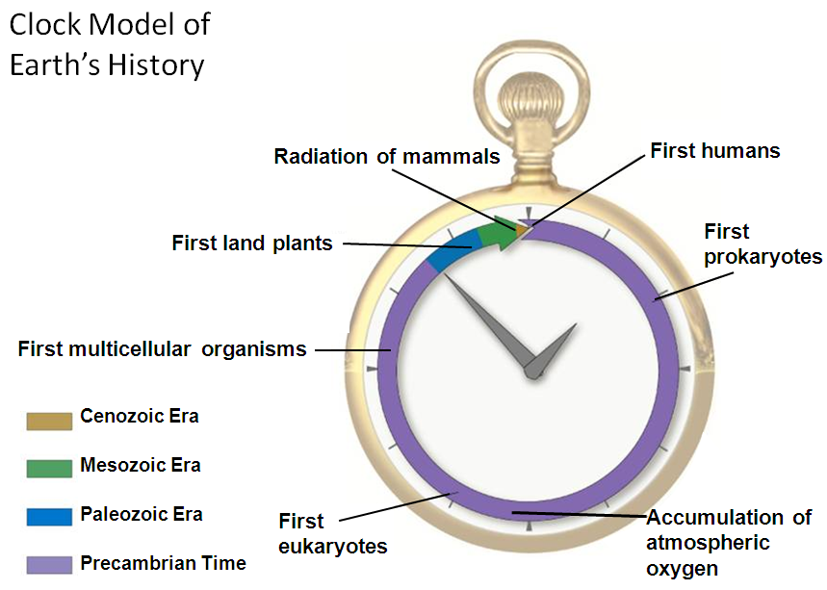
    - Many periods are named for places around the world where geologists first discovered the rocks and ____________________________ of that period.

Section 2 – Earth’s Early History (Part 1)
- Formation of Earth
  - Hypotheses about Earth’s early history are based on a relatively small amount of ________________________.
  - Gaps and uncertainties make it likely that scientific ideas about the origin of life will _____________________.
  - Evidence shows that Earth was not “______________________” in a single event.
  - Pieces of cosmic debris were probably attracted to one another over the course of 100 million years.
  - While Earth was young, it was struck by one or more objects, producing enough heat to ________________________ the entire globe.
  - Once Earth melted, its elements rearranged themselves according to _______________.
  - The most dense elements formed the planet’s _______________________.
  - Moderately dense elements floated to the surface, cooled, and formed a solid crust.
  - The least dense elements formed the first ___________________________.
- What substances made up Earth's early atmosphere?
  - Earth's early atmosphere probably contained hydrogen cyanide, carbon dioxide, carbon monoxide, nitrogen, hydrogen sulfide, and ______________________.
  - Scientists infer that about four billion years ago, Earth cooled and solid ____________________ formed on its surface.
  - Millions of years later, ________________________ activity shook Earth’s crust.
  - About 3.8 billion years ago, Earth’s surface cooled enough for water to remain a liquid, and __________________________ covered much of the surface.
- The First Organic Molecules
  - Could organic molecules have evolved under conditions on early Earth?
  - In the 1950s, Stanley ___________________ and Harold Urey tried to answer that question by simulating conditions on the early Earth in a laboratory setting.
- What did Miller and Urey's experiments show?
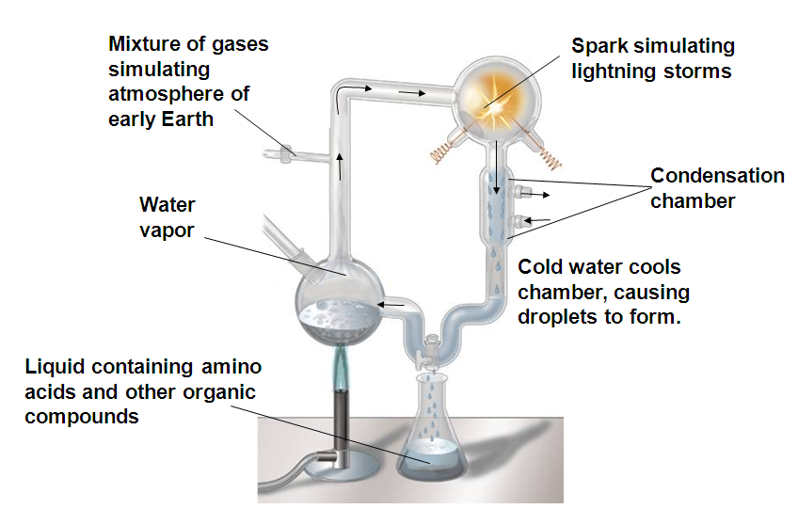

  - Miller and Urey's experiments suggested how mixtures of the organic compounds necessary for life could have arisen from simpler compounds present on a primitive ______________________. ***The building blocks know as amino __________ formed.
  - Although their simulations of early Earth were not accurate, experiments with current knowledge yielded ________________________ results.
- The Puzzle of Life's Origin
  - Evidence suggests that 200–300 million years after Earth had liquid water, cells similar to modern ________________________ were common.
- Formation of Microspheres
  - In certain conditions, large organic molecules form tiny bubbles called proteinoid microspheres.
    - Proteinoid = made up of ____________________________
  - Microspheres are not cells, but they have ________________________ permeable membranes and can store and release energy.
  - Hypotheses suggest that structures similar to microspheres might have acquired more characteristics of living __________________________.
Section 2 – Earth’s Early History (Part 2)
- Evolution of RNA and DNA
- How could DNA and RNA have evolved? Several hypotheses suggest:
  - Some RNA sequences can help DNA ____________________ under the right conditions.
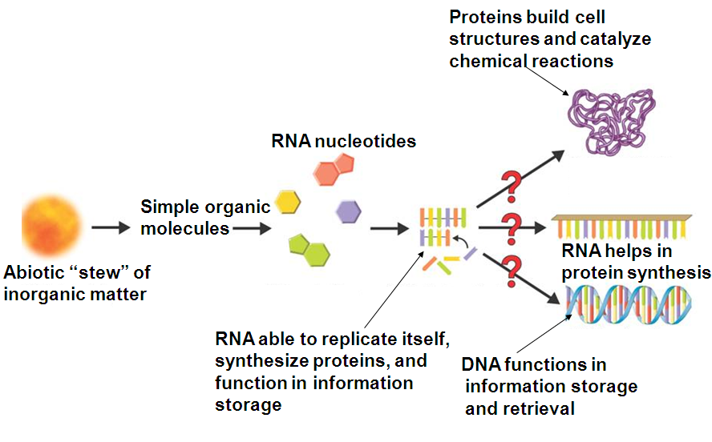
  - Some RNA molecules can even grow and duplicate themselves suggesting RNA might have existed ___________________ DNA.

- Free Oxygen
  - Microscopic fossils, or ___________________fossils, of unicellular prokaryotic organisms resembling modern bacteria have been found in rocks over 3.5 _____________________ years old.
  - These first life-forms evolved without ___________________________.
  - About 2.2 billion years ago, photosynthetic bacteria began to pump oxygen into the ______________________.
  - Next, oxygen gas accumulated in the _____________________________________.
- What occurred when oxygen was added to Earth's atmosphere?
  - The rise of oxygen in the atmosphere drove some life forms to ______________________, while other life forms evolved new, more efficient metabolic pathways that used ________________________ for respiration.
- What hypothesis explains the origin of eukaryotic cells?
- The Endosymbiotic Theory
  - The endosymbiotic theory proposes that eukaryotic cells arose from living communities formed by ___________________________ organisms.
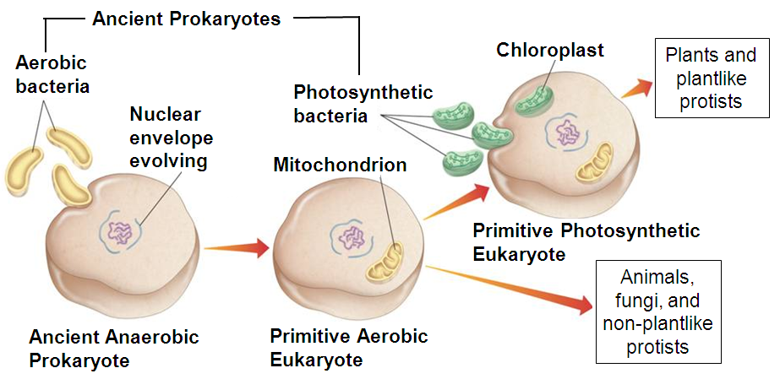

  - About 2 billion years ago, prokaryotic cells began evolving internal cell ____________________.
  - The result was the ________________________ of all eukaryotic cells.
  - According to the endosymbiotic theory, eukaryotic cells formed from a symbiosis among several different ___________________________.
  - Prokaryotes that use oxygen to generate energy-rich molecules of ATP evolved into _________________________.
  - Prokaryotes that carried out photosynthesis evolved into ________________________.
- Sexual Reproduction and Multicellularity
  - Most prokaryotes reproduce _______________________. Asexual reproduction:
    - yields daughter cells that are exact ______________________ of the parent cell.
    - restricts genetic variation to mutations in _____________________.
- Sexual reproduction shuffles genes in each generation. In sexual reproduction:
  - offspring _______________________ resemble parents exactly
  - there is an increased probability that favorable combinations will be produced
  - there is an increased chance of evolutionary ____________________ due to natural selection
Section 3 – Evolution of Multicellular Life (Part 1)
- Precambrian Time
  - Few fossils exist from Precambrian time because the animals were all ___________________-bodied.
  - Life existed only in the _______________________.
- Paleozoic Era
  - What were the characteristic forms of life in the Paleozoic era?
  - Rich fossil evidence shows that early in the Paleozoic Era, there was a diversity of __________________________ life.
  - The Paleozoic Era is divided into the following periods:
    - Cambrian
    - Ordovician
    - _______________________
    - Devonian
    - Carboniferous
    - _______________________________
- Cambrian Period
  - The diversification of life at this time is called the “Cambrian ____________________.”
  - The first known representatives of most animal phyla evolved. These included:
    - ______________________________****
    - brachiopods
    - trilobites
- Ordovician and Silurian Periods
  - Some arthropods became the first ___________________________ animals.
  - The first vertebrates appeared.
  - The first land ___________________________ evolved from aquatic ancestors.
- Devonian Period
  - Some plants adapted to ______________________ areas and invaded more habitats.
  - ___________________________ appeared on land.
  - The Devonian is often called the Age of ________________________ because many groups of fishes were present in the oceans.
  - Most fishes had jaws, bony skeletons, and scales.
  - During the Devonian, vertebrates began to invade the _________________________.
  - Some of these early four-legged vertebrates evolved into the first amphibians.
- Carboniferous and Permian Periods
  - ___________________________ evolved from certain amphibians.
  - Winged insects evolved into many forms.
  - Giant ferns and other plants formed vast swampy forests.
  - Remains of ancient plants formed thick deposits of sediment that changed into _________________________ over millions of years.
  - At the end of the Permian Period, there was a mass ________________________ in which many living things became extinct at the same time.
  - The mass extinction at the end of the Paleozoic affected both plants and animals on land and in the seas. As much as ________% of the complex life in the oceans disappeared.
Section 3 – Evolution of Multicellular Life (Part 2)
- Mesozoic Era
  - What were the characteristic forms of life in the Mesozoic era?
  - During the Mesozoic Era, ____________________ became dominant. The Mesozoic is also marked by the appearance of flowering plants.
  - The Mesozoic Era is often called the Age of _________________________.
- Triassic Period
  - Organisms that survived the Permian mass _____________________ became the main life forms early in the Triassic.
  - These organisms included fishes, insects, reptiles, and ___________-bearing plants.
- Jurassic Period
  - Dinosaurs became the dominant animals on land.
  - One of the first __________________, Archaeopteryx, appeared.
  - Many paleontologists think that birds are close relatives of ________________________
- Cretaceous Period
  - Dominant animals during this period included: reptiles, birds, turtles, crocodiles, fishes, and marine invertebrates.
  - New forms of plant life included leafy trees, shrubs, and small _______________ plants.
  - The Cretaceous Period ended with a mass _________________________.
  - More than half of all plant and animal groups were wiped out, including all of the __________________________________.
- Cenozoic Era
  - What were the characteristic forms of life in the Cenozoic era?
  - During the Cenozoic, ____________________ evolved adaptations that allowed them to live in various environments—on land, in water, and even in the ______________.
  - The Cenozoic often is called the Age of ______________________.
  - The Cenozoic is divided into the Tertiary Period and the Quaternary ________________.
- Tertiary Period
  - The climate was generally _______________________ and mild.
  - Marine mammals such as whales and ____________________________ evolved.
  - Grasses evolved, providing ______________________ for grazing mammals.
  - Some mammals became very ________________, as did some birds.
- Quaternary Period
  - Earth’s climate _________________, causing a series of ice ages.
  - About 20,000 years ago, Earth’s climate began to warm and sea levels began to ____________________.
  - In the oceans, algae, coral, mollusks, fishes, and mammals thrived.
  - Insects, birds, and land mammals were ______________________.
  - The fossil record suggests that the early ancestors of our species appeared about 4.5 million years ago.
  - The first fossils of Homo __________________ may have appeared as early as 200,000 years ago in Africa.
  - According to one hypothesis, members of our species migrated from ____________________ and ultimately colonized the world.
Section 4 – Patterns of Evolution (Part 1)
- ________________evolution refers to large-scale evolutionary patterns and processes that occur over long periods of time.
- Six important topics in macroevolution are:
  - extinction
  - ___________________ radiation
  - ___________________________ evolution
  - coevolution
  - punctuated _________________________________
  - changes in developmental genes
- Extinction
  - More than _______% of all species that have ever lived are now extinct.
  - In the past, most researchers looked for a ___________________, major cause for each mass extinction.
  - Many paleontologists now think that mass extinctions were caused by _______________________ factors.

  - What effects have mass extinctions had on the history of life? Mass extinctions have:
    - provided ecological opportunities for organisms that ____________________
    - resulted in bursts of ______________________ that produced many new species
- Adaptive Radiation
  - Adaptive radiation is the process by which a single species or a small group of species evolves into several different ____________________ that live in different ways.
  - For example, in the adaptive radiation of Darwin's _____________________, more than a dozen species evolved from a single species.
  - Adaptive radiations can occur on a much larger scale.
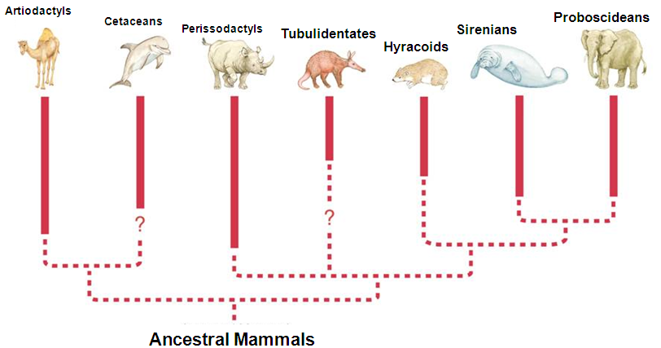
  - The disappearance of _________________________ then resulted in the adaptive radiation of mammals.

Section 4 – Patterns of Evolution (Part 2)
- Convergent Evolution
  - Different organisms undergo adaptive radiation in different places or at different times but in similar environments.
  - The process by which ______________________ organisms come to resemble one another is called convergent evolution.
  - Convergent evolution has resulted in sharks, dolphins, seals, and penguins.
  - Structures that look and function similarly but are made up of parts that do not share a common evolutionary ______________________ are called analogous structures.
  - A dolphin’s fluke and a fish’s tail ____________________ are analogous structures.
- Coevolution
  - Sometimes organisms that are closely connected to one another by ecological interactions evolve ________________________.
  - The process by which two species evolve in response to changes in each other over time is called ___________________________.
- Punctuated Equilibrium
  - Darwin felt that biological change was ____________ and steady, an idea known as gradualism.
  - Punctuated _______________________ is a pattern of evolution in which long stable periods are interrupted by brief periods of more ________________ change.
  - ******The concept of punctuated equilibrium has generated debate and is still controversial among some biologists today.******
  - Evolution has often proceeded at different ______________ for different organisms at different times during the history of life on Earth.
- Developmental Genes and Body Plans
  - It is suspected that changes in ________________ for growth and differentiation during embryological development could produce changes in body shape and ___________________.
  - Small changes in the activity of control ___________________ can affect many other genes to produce large changes in adult animals.
  - Small changes in the timing of cell differentiation and gene expression can make the difference between long legs and ___________________ ones.

