Chapter 4 – Ecosystems and Communities
Section 1 – The Role of Climate
- What Is Climate?
  - ______________ is the day-to-day condition of Earth's atmosphere at a particular time and place.
  - Climate refers to the _______________ year-after-year conditions of temperature and precipitation in a particular region.
- Climate is caused by:
  - trapping of heat by the atmosphere
  - latitude
  - transport of heat by winds and ocean currents
  - amount of precipitation
  - shape and elevation of landmasses
- The Greenhouse Effect
  - How does the greenhouse effect maintain the biosphere's temperature range?
  - Atmospheric gases that trap the heat energy of sunlight and maintain Earth's temperature range include:
    - carbon __________________
    - methane
    - water vapor
  - The natural situation in which heat is retained in Earth’s atmosphere by this layer of gases is called the greenhouse _______________.
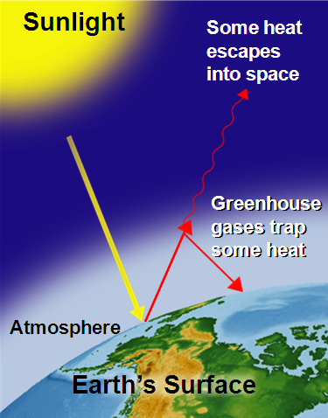

  - Solar radiation strikes different parts of Earth’s surface at an angle that varies throughout the year.
  - At the __________________, energy from the sun strikes Earth almost directly.
  - At the North and South Poles, the sun’s rays strike Earth’s surface at a lower angle.
- As a result of differences in latitude and thus the angle of heating, Earth has three main climate zones:
  - polar,
  - temperate, and
  - __________________
- Polar Zones
  - The polar zones are _______ areas where the sun's rays strike Earth at a very low angle.
  - Polar zones are located in the areas around the North and South poles, between 66.5° and 90° North and South latitudes.
- Temperate Zones
  - The temperate zones sit between the polar zones and the tropics.
  - Temperate zones are more affected by the changing _________________ of the sun over the course of a year.
  - As a result, the climate in these zones ranges from hot to cold, depending on the season.
- Tropical Zones
  - The tropical zone, or tropics, is near the equator, between 23.5° North and 23.5° South latitudes.
  - The tropics receive direct or nearly direct sunlight year-round, making the climate almost always ______________________.
- Heat Transport in the Biosphere
  - Unequal heating of Earth’s surface drives winds and ocean currents, which transport _______________ throughout the biosphere.
  - Warm air over the equator rises, while cooler air over the poles sinks toward the ground.
  - The upward and downward movement of air creates air currents, or ________________, that move heat throughout the atmosphere.
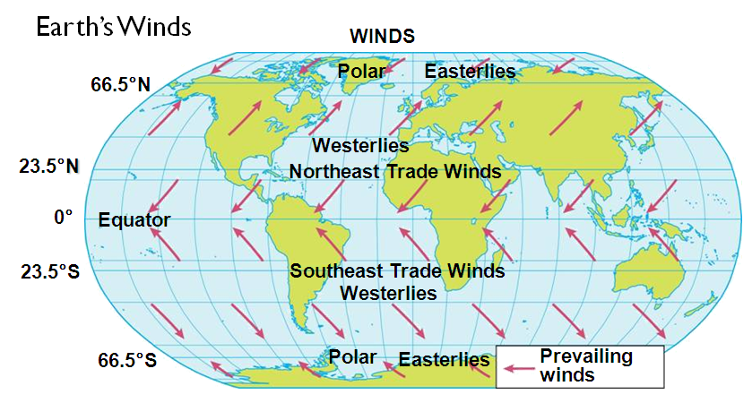

- Similar patterns of heating and cooling occur in Earth’s oceans. Cold water near the poles sinks, then flows parallel to the ocean bottom, and rises in warmer regions.
- Water is also moved at the surface by winds.
- The movement of the water creates ocean _________________, which transport heat energy throughout the biosphere.
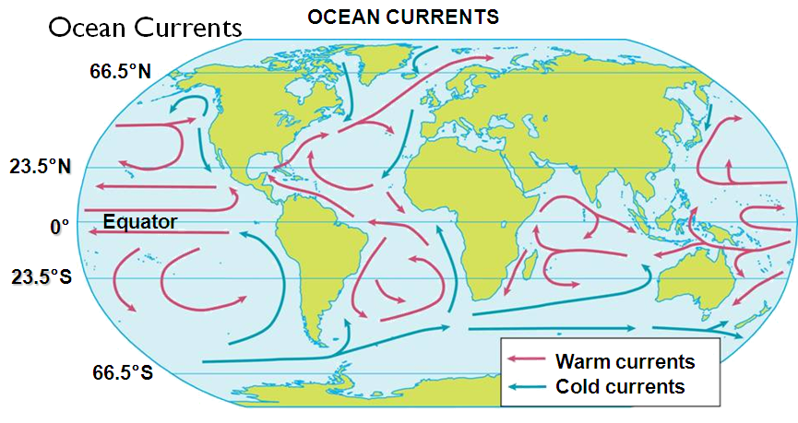
- Surface ocean currents warm or cool the air above them, affecting the weather and climate of nearby _________________.

Section 2 – What Shapes an Ecosystem? (Part 1)
- Biotic and Abiotic Factors
  - Ecosystems are influenced by a combination of biological and physical factors.
- The biological influences on organisms within an ecosystem are called biotic factors.
  - Biotic factors include all the ________________ things with which an organism might interact.
- Physical, or ______________, factors that shape ecosystems are called abiotic factors.
  - Abiotic factors include:
    - temperature
    - precipitation
    - humidity
    - wind
    - nutrient availability
    - soil type
    - sunlight
- How do biotic and abiotic factors influence an ecosystem?
  - Biotic and abiotic factors determine the ________________ and growth of an organism and the productivity of the ecosystem in which the organism lives.
  - The area where an organism lives is called its __________________. A habitat includes both biotic and abiotic factors.
- The Niche
  - A niche is the full range of physical and biological conditions in which an organism lives and the way in which the organism uses those conditions.
  - The range of temperatures that an organism needs to survive and its place in the ________________ web are part of its niche.
  - The combination of biotic and abiotic factors in an ecosystem often determines the number of different niches in that ecosystem.
  - No two species can ______________ the same niche in the same habitat.
  - Different species can occupy niches that are very similar.
- Community Interactions
  - When organisms live together in ecological communities, they ___________ constantly.
  - Community interactions, such as competition, predation, and various forms of symbiosis, can affect an ecosystem.
- Competition
  - Competition occurs when organisms of the same or different species attempt to use an ecological ___________________ in the same place at the same time.
  - A resource is any necessity of _________, such as water, nutrients, light, food, or space.
  - Direct competition in nature often results in a winner and a loser—with the losing organism failing to ___________________.
  - The competitive exclusion principle states that no two species can occupy the same niche in the same habitat at the same time.
  - The distribution of these warblers avoids direct competition, because each species feeds in a different _________________ of the tree.
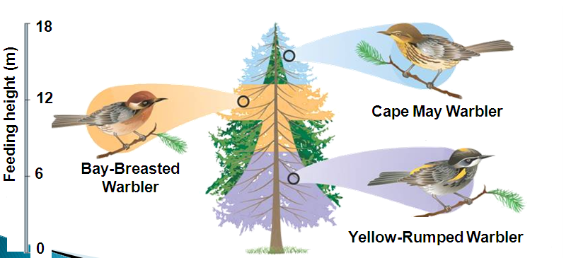

- Predation
  - An interaction in which one organism captures and ________________ on another organism is called predation.
  - The organism that does the killing and eating is called the predator, and the food organism is the ___________________.
- Symbiosis
  - Any relationship in which two species live closely together is called symbiosis.
  - Symbiotic relationships include:
    - mutualism
    - commensalism
    - parasitism
  - Mutualism: both species ________________ from the relationship.
  - Commensalism: one member of the association benefits and the other is neither helped nor _________________.
  - Parasitism: one organism lives on or inside another organism and ______________ it.
Section 2 – What Shapes an Ecosystem (Part 2)
- Ecological Succession
  - Ecosystems are constantly changing in response to natural and human disturbances.
  - As an ecosystem changes, older inhabitants gradually ______________ out and new organisms move in, causing further changes in the community.
  - This series of predictable changes that occurs in a community over time is called ecological succession.
  - Sometimes, an ecosystem changes in response to an abrupt disturbance.
  - At other times, change occurs as a more gradual response to _________________ fluctuations in the environment.
- Primary Succession
  - On land, succession that occurs on surfaces where no soil exists is called primary succession. For example, primary succession occurs on rock surfaces formed after volcanoes erupt.
  - The first species to populate the area are called ______________ species.
  - In this example, a volcanic eruption has destroyed the previous ecosystem.
  - The first organisms to appear are lichens.
  - Mosses soon appear, and grasses take root in the thin layer of soil.
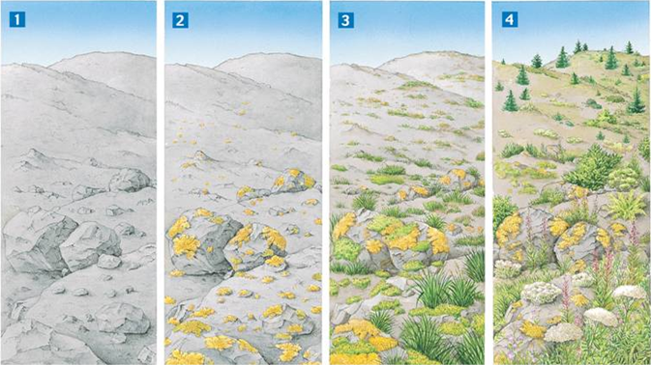
  - Eventually, tree seedlings and shrubs sprout among the plant __________________.

- Secondary Succession
  - Components of an ecosystem can be changed by natural events, such as fires.
  - When the disturbance is over, community interactions tend to restore the ecosystem to its original condition through ______________ succession.
  - Healthy ecosystems usually recover from natural disturbances, but may not recover from long-term, _______________-caused disturbances.
- Succession in a Marine Ecosystem
  - Succession can occur in any ecosystem, even in the permanently dark, deep ocean.
  - In 1987, scientists documented an unusual community of organisms living on the remains of a dead ___________________.
  - The community illustrates the stages in the succession of a whale-fall community.
  - Succession begins when a whale dies and sinks to the ocean floor.
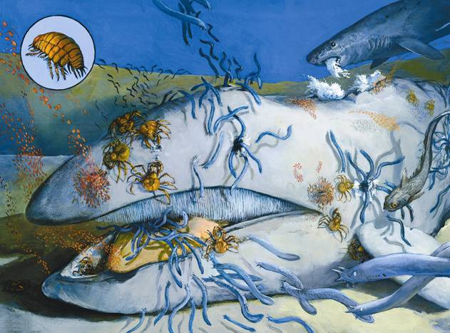

  - Within a year, most of the whale’s tissues have been eaten by scavengers and ____________________.
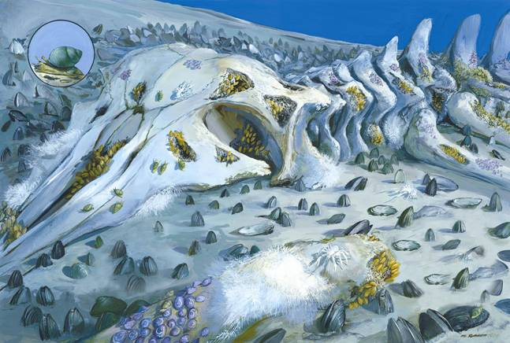

- The decomposition of the whale’s body enriches the surrounding sediments with nutrients.
- When only the skeleton remains, heterotrophic bacteria decompose oils in the whale bones.
- This releases compounds that serve as _____________ sources for chemosynthetic autotrophs.
- The chemosynthetic bacteria support a diverse community of organisms.
Section 3 – Biomes (Part 1)
- A biome is a complex of terrestrial communities that covers a large area and is characterized by certain soil and ____________ conditions and particular assemblages of plants and animals.
  - Variations in plants and animals help different species survive under different conditions in different biomes.
  - Plants and animals exhibit variations in ________________, or the ability to survive and reproduce under conditions that differ from their optimal conditions.
  - The climate of a region is an important factor in determining which organisms can survive there.
  - Within a biome, temperature and precipitation can vary over small distances.
  - The climate in a small area that differs from the climate around it is called a _________climate.
- The Major Biomes
  - The world's major biomes include:
    - tropical rain forest
    - tropical dry forest
    - tropical savanna
    - desert
    - temperate grassland
    - temperate woodland and shrubland
    - temperate forest
    - northwestern coniferous forest
    - boreal forest
    - tundra
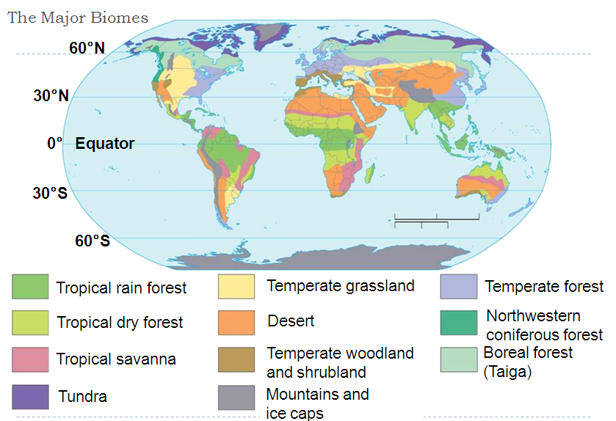
- Biomes are defined by a unique set of abiotic factors—particularly climate—and a characteristic assemblage of ___________ and __________________.

- Tropical Rain Forest
  - Tropical rain forests are home to more species than all other biomes combined.
  - The tops of tall trees, extending from 50 to 80 meters above the forest floor, form a dense covering called a _____________
  - In the shade below the canopy, a second layer of shorter trees and vines forms an understory.
  - Organic matter that falls to the forest floor quickly decomposes, and the nutrients are __________________.
    - Abiotic factors: hot and high precipitation year-round; thin, nutrient-poor soils
    - Dominant plants: broad-leaved evergreen trees; ferns; large woody vines and _____________ plants
    - Dominant wildlife: sloths, capybaras, jaguars, anteaters, monkeys, toucans, parrots, butterflies, beetles, piranhas, caymans, boa constrictors, and anacondas.
    - Geographic distribution: parts of South and Central America, Southeast Asia, parts of Africa, southern India, and northeastern Australia
- Tropical Dry Forest
  - Tropical dry forests grow in places where _______________ is highly seasonal rather than year-round.
  - During the dry season, nearly all the trees drop their ____________ to conserve water.
  - A tree that sheds its leaves during a particular season each year is called deciduous.
    - Abiotic factors: generally warm year-round; alternating wet and dry seasons; rich soils subject to erosion
    - Dominant plants: tall, deciduous trees; drought-tolerant plants; aloes and other succulents
    - Dominant wildlife: tigers, monkeys, elephants, Indian rhinoceroses, hog deer, great pied hornbills, pied harriers, spot-billed pelicans, termites, snakes and monitor lizards
    - Geographic distribution: parts of Africa, South and Central America, Mexico, India, Australia, and tropical islands
Section 3 – Biomes (Part 2)
- Tropical Savanna
  - Tropical savannas, or grasslands, receive more rainfall than deserts but less than tropical dry forests.
  - They are covered with __________________.
  - Compact soils, fairly frequent _____________, and the action of large animals prevent them from becoming dry forest.
    - Abiotic factors: warm temperatures; seasonal rainfall; compact soil; frequent fires set by lightning
    - Dominant plants: tall, perennial grasses; drought-tolerant and fire-resistant trees or shrubs
    - Dominant wildlife: lions, leopards, cheetahs, hyenas, jackals, aardvarks, elephants, giraffes, antelopes, zebras, baboons, eagles, ostriches, weaver birds, and storks
    - Geographic distribution: large parts of eastern Africa, southern Brazil, and northern Australia
- Desert
  - All deserts are dry, defined as having annual precipitation of less than ____ centimeters.
  - Deserts vary greatly, some undergoing extreme _________________ changes during the course of a day.
  - The organisms in this biome can tolerate extreme conditions.
    - Abiotic factors: low precipitation; variable temperatures; soils rich in minerals but poor in organic material
    - Dominant plants: cacti and other succulents; plants with short growth cycles
    - Dominant wildlife: mountain lions, gray foxes, bobcats, mule deer, pronghorn antelopes, desert bighorn sheep, kangaroo rats, bats, owls, hawks, roadrunners, ants, beetles, butterflies, flies, wasps, tortoises, rattlesnakes, and lizards
    - Geographic distribution: Africa, Asia, the Middle East, United States, Mexico, South America, and Australia
- Temperate Grassland
  - Temperate grasslands are characterized by a rich mix of grasses and underlaid by fertile ______________.
  - Periodic fires and heavy grazing by large ________________ maintain the characteristic plant community.
    - Abiotic factors: warm to hot summers; cold winters; moderate, seasonal precipitation; fertile soils; occasional fires
    - Dominant plants: lush, perennial grasses and herbs; most are resistant to drought, fire, and cold
    - Dominant wildlife: coyotes, badgers, pronghorn antelopes, rabbits, prairie dogs, introduced cattle, hawks, owls, bobwhites, prairie chickens, mountain plovers, snakes, ants and grasshoppers
    - Geographic distribution: central Asia, North America, Australia, central Europe, and upland plateaus of South America
- Temperate Woodland and Shrubland
  - This biome is characterized by a semiarid climate and mix of shrub communities and open woodlands.
  - Large areas of grasses and wild_____________ are interspersed with oak trees.
  - Communities that are dominated by shrubs are also known as chaparral.
  - The growth of dense, low plants that contain flammable oils makes _____________ a constant threat.
    - Abiotic factors: hot, dry summers; cool, moist winters; thin, nutrient-poor soils; periodic fires
    - Dominant plants: woody evergreen shrubs; herbs that grow during winter and die in summer
    - Dominant wildlife: coyotes, foxes, bobcats, mountain lions, black-tailed deer, rabbits, squirrels, hawks, California quails, warblers, lizards, snakes, and butterflies
    - Geographic distribution: western coasts of North and South America, areas around the Mediterranean Sea, South Africa, and Australia
Section 3 – Biomes (Part 3)
- Temperate Forest
  - Temperate forests contain a mixture of deciduous and coniferous trees.
  - Coniferous trees, or conifers, produce ____________-bearing cones and most have leaves shaped like needles.
  - These forests have cold ______________ that halt plant growth for several months.
  - In autumn, the deciduous trees shed their leaves.
  - Soils of temperate forests are often rich in humus, a material formed from decaying leaves and other organic matter that makes _____________ fertile.
    - Abiotic factors: cold to moderate winters; warm summers; year-round precipitation; fertile soils
    - Dominant plants: broadleaf deciduous trees; some conifers; flowering shrubs; herbs; a ground layer of mosses and ferns
    - Dominant wildlife: Deer, black bears, bobcats, squirrels, raccoons, skunks, numerous songbirds, turkeys
    - Geographic distribution: eastern United States; southeastern Canada; most of Europe; and parts of Japan, China, and Australia
- Northwestern Coniferous Forest
  - Mild, moist air from the Pacific Ocean provides abundant ____________ to this biome.
  - The forest is made up of a variety of trees, including giant redwoods, spruce, fir, hemlock, and dogwood.
  - Because of its lush vegetation, the northwestern coniferous forest is sometimes called a “temperate rain forest.”
    - Abiotic factors: mild temperatures; abundant precipitation during fall, winter, and spring; relatively cool, dry summer; rocky, acidic soils
    - Dominant plants: Douglas fir, Sitka spruce, western hemlock, redwood
    - Dominant wildlife: bears, elk, deer, beavers, owls, bobcats, and members of the weasel family
    - Geographic distribution: Pacific coast of northwestern United States and Canada, from northern California to Alaska
- Boreal Forest
  - Dense evergreen forests of coniferous trees are found along the northern edge of the temperate zone.
  - These forests are called boreal forests, or taiga.
  - Winters are bitterly __________________.
  - Summers are mild and long enough to allow the ground to _______________.
  - Boreal forests occur mostly in the Northern Hemisphere.
    - Abiotic factors: long, cold winters; short, mild summers; moderate precipitation; high humidity; acidic, nutrient-poor soils
    - Dominant plants: needleleaf coniferous trees; some broadleaf deciduous trees; small, berry-bearing shrubs
    - Dominant wildlife: lynxes, timber wolves, members of the weasel family, small herbivorous mammals, moose, beavers, songbirds, and migratory birds
    - Geographic distribution: North America, Asia, and northern Europe
- Tundra
  - The tundra is characterized by _____________, a layer of permanently frozen subsoil.
  - During the short, cool summer, the ground thaws to a depth of a few centimeters and becomes soggy and wet. In winter, the topsoil freezes again.
  - _____________ temperatures, high winds, the short growing season, and humus-poor soils also limit plant _____________.
    - Abiotic factors: strong winds; low precipitation; short and soggy summers; long, cold, and dark winters; poorly developed soils; permafrost
    - Dominant plants: ground-hugging plants such as mosses, lichens, sedges, and short grasses
    - Dominant wildlife: birds, mammals that can withstand the harsh conditions, migratory waterfowl, shore birds, musk ox, Arctic foxes, caribou, lemmings and other small rodents
    - Geographic distribution: northern North America, Asia, and Europe
- Other Land Areas
  - Mountain ranges and polar icecaps do not fit neatly into any of Earth’s major biomes.
- Mountain Ranges
  - Abiotic and biotic conditions vary with ________________.
  - Temperatures become colder as you move from base to summit.
  - The amount of precipitation _________________ as you move from base to summit.
  - Plants and animals also change, adapting to the changing environment.
- Polar Ice Caps
  - The polar regions are ________________ all year round.
  - In the north polar region, the Artic Ocean is covered with sea ice and a thick ice cap.
  - Dominant organisms include mosses, lichens, polar bears, seals, insects, and mites.
  - In the south polar region, Antarctica is covered by a layer of ice nearly 5 kilometers thick in some places.
  - The dominant wildlife includes _______________ and marine mammals.
Section 4 – Aquatic Ecosystems (Part 1)
- Nearly three-fourths of the Earth’s surface is covered with ________________.
  - Almost all bodies of water contain a wide variety of communities governed by biotic and abiotic factors including light, nutrient availability, and oxygen.
- What are the main factors that govern aquatic ecosystems?
  - Aquatic ecosystems are determined primarily by the depth, flow, temperature, and chemistry of the overlying water.
  - Aquatic ecosystems are often grouped according to the ____________ factors that affect them.
  - The depth of water determines the amount of _____________ that organisms receive.
  - Water chemistry refers to the amount of dissolved chemicals on which life depends.
  - Communities of organisms found in shallow water close to shore can be very different from the communities that occur away from shore in deep water.
  - Latitude is an important abiotic factor to both land biomes and aquatic ecosystems.
- What are the two types of freshwater ecosystems?
- Freshwater Ecosystems
- Freshwater ecosystems can be divided into two main types:
  - flowing-water ecosystems
  - ____________________-water ecosystems
- Flowing-Water Ecosystems
  - Rivers, streams, creeks, and brooks are freshwater ecosystems that flow over land.
  - Organisms that live there are well adapted to the rate of flow.
  - Flowing-water ecosystems originate in mountains or ___________________.
  - Turbulent water near the source has little ________________ life.
  - As the water flows downhill, sediments build up and enable plants to grow.
  - Downstream, water may meander slowly, where turtles, beavers, and river otters live.
- Standing-Water Ecosystems
  - Lakes and _____________ are standing-water ecosystems.
  - In addition to the net flow of water in and out of these systems, there is usually water circulating within them.
  - This circulation helps to distribute heat, oxygen, and nutrients throughout the ecosystem.
  - Still waters provide habitats for organisms such as plankton.
  - Plankton is a general term for free-floating organisms that live in both freshwater and saltwater environments.
  - Unicellular algae, or phytoplankton, are supported by nutrients in the water and form the base of many aquatic food webs.
  - Zooplankton are unicellular __________________ that feed on phytoplankton.
- Freshwater Wetlands
  - A wetland is an ecosystem in which water covers the soil or is present at or near the surface of the soil at least part of the year.
  - The water in wetlands may be flowing or standing and fresh, salty, or brackish.
  - Many wetlands are productive ecosystems that serve as _________________ grounds for many types of wildlife.
- The three main types of freshwater wetlands are bogs, marshes, and swamps.
  - ___________ are wetlands that typically form in depressions where water collects.
  - Marshes are shallow wetlands along _________________.
  - In swamps, which often look like flooded ____________, water flows slowly.
Section 4 – Aquatic Ecosystems (Part 2)
- Estuaries
  - Estuaries are wetlands formed where rivers meet the _________________.
  - Estuaries contain a mixture of fresh and salt water, and are affected by the ocean tides.
  - Primary producers include plants, algae, and bacteria.
  - In estuary food webs, most primary production is not consumed by herbivores. Instead, much of that organic material enters the food web as detritus.
  - Detritus is made up of tiny pieces of organic material that provide food for organisms at the base of the estuary's food web.
- Salt marshes are temperate-zone estuaries dominated by salt-tolerant ____________ above the low-tide line, and by seagrasses under water.
  - Salt marshes occur in estuaries along seacoasts in the temperate zone.
- Mangrove swamps are coastal wetlands that occur in bays and estuaries across _______________ regions, including southern Florida and Hawaii.
  - The dominant plants are salt-tolerant trees, called mangroves, with seagrasses common below the low-tide line.
- Marine Ecosystems
  - The well-lit upper layer of the ocean is known as the __________ zone.
    - Algae and other producers can grow only in this thin surface layer.
  - Below the photic zone is the _____________ zone, which is permanently dark.
    - Chemosynthetic autotrophs are the only producers that can survive in the aphotic zone.
- In addition to the division between photic and aphotic zones, marine biologists divide the ocean into zones based on the depth and distance from shore:
  - the intertidal zone
  - the coastal ocean
  - the open ocean
- Intertidal Zone
  - Organisms that live in the intertidal zone are exposed to regular and _______________ changes in their surroundings.
  - Competition among organisms in the rocky intertidal zone often leads to zonation, the prominent arrangement of organisms in a particular habitat in horizontal bands.
- Coastal Ocean
  - The coastal ocean extends from the low-tide mark to the outer edge of the continental shelf.
  - It falls within the photic zone, and ________________ occurs throughout its depth.
  - The coastal ocean is often rich in plankton and many other organisms.
- __________ forests are named for their dominant organism, a giant brown alga. Kelp forests are one of the most productive coastal ocean communities.
  - Kelp forests support a complex food web.
- Coral Reefs
  - _____________ reefs, found in tropical coastal waters, are named for the coral animals whose calcium carbonate skeletons make up their primary structure.
  - An extraordinary diversity of organisms flourishes among coral reefs.
  - Reef-building corals grow with the help of algae that live symbiotically within their tissues.

