Chapter 6 – Humans in the Biosphere
Section 1 – A Changing Landscape
- Earth as an Island
  - All organisms on Earth share a limited _________________ base and depend on it for their long-term survival.
  - To protect these resources, we need to understand how humans interact with the biosphere.
- What types of human activities can affect the biosphere?
- Human Activities
  - From the ecosystems in which they live, humans obtain such necessities as clean ________________ and recycled nutrients.
  - Ecologists refer to such necessities as “ecosystem goods and services” because they have value to individuals and societies.
- Some human activities that affect the biosphere include:
  - hunting and ____________________
  - agriculture
  - ____________________
  - urban development
- Hunting and Gathering
  - For most of history, humans obtained _______________ by hunting and gathering.
  - Today, groups of people in scattered parts of the world still follow the hunter-gatherer way of life.
- Agriculture
  - Agriculture is the practice of __________________. It includes the production of crops and the raising of livestock.
  - Agriculture provides human societies with a dependable supply of food that can be produced in large quantity and stored for later use.
- From Traditional to Modern Agriculture
  - In the 1800s and 1900s, advances in science and technology set the stage for a remarkable change in agriculture.
    - Large-scale irrigation turned ________________ into fertile farmlands.
    - New machinery helped farmers increase yields.
    - New varieties of crops produced higher yields.
    - Chemical _______________________ boosted plant growth.
    - Pesticides controlled crop-damaging ___________________.
  - New crops were often grown using a practice called _____________________, in which large fields are planted with a single variety of crop year after year.
- The Green Revolution
  - The green revolution was an effort in the mid-twentieth century to increase global _____________ production through modern plant breeding and agricultural techniques.
  - Over the last 50 years, the green revolution has helped world food production double.
- Challenges for the Future
  - While increasing world food supplies, modern agriculture has created ecological challenges. For example:
    - Monoculture leads to problems with insect pests and __________________.
    - Finding enough _________________ for irrigation is difficult.
- Industrial Growth and Urban Development
  - Human society and its impact on the biosphere were transformed by the Industrial Revolution, which added machines and factories to civilization.
  - The energy to power machinery comes mostly from __________________ fuels—coal, oil, and natural gas.
  - Industrial growth and urban development affect both the local and global environment.
  - Discarded industrial waste pollutes air, water, and soil.
  - Dense human communities also produce waste.
  - Suburban growth consumes ________________ and stresses native plants and animals.
Section 2 – Renewable and Nonrenewable Resources (Part 1)
- Classifying Resources
  - Environmental goods and services may be classified as either renewable or ____________________.
- Renewable resources can regenerate if they are ________________, or can be replenished by biochemical cycles if they are nonliving.
  - A tree is an example of a renewable resource because a new tree can be planted in place of an old tree that dies or is ____________ down.
- A nonrenewable resource is one that cannot be replenished by natural processes.
  - Fossil fuels such as coal, oil, and natural gas are nonrenewable resources. Once these fuels are depleted, they are gone ___________________.
- What effects do human activities have on natural resources?
  - Human activities can affect the quality and supply of renewable resources such as land, forests, fisheries, air, and fresh __________________.
- Sustainable Development
  - Sustainable development is a way of using natural resources without depleting them, and of providing for human needs without causing long-term environmental harm.
- Land Resources
  - Land provides space for ______________ communities and raw materials for industry. Land also includes the soils in which crops are grown.
    - If managed properly, soil is a ___________________ resource.
  - Food crops grow best in _______________ soil—a mixture of sand, clay, rock particles, and humus (material from decayed organisms).
  - Soil erosion is the wearing away of surface soil by water and wind.
    - Plowing the land removes the roots that hold the soil in ________________, and therefore increases the rate of soil erosion.
  - Desertification is the process by which productive areas are turned into ____________.
    - Desertification is caused by a combination of farming, overgrazing, and drought.
  - A variety of sustainable-development practices can prevent problems such as soil erosion and desertification.
  - Sustainable-development practices include:
    - contour plowing—fields are plowed across the slope of the land to reduce erosion
    - leaving stems and roots of the previous year's crop in place to help hold the soil
    - planting a field with __________ rather than leaving it unprotected from erosion
- Forest Resources
  - Earth’s forests are an important resource for the products they provide and for the ecological functions they perform.
  - Forests:
    - provide wood for products and ________________.
    - remove carbon dioxide and produce ________________.
    - store nutrients.
    - provide habitats and food for organisms.
    - moderate climate.
    - limit soil _________________.
    - protect freshwater supplies.
  - Whether a forest can be considered a renewable resource depends partly on the type of forest.
  - Temperate forests of the Northeast are renewable because they have been logged and have grown back naturally.
  - Old-growth forests, such as those in Alaska and the Pacific Northwest, are nonrenewable because it takes __________________ to produce them.
- Deforestation
  - Loss of forests, or deforestation, has several effects:
  - Erosion can wash away nutrients in the topsoil.
  - Grazing or plowing can permanently change local soils and microclimates, which prevents the regrowth of ________________.
- Forest Management
  - Mature trees can be harvested selectively to promote the growth of __________________ trees and preserve the forest ecosystem.
  - Tree geneticists are breeding new, faster-growing trees that produce high-quality wood.
Section2 – Renewable and Nonrenewable Resources (Part 2)
- Fishery Resources
  - Fishes and other animals that live in water are a valuable source of ________________.
  - Overfishing
    - Overfishing, or harvesting fish faster than they can be replaced by reproduction, has greatly reduced the amount of fish in parts of the world’s oceans.
    - Until recently, __________________ seemed to be a renewable resource, but overfishing has limited that resource.
- Sustainable Development
  - The U.S. National Marine Fisheries Service has issued guidelines that specify how many fish, and of what size, can be caught in various parts of the oceans.
  - The regulations have helped fish populations _______________________.
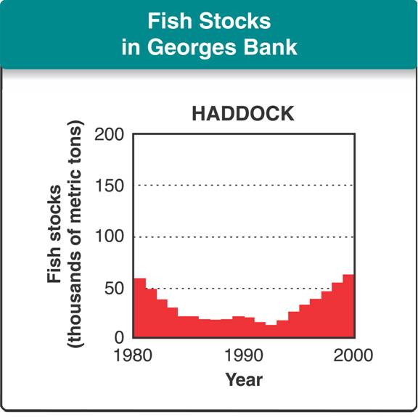
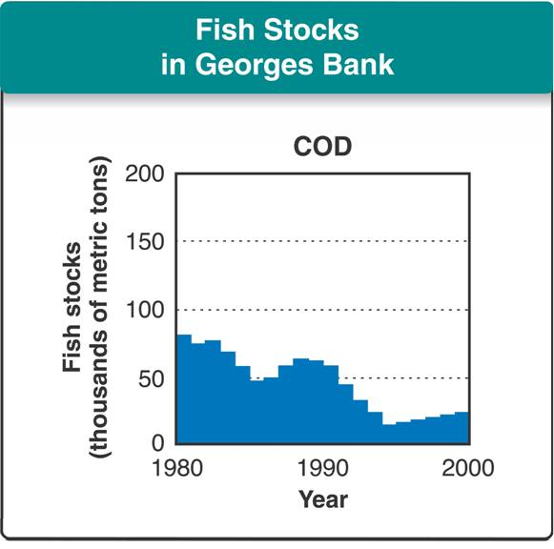

- Aquaculture
  - The raising of aquatic animals for human ______________________, which is called aquaculture, is also helping to sustain fish resources.
- Air Resources
  - The condition of the air affects people’s health.
  - ________ is a mixture of chemicals that occurs as a gray-brown haze in the atmosphere.
  - Smog is:
    - due to automobile exhausts and industrial emissions.
    - considered a pollutant because it threatens people’s ________________.
  - A pollutant is a __________________ material that can enter the biosphere through the land, air, or water.
    - The burning of _________________ fuels can release pollutants that cause smog and other problems in the atmosphere.
  - Strict automobile emissions standards and clean-air regulations have improved air quality in many cities, but air pollution is still a problem.
  - Many combustion processes release nitrogen and sulfur compounds into the atmosphere.
  - These compounds combine with water vapor to form __________________ rain.
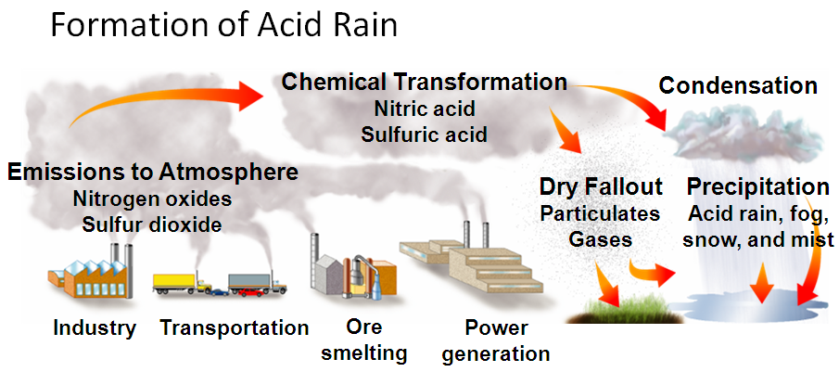

- Acid rain kills plants by damaging their leaves and changing the chemistry of soils and standing-water ecosystems.
- Acid rain may dissolve and releases _________________ elements, such as mercury, from the soil, freeing the elements to enter other portions of the biosphere.
- Freshwater Resources
  - Americans use billions of liters of fresh water daily for everything from drinking and washing to watering crops and making steel.
  - Although water is a renewable resource, the total supply of fresh water is limited and is threatened by ___________________________.
  - Sources of pollution include:
    - improperly discarded chemicals that enter streams and rivers.
    - wastes discarded on land that seep through soil and enter underground water supplies.
    - domestic sewage containing compounds that encourage growth of algae and bacteria.
    - sewage containing microorganisms that spread _____________________.
- Sustainable Use of Water
  - One way to ensure the sustainable use of water is to protect the natural systems involved in the water __________________ that help purify water.
  - These include:
    - wetlands
    - forests
    - other vegetation
  - Also, by conserving water in:
    - home
    - industry
    - _______________________
Section 3 – Biodiversity (Part 1)
- The Value of Biodiversity
  - Biological diversity, or biodiversity, is the sum total of the genetically based variety of all organisms in the biosphere.
  - Ecosystem diversity includes the variety of habitats, communities, and ecological processes in the living world.
  - Species diversity is the number of different _______________ in the biosphere.
  - Genetic diversity is the sum total of all the different forms of genetic information carried by all organisms living on Earth today.
- Why is biodiversity important?
  - Biodiversity is one of Earth's greatest natural __________________.
  - Species of many kinds have provided us with foods, industrial products, and ___________________—including painkillers, antibiotics, heart drugs, antidepressants, and anticancer drugs.
- What are the current threats to biodiversity?
- Threats to Biodiversity
- Human activity can reduce biodiversity by:
  - altering habitats
  - hunting species to ______________________
  - introducing toxic compounds into food ____________________
  - introducing foreign species to new environments
  - Extinction occurs when a species _________________ from all or part of its range.
  - A species whose population size is declining in a way that places it in danger of extinction is called an ______________________ species.
  - As the population of an endangered species declines, the species loses genetic diversity.
- Habitat Alteration
  - When land is developed, natural habitats may be _____________________.
  - Development often splits ecosystems into pieces, a process called habitat fragmentation.
  - The smaller a species’ habitat is, the more vulnerable the species is to further disturbance.
- Demand for Wildlife Products
  - Throughout history, humans have pushed some animal species to extinction by hunting them for food or other products.
  - Today, in the U.S., endangered species are protected from ____________________.
  - The Convention on International Trade in Endangered Species, CITES, bans international trade in products derived from endangered species.
- Pollution
  - Many forms of pollution can threaten biodiversity.
  - One of the most serious problems occurs when toxic compounds accumulate in the tissues of organisms.
  - DDT, one of the first ___________________, is a good example of this.
  - For a long time DDT was considered harmless, and it drained into rivers and streams in low concentrations.
  - However, DDT has two hazardous properties:
  - It is nonbiodegradable, which means that it cannot be broken _________ by organisms.
  - Once DDT is picked up by organisms, it cannot be eliminated from their ____________.
Biodiversity (Part 2)
- When DDT enters food webs, it undergoes biological magnfication.
  - In biological magnification, concentrations of a harmful substance increase in organisms at higher trophic levels in a food chain or food __________________.
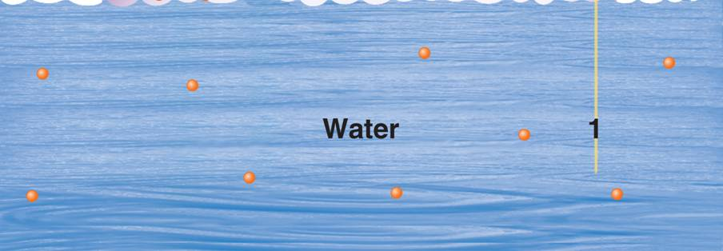
  - In 1962, biologist Rachel Carson wrote Silent Spring, which alerted people to the dangers of biological magnification.

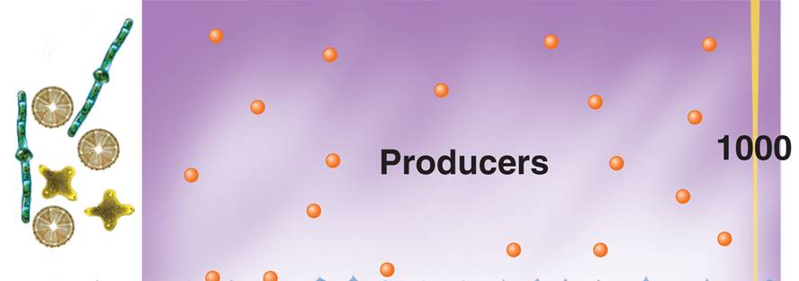

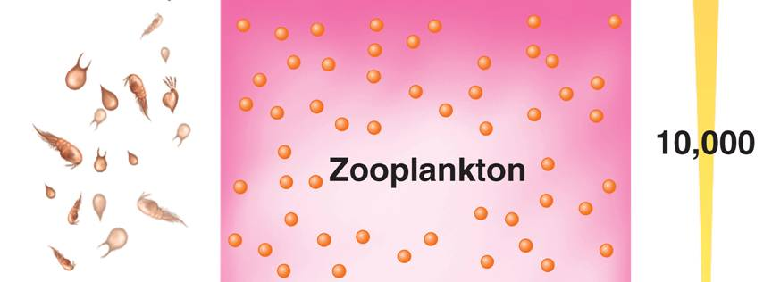

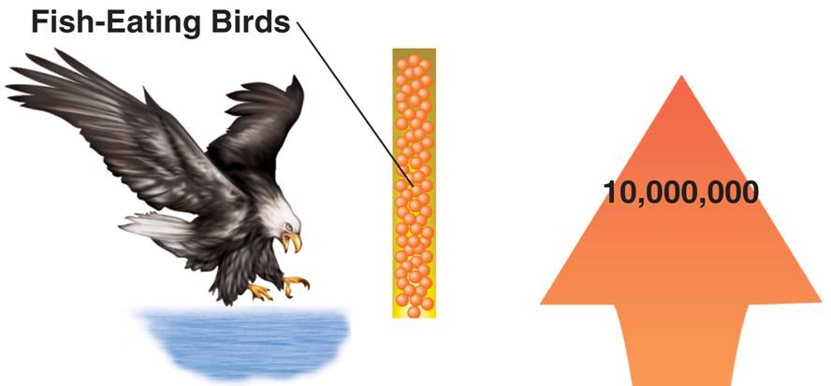
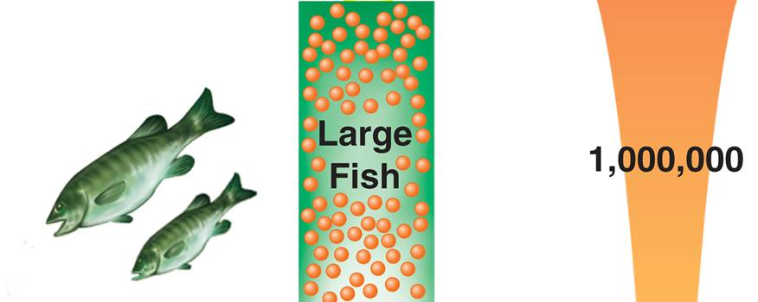
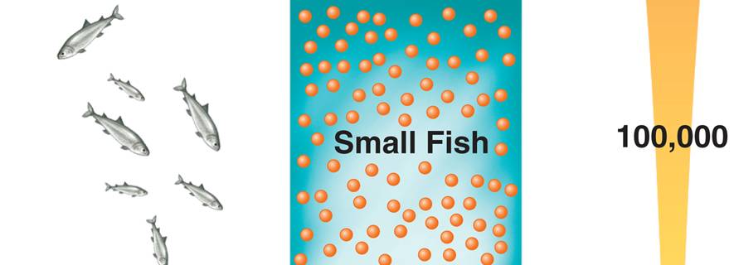

- The widespread use of DDT threatened populations of many animals—especially fish-eating birds like the bald ___________________—with extinction.
- By the early 1970s, DDT was banned in the U.S. and in most other industrialized countries; as a result, affected bird populations have recovered.
- Introduced Species
  - Another threat to biodiversity comes from plants and animals that humans transport around the world either accidentally or intentionally.
  - _________________ species are introduced species that reproduce rapidly because their new habitat lacks the predators that would control their population.
  - Hundreds of invasive species—including zebra mussels in the Great Lakes and the leafy spurge across the Northern Great Plains—are already causing ecological problems in the United States.
- Conserving Biodiversity
  - Conservation is the wise management of natural resources, including the preservation of habitats and wildlife.
- Strategies for Conservation
  - Many conservation efforts are aimed at managing individual species to keep them from becoming ______________________.
- What is the goal of conservation biology?
  - Conservation efforts focus on protecting entire ecosystems as well as single species.
  - Protecting an ecosystem will ensure that the natural habitats and the interactions of many different species are preserved at the same time.
- Conservation Challenges
  - Protecting resources for the future can require people to change the way they earn their living today.
  - Conservation regulations must be informed by solid research and must try to maximize benefits while minimizing economic costs.
Section 4 – Charting a Course for the Future
- What are two types of global change of concern to biologists?
- Researchers are gathering data to monitor and evaluate the effects of human activities on important systems in the biosphere. Two of these systems are:
  - the _______________ layer high in the atmosphere
  - the global climate system
- Ozone Depletion
  - Between 20 and 50 kilometers above Earth's surface, the atmosphere contains a relatively high concentration of ozone gas. This layer of the atmosphere is called the ozone ___________________.
  - The ozone layer absorbs a good deal of harmful ultraviolet, or ___________, radiation from sunlight before it reaches Earth's surface.
- Exposure to UV can:
  - cause ___________________
  - damage _____________
  - decrease organisms' resistance to disease
  - damage plant leaf tissue and phytoplankton in the oceans
- Early Evidence
  - In the 1970s, scientists discovered a hole in the ozone layer over _________________.
  - After it was first discovered, the ozone hole grew larger.
  - Since the ban, the level of CFCs in the atmosphere has decreased, indicating that the ban will have positive, long-term effects on the global environment.
  - Current data predict that the ozone holes should shrink and disappear within ___ years.
- Global Climate Change
  - All life on Earth depends on climate conditions such as temperature and rainfall.
  - Many ecologists are concerned about strong evidence that climate is changing.
  - Since the late 19th century, average temperatures have ______________ about 0.6 Celsius degrees.
  - Data indicate that since 1980, average temperatures have risen between 0.2 and 0.3 Celsius degrees.
  - The term used to describe the increase in the average temperature of the biosphere is global _________________________.
  - One sign of global warming is melting polar ice.
- Evidence of Global Warming
  - The geological record shows that Earth’s climate has changed repeatedly during its history.
  - Researchers must determine whether the current warming trend is part of a larger, natural cycle of climate change, or whether it is caused by _____________ activity.
  - A widely accepted hypothesis is that current warming is related, in part, to human activities that add carbon dioxide and other greenhouse gases to the atmosphere.
  - The burning of fossil fuels, along with the cutting and burning of forests, adds carbon _______________ to the atmosphere faster than the carbon cycle removes it.
  - Data show that concentrations of carbon dioxide in the atmosphere have been rising for _____________________ years.
  - As a result, the atmosphere’s natural greenhouse effect is intensified, causing the atmosphere to retain more heat.
- Possible Effects of Global Warming
  - Most recent computer models suggest that average global surface temperatures will increase by 1 to 2 Celsius degrees by the year 2050.
  - Sea levels may rise enough to ___________________ coastal areas, affecting coastal ecosystems as well as human communities.
  - Parts of North America may experience more droughts during the summer growing season.
  - New organisms may be able to live in places where they once could not.
  - Other organisms may become threatened or _______________ in areas where they once thrived.
- The Value of a Healthy Biosphere
  - Ecosystems provide many goods and services, such as water purification and waste recycling.
  - Ecosystems are also a reservoir of organisms that may one day provide humans with new ___________________ and new crops.
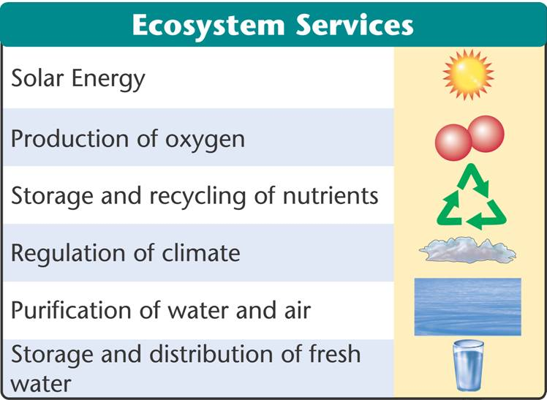

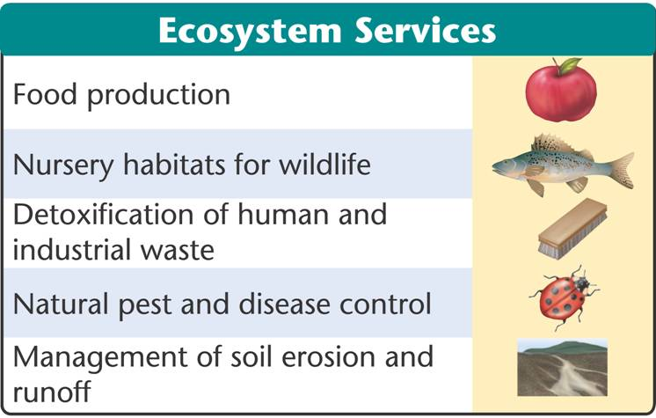

- People can make wise choices in the use and conservation of resources.
  - Avoid using more ______________________ than necessary.
  - Plant trees to replace those that have been cut down.
  - ______________________ and reuse trash and other wastes.
  - Safely remove hazardous materials.

