Chapter 9 – Cellular Respiration
Section 1 – Chemical Pathways
- Chemical Energy and Food
  - ______________ serves as a source of raw materials for the cells in the body and as a source of energy.
  - One gram of the sugar glucose (C₆H₁₂O₆), when burned in the presence of oxygen, releases 3811 calories of heat energy.
  - A ____________ is the amount of energy needed to raise the temperature of 1 gram of water 1 degree Celsius.
  - Cells don't “burn” glucose. Instead, they gradually release the energy from glucose and other food compounds.
  - This process begins with a pathway called ______________.
    - Glycolysis releases a small amount of energy.
  - If oxygen is present, glycolysis is followed by the Krebs cycle and the electron transport chain.
  - Glycolysis, the Krebs cycle, and the electron transport chain make up a process called _____________ respiration.
- Overview of Cellular Respiration
  - Cellular respiration is the process that releases _____________ by breaking down glucose and other food molecules in the presence of oxygen.
    - The equation for cellular respiration is:
      - 6O₂ + C₆H₁₂O₆ → 6CO₂ + 6H₂O + Energy
      - oxygen + glucose → carbon dioxide + water + Energy
      - This equation is the exact opposite of ______________
  - Each of the three stages of cellular respiration captures some of the chemical energy available in food molecules and uses it to produce _____________.
  - Glycolysis takes place in the _____________. The Krebs cycle and electron transport take place in the mitochondria.
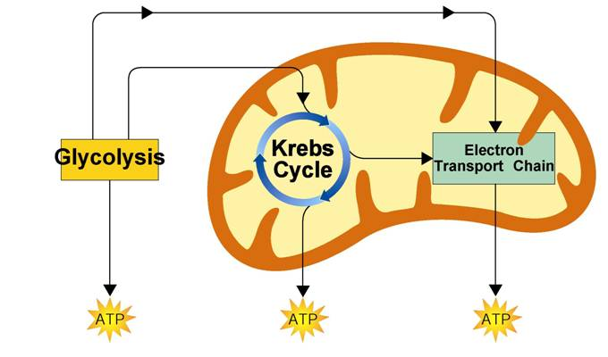

Chemical Pathways (Part 2)
- Glycolosis
  - Glycolysis is the process in which one molecule of glucose is broken in _____________, producing two molecules of pyruvic acid, a 3-carbon compound.
  - The Advantages of Glycolysis
    - The process of glycolysis is so fast that cells can produce _____________ of ATP molecules in a few milliseconds.
    - Glycolysis does not require ______________.
    - Therefore, glycolysis is an anaerobic process.
- Fermentation
  - When oxygen is not present, glycolysis is followed by a different pathway. The combined process of this pathway and glycolysis is called fermentation.
  - Fermentation ______________ energy from food molecules by producing ATP in the absence of oxygen.
  - The two main types of fermentation are lactic acid fermentation and alcoholic fermentation.
    - Alcoholic Fermentation
      - Yeasts and a few other microorganisms use alcoholic fermentation, forming ethyl alcohol and carbon dioxide as wastes.
    - Lactic ____________ Fermentation
      - Lactic acid fermentation converts glucose into lactic acid.
      - This is the reason why muscles ____________ during physical activity.

Section 2 - The Krebs Cycle and Electron Transport
- ______________ is required for the final steps of cellular respiration.
- Because the pathways of cellular respiration require oxygen, they are ______________.
- The Krebs Cycle
  - In the presence of oxygen, pyruvic acid produced in glycolysis passes to the _____________ stage of cellular respiration, the Krebs cycle.
  - During the Krebs cycle, pyruvic acid (from glycolysis) is broken down into ______________ dioxide in a series of energy-extracting reactions.
  - As a result, _______________ is produced.
  - Also, high energy ________________ are produced to aid take part in the electron transport chain.
- Electron Transport Chain
  - The electron transport chain uses the high-energy electrons from the Krebs cycle to convert ____________ into ATP.
  - On average, each pair of high-energy electrons that moves down the electron transport chain provides enough energy to produce three molecules of ATP from ADP.
- The Totals
  - Glycolysis produces just 2 ATP molecules per molecule of glucose.
  - The complete breakdown of glucose through cellular respiration, including glycolysis, results in the production of ______________ molecules of ATP.
- Comparing Photosynthesis and Cellular Respiration
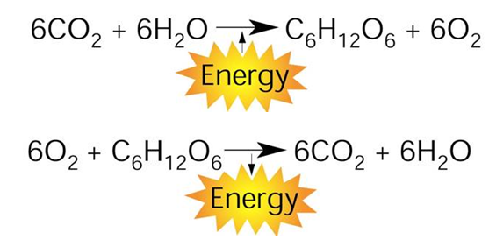
  - The energy flows in photosynthesis and cellular respiration take place in _____________ directions.

- On a global level, photosynthesis and cellular respiration are also opposites.
  - Photosynthesis ______________ carbon dioxide from the atmosphere and cellular respiration puts it back.
  - Photosynthesis ________________ oxygen into the atmosphere and cellular respiration uses that oxygen to release energy from food.

