Create at least 6 ORIGINAL questions that cover the material from section 2 – Chromosomes and DNA Replication – from chapter 12. For this activity, write questions that require shorter answers or can be fill in the blank.
3 questions should cover material from your guided notes (Section 2 – Chromosomes and DNA Replication).
3 questions should cover material from your textbook (pages 350-353 – this is technically section 3 in your book, but it covers the same material)
When you are writing your questions, format them as they are in the picture below. Type your question (with a question mark at the end), type an asterisk (* - this is done by holding shift and 8), and then type the answer to the question. It must be in this format in order for the next step to work correctly.
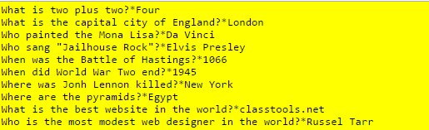

Type your questions on Word and upload them to the assignment in Edmodo.

