Chapter 12 Review – Arcade games
Step 1: Create at least 10 ORIGINAL questions that cover the material from section 1 (Parts 1, 2, and 3) from chapter 12. For this activity, write questions that require shorter answers or can be fill in the blank. These questions can come from your guided notes or the textbook (pages 338-343).
When you are writing your questions, format them as they are in the picture below. Type your question (with a question mark at the end), type an asterisk (* - this is done by holding shift and 8), and then type the answer to the question. It must be in this format in order for the next step to work correctly.
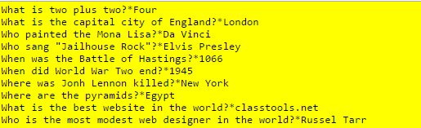
Step 2: Go to the website classtools.net (it may take a while to load) and choose the “Arcade Game Generator” tile. It is on the left side (see the picture below).
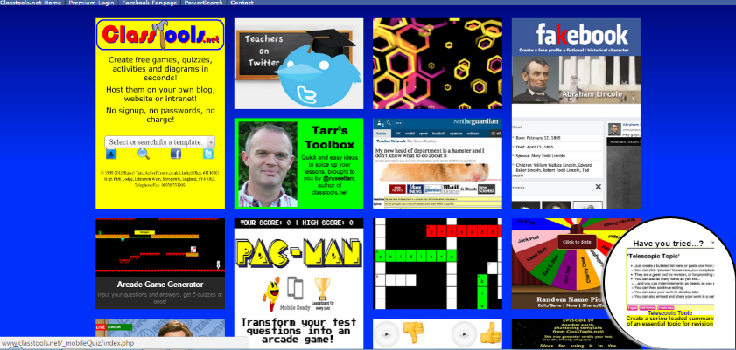

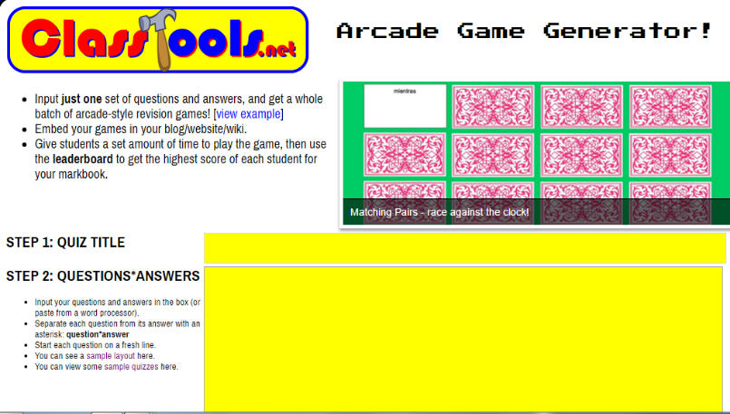
Step 3: Give your quiz a title (use your name followed by the word quiz – Example: Mr. B - Quiz) and copy and paste your questions into the box. Make sure they are in the format given above. Click “Create My Games” when you are finished.

Step 4: Copy the URL at the top of the screen.
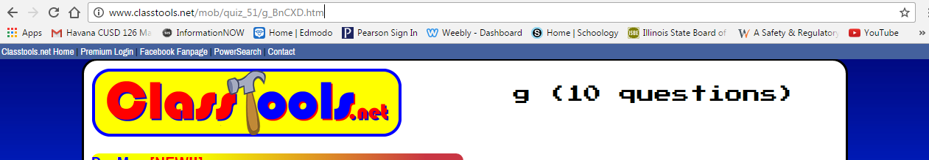

Step 5: Paste the URL into the Google Doc that Mr. B has shared with you. Paste your link next to your name.
Step 6: Play your game if you are the first person finished. Play the games of other students as well. There are a lot of different options for you to choose from after you select a set of questions.
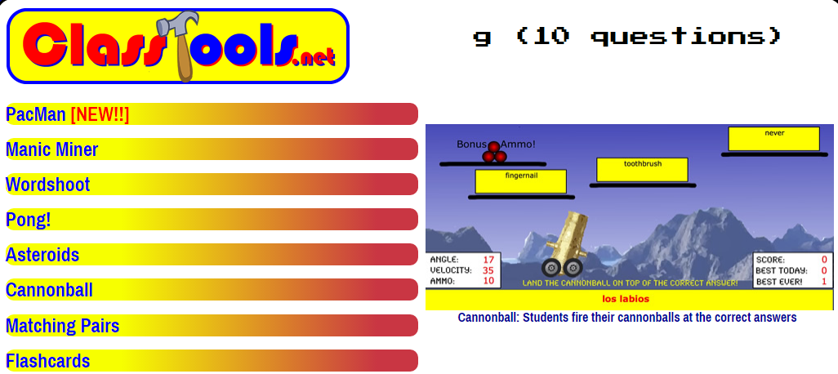

*******There will be a quiz tomorrow based off of the questions that you and your classmates have created. ***********

