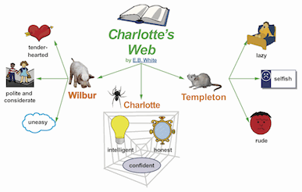[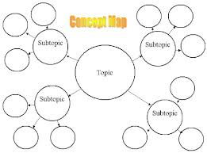](http://www.google.com/url?sa=i&rct=j&q=&esrc=s&source=images&cd=&cad=rja&uact=8&docid=b9vp21yq6TgykM&tbnid=10Q-MmrdhsUEbM:&ved=0CAcQjRw&url=http://www1.chapman.edu/cll/faculty/piper/2042/graphorg.htm&ei=nQkrVIGfHcnyoAT_l4GQAQ&bvm=bv.76477589,d.cGU&psig=AFQjCNEcKjUQL0yFZdg55kUiCHVm40F1NA&ust=1412187479366356)

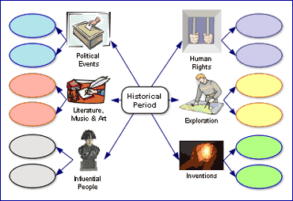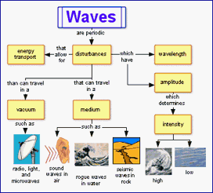

[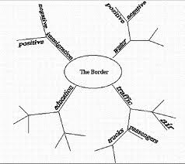](http://www.google.com/url?sa=i&rct=j&q=&esrc=s&source=images&cd=&cad=rja&uact=8&docid=mpqwPupr5askZM&tbnid=N2c6khDALOMw1M:&ved=0CAcQjRw&url=http://museum2.utep.edu/allpass/frontera.htm&ei=tAsrVO_jOJfZoAS1rYHwBA&psig=AFQjCNEcKjUQL0yFZdg55kUiCHVm40F1NA&ust=1412187479366356)