Name:______________________
Other Evolutionary Scientists – STAPLE THIS TO YOUR GUIDED NOTES ONCE YOU ARE FINISHED!
Directions – Under the picture of each scientist, answer the questions about their contribution to the theory of Evolution. Use your guided notes to answer these questions.
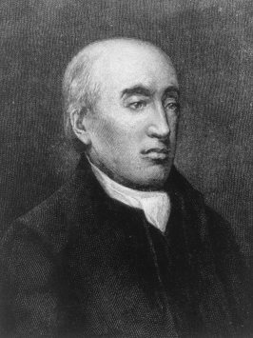
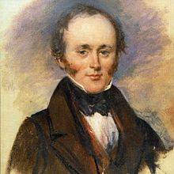

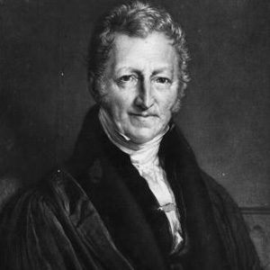
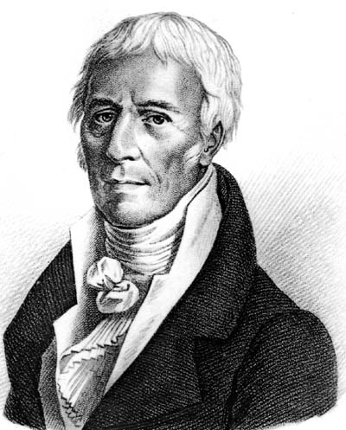
Thomas Malthus
1. Malthus reasoned that if the human _____________ continued to grow unchecked, sooner or later there would be insufficient living space and _______________ for everyone.
2. How did the work of Malthus influence Darwin?

Jean-Baptiste Lamarck
1. Lamarck proposed that by selective use or ________________ of organs, organisms acquired or lost certain traits during their lifetime. These traits could then be passed on to their _________________.
2. True or False: Lamarck’s theory of evolution was correct.
3. True or False: The work of Lamarck did not benefit scientists in any way.
Charles Lyell
1. The processes that shaped the Earth ______________ of years earlier continue in the _______________.
2. This influenced Darwin because, If the Earth could change over time, ___________________ might change as well.

James Hutton
1. True or False: Hutton stated that geologic forces acted on the Earth very slowly.
2. What did Hutton say about the age of the Earth?

Directions – Draw, color, and label (there is a caption underneath the picture that you can use to label) the picture on page 376. USE THE HARD COPY TEXT BOOK IN THE BACK OF MR.B’S ROOM. After drawing this picture, you should be able to explain Lamarck’s theory of Use and Disuse.

