Works Cited Guide

- Format:
  - Font: Times New Romans
  - Size Font: 12
  - Space: Double
  - Special: Hanging

- Citing your book sources:
  - Make sure you put the following in numerical order!!
- Author (Last name first and follow with a period.)
- Title (Underline and follow with a period.)
- City of publication (Follow with a colon. This is a colon. : )
- Publisher (Follow with a comma.)
- Date of publication (Follow with a period.)

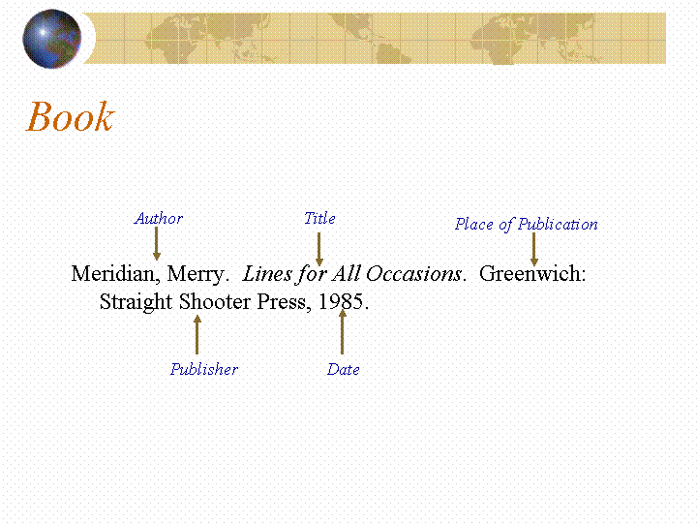

- Citing your web sources:
- Author (Last name first and follow with a period.)
- Title (Put in quotations and follow with a period.)
- Title of web site. (Underline and follow by period.)
- Date of publication (Follow with a period. Write like the following date: 19 Feb. 2012)
- Sponsor of site. (Follow with a period.)
- Date of access. (When did you find it? Write like the following date: 19 Feb. 2012)
- URL. (Web site link. You may do the short version ending in .com, .org, .net, etc.)
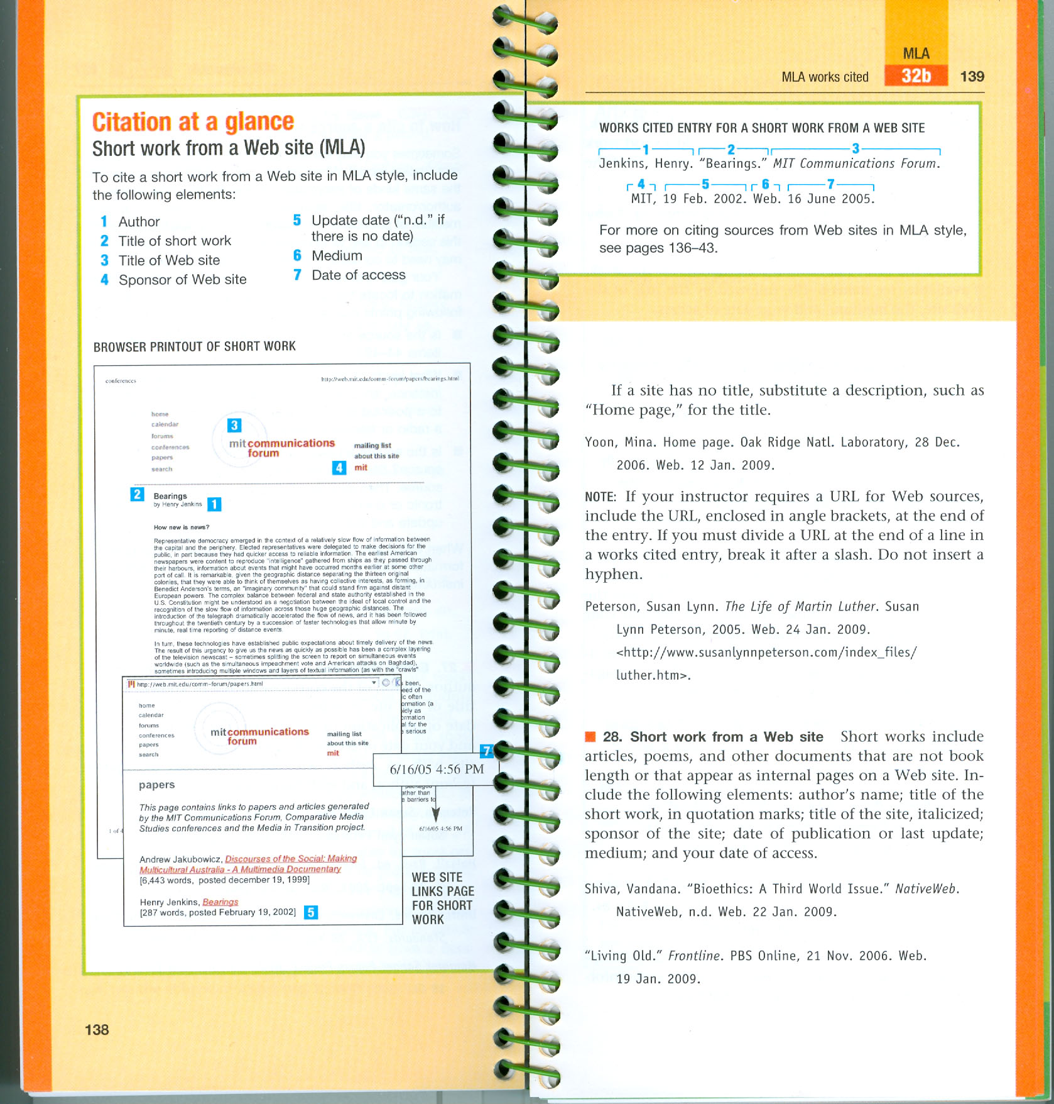

- The finished bibliographies for the books and websites will need to be listed in alphabetical order according to the author’s last name.
